 DHCP Setup Instructions for Macintosh OS X.3

Step 1: Click on the Apple in the upper left hand corner and select System Preferences as shown below:
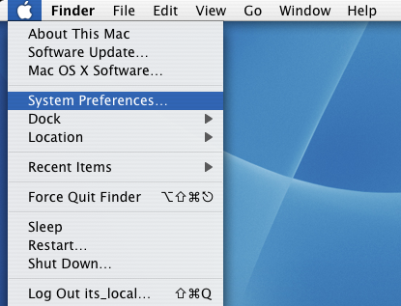

Step 2: Click on the Network icon in System Preferences:
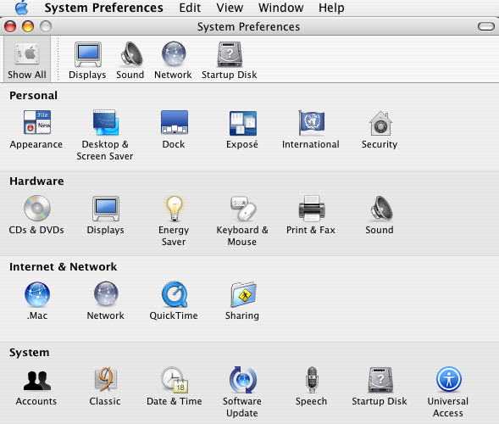

Step 3: You should see all your Network connections. Highlight Built-in Ethernet and click Configure. (the IP address has been blanked out for security)
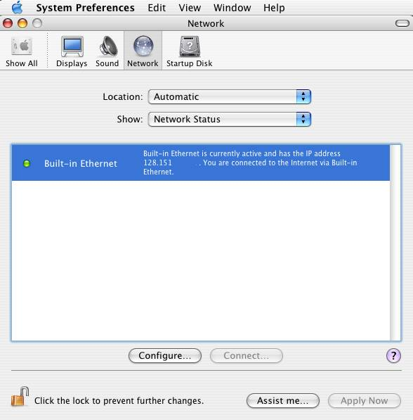

Step 4:**Note write down any numbers that currently appear in the boxes below in case you need to revert back to them. Make sure that Using DHCP is selected for Configure IP v4. If you are connected to a network using DHCP the IP, Subnet Mask, & Router should fill in with numbers. (Some numbers have been blanked out for security)
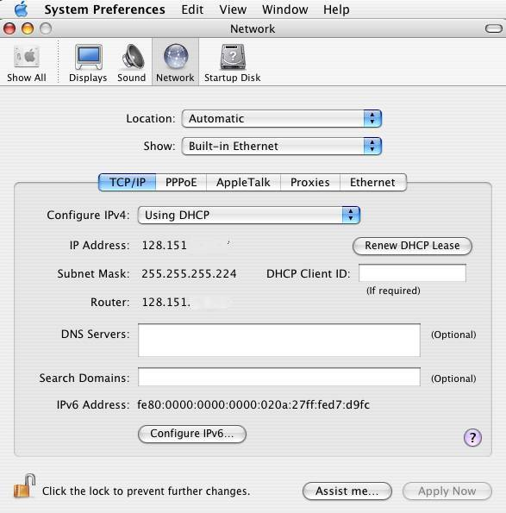
You can now close the System Preferences and you are ready to access the network using DHCP.

