DHCP Setup Instructions for Windows XP (normal view)

Step 1: Click on the Start button and click on Control Panel, as shown below:
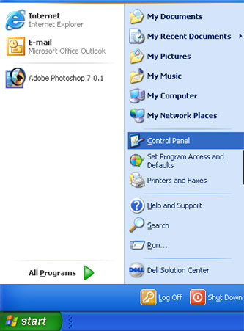

Step 2a: Next click on the Network and Internet Connections icon:
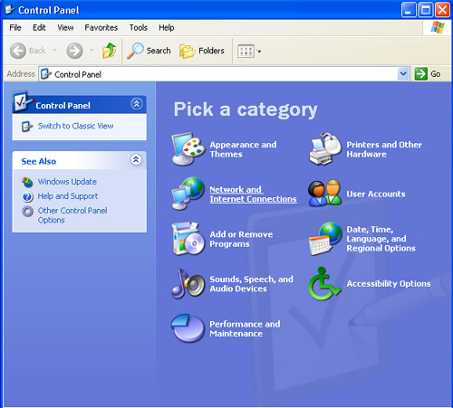

Step2b: Next click on Network Connections:
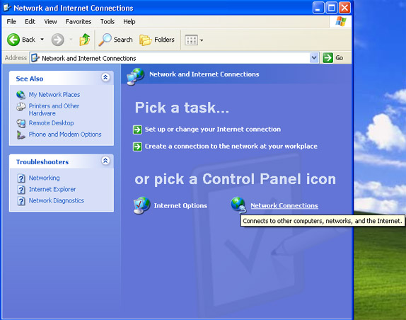

Step 3: Next “right click” on Local Area Connection and select Properties.
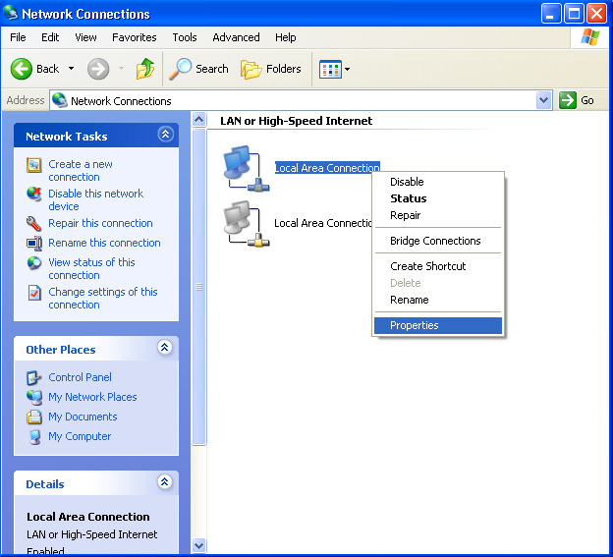

Step 4: In the center window scroll down until you see Internet Protocol (TCP/IP) highlight it and click the Properties button.
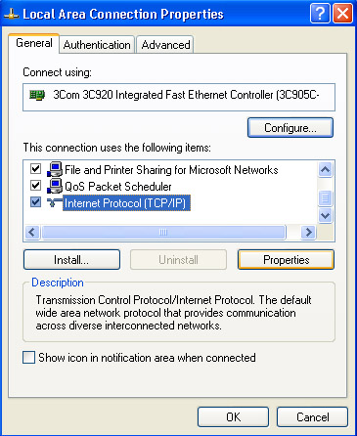
Step 5: **Note, write down any numbers currently in the boxes below incase you need to revert back to them. Make sure that Obtain an IP address automatically & Obtain DNS server address automatically are selected as shown below:
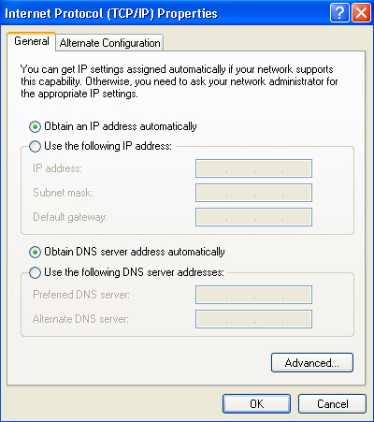
Click OK (possibly more than once) to save the settings and return to the desktop.
You are now ready to use the network using DHCP.

