
DHCP instructions of Macintosh OS 9.2.x

Step 1: Click on the colored Apple in the upper left hand corner, then select “control panel”, then select “TCP/IP”, as shown below:

Step 2: **Note copy down all info from the window below if you have numbers already in the boxes below in case you need to revert back to them. Make sure that “Connect via” is set to Ethernet and “Configure” is set to Using DHCP Server. (Some numbers were blanked out for security)
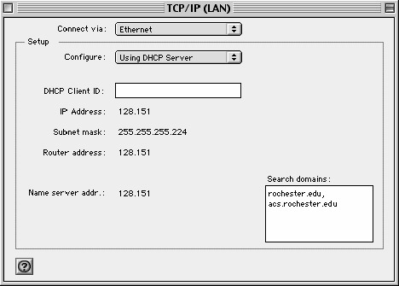
Click the close box and if prompted to save click on the Save button and you are now ready to access the network using DHCP.

