Subject Line: XXXXX

Today, documentation regarding the above-entitled research project was received by our office. {Contract Manager Name/email address/phone number} will be the contract manager handling the contract on behalf of the University of Rochester.

The University of Rochester is dedicated to providing its patients with access to promising new treatments. Therefore, in order to expedite the contract process, we would like to propose utilizing the Accelerated Clinical Trial Agreement (ACTA) developed by 25 CTSA institutions for sponsor-initiated multi-site studies. To date, 50 organizations representing over 225 sites, including academic medical centers, have agreed to use the ACTA without the need for further legal negotiations. The ACTA was developed with input from industry.

I have attached the ACTA agreement, as well as a Fact Sheet, providing some additional background concerning the development of this agreement, for your review and consideration. If you have further questions regarding the ACTA, or if you are in agreement with using the ACTA for this study, please contact {Contract Manager}.

We look forward to working with you.

Sincerely,

Attachments: ACTA Agreement (PDF) & ACTA Fact Sheet
Many organizations face challenges in finalizing clinical trial agreements. Data from a 2010 Clinical and Translational Science Awards (CTSA) Contracts Processing Study¹ showed that an average contract negotiation of contract terms (exclusive of budget and IRB approval) of 55 days could be reduced to 22 days if a “master agreement” was used. This information prompted CTSA awardees to develop an efficient contract that, if adopted, could help further reduce delays in trial start-up.
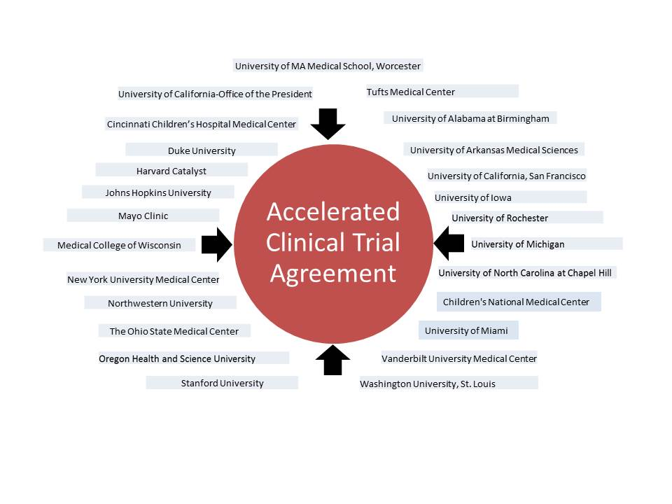
With support from the National Institutes of Health’s National Center for Advancing Translational Sciences, grant #5U54TR000123, the Accelerated Clinical Trial Agreement (ACTA) was developed by 25 leading academic institutions and medical centers engaged in clinical research and translational science in collaboration with the University Industry Demonstration Partnership (UIDP) and with input from several pharmaceutical companies. The ACTA is a straightforward and unambiguous document which clearly sets forth the contractual obligations of both parties, and presents language which — while perhaps not ideal for either party — is acceptable to both. Adoption and use of the ACTA will expedite the contract negotiation process and reduce the time it takes to start up industry-sponsored, multi-center clinical trials.
To date, approximately 50 organizations representing more than 225 research sites, including academic medical centers, universities, hospitals and physician practices, have agreed to the terms of the ACTA and accept the ACTA without revision. Those interested in using the ACTA or additional accelerated agreements can learn more at www.ara4us.org.
The initial ACTA was drafted and finalized by participating CTSA institutions and shared with external reviewers — AAHRPP, Shire, Pfizer and Epizyme — for their input. The UIDP joined this initiative in March 2014.
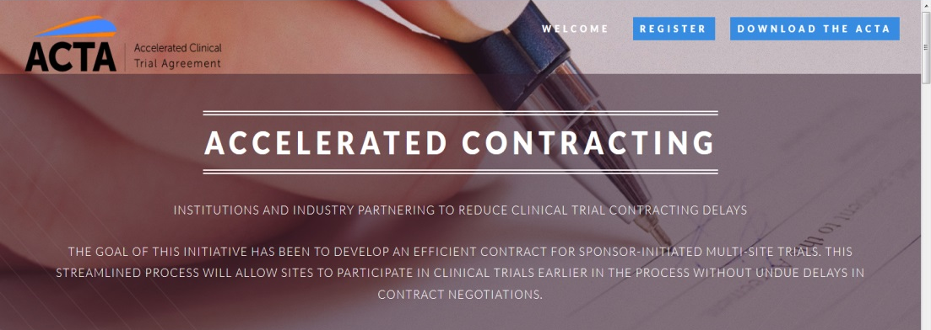
Use of the ACTA is voluntary; accepting the terms does not in any way mandate its use by any party.

- * Observational study of contracts processing at 29 CTSA sites. Clin Transl Sci. 2013 Aug;6(4):279-85. Kiriakis J, Gaich N, Johnston SC, Kitterman D, Rosenblum D, Salberg L, Rifkind A.

Examples of Institutions/Organizations that have accepted the ACTA
Albert Einstein College of Medicine | Stanford University | University of Michigan
Boston University | Tufts Medical Center | University of Minnesota
Children’s National Medical Center | University of Illinois, Chicago | University of New Mexico Health Sciences Center
Cincinnati Children’s Hospital Medical Center | University of Alabama at Birmingham | University of North Carolina at Chapel Hill
Dartmouth College | University of Arkansas for Medical Sciences | University of Pennsylvania
Duke University | University of California, Davis | University of Pittsburgh/University of Pittsburgh Medical Center (UPMC)
Georgia Regents University | University of California, Irvine | University of Rochester
The Ohio State University | University of California, Los Angeles | University of Southern California
Indiana University School of Medicine | University of California, Riverside | University of Texas-Austin
Johns Hopkins University | University of California, San Diego | University of Texas-Houston
Mayo Clinic | University of California, San Francisco | University of Texas-Medical Branch
Medical College of Wisconsin | University of Chicago | University of Texas, San Antonio
Mount Sinai School of Medicine | University of Florida | Georgetown University
New York University School of Medicine | University of Iowa | University of Texas-Southwestern Dallas
Northwestern University | University of Kansas Medical Center | University of Utah
Oregon Health & Science University | University of Kentucky Research Foundations | University of Wisconsin – Madison
The Pennsylvania State University/The Milton S. Hershey Medical Center | University of Louisville | Vanderbilt University Medical Center
Rockefeller University | University of Massachusetts Medical School, Worcester | Washington University, St. Louis
Scripps Health | University of Miami | Yale University
Case Western University School of Medicine | University Hospitals Case Medical Center | University of Kansas
Rush University Medical Center | Healthcare Corporations of America (HCA) (includes 165 Institutions) | Sucampo Pharmaceuticals, Inc
MedStar Health Research Institute | Medpace | Medical University of South Carolina
Michigan State University | Aurora Denver Cardiology Assoc. | PPD
Clinical Physiology Associates | Expedite Research, LLC | FibroGen Inc.
Future Care Solution, LLC | Pharma Research International, Inc. | Pinnacle Research Group, LLC
QUEST Research Institute | Wisconsin Center for Advanced Research | Mercy Research Institute
Apellis Pharmaceuticals, Inc. | AZCERT | Wake Forest University Health Services

Contact: Terri Edwards, RN, RAC | Project Manager | 615-322-7342 | acta@ara4us.org

