University of Rochester

Fundriver Balance


User Guide

Last Edit: 05/15/26

Table of Contents

- Fundriver Overview
- Fundriver Close Timeline
- Accessing Fundriver
  - Fundriver Link
  - Requesting Login Access
  - Resetting Your Password
- Navigation
  - Dashboard Tab
  - Funds Tab
  - Reporting Tab
- Reference Materials
  - Fundriver Fund Table
  - University Fundriver Accounting Crosswalk
  - University Trial Balance Report Examples
- Frequently Asked Questions

Fundriver Overview

The University of Rochester utilizes Fundriver, a web-based endowment management platform, to track and manage investment performance for the University’s Long-Term Investment Pool. Each user is granted personalized access within the system to funds and reports relevant to their role.
This guide has been prepared by the Endowment Accounting team to assist both Central and Company-level users in navigating and accessing Fundriver effectively.
Please use the instructions in this guide when navigating Fundriver. Please do not use the “Support” button within Fundriver.
For assistance, contact EndowmentAccounting@rochester.edu.

Fundriver Close Timeline

Fundriver performance is updated based on the monthly and year-end close schedules outlined below.
Period | Close Timeline
October – June Preliminary Close | Monthly performance is integrated to the Post Close book on or before the 11th banking business day of the following month.
June Final Close | Final June performance is integrated to the Post Close book at the end of August, following completion of year-end close activities.
July – September | Performance is held during the fiscal year-end audit period. July, August, and September performance will be integrated to the September Post Close book on or before the 11th banking business day of October.

After the Fundriver monthly close is complete, users will receive an email notification from Endowment Accounting. Once this notification is received, users may run Fundriver reports and related UR Financials reports.

Monthly Fundriver Close Email Notification Example:
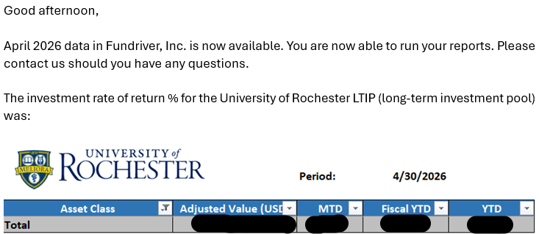

Back to Table of Contents.

Accessing Fundriver

Fundriver Link
To access the Fundriver login page, navigate to: https://rochester.fundriverbalance.com/
Please bookmark this link for easy access in the future.

Requesting Login Access
To request access to Fundriver, contact Endowment Accounting at EndowmentAccounting@rochester.edu
Endowment Accounting will review the request and provide the appropriate access instructions, if applicable.
Note: Fundriver access is limited to users who have Company-level access within UR Financials. Users without Company-level access are not eligible for Fundriver access.

Resetting Your Password
If you are unable to sign in:
- On the login page, select “Forgot Password”
- Enter your Fundriver Username (email address) and select “Reset password”
- Next verify your identity, select your preferred authentication method and select “Get code”
- Once code is received enter it in the Access Code field and select “Submit”
- Enter your New Password, Confirm Password, and select “Update”

Password requirements:
- At least 1 uppercase character
- At least 1 lowercase character
- At least 1 number
- At least 1 special character (!?-@#$%^&*)
  - Only one of each special character may be used in your password
- Minimum of 8 characters in length.
If you are signed in:
You can reset your password by navigating to User Settings. Click on the silhouette of a person icon located in the upper righthand corner of the page and select “Settings”.
On the User Settings page, you can add or update your contact information and multifactor authentication information. On this page, you can also update your password.

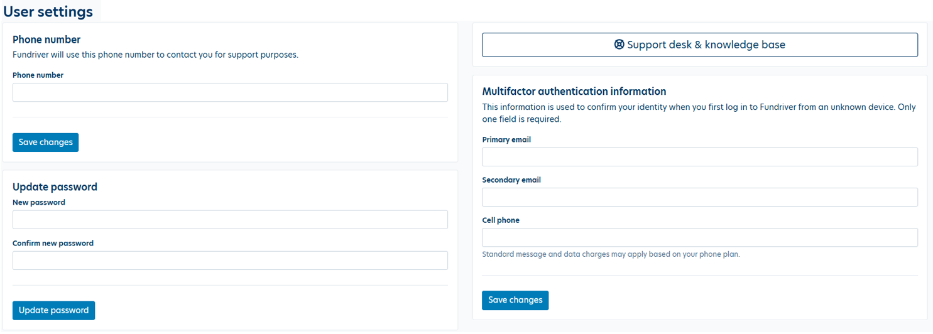

Back to Table of Contents.

Navigation

Dashboard Tab
When you log into Fundriver, the Dashboard is the first page you will see. It displays:
- The navigation tabs on the left side: Dashboard, Funds, Reporting
- The current open accounting period across the top center
- The market value and total number of funds you are authorized to view
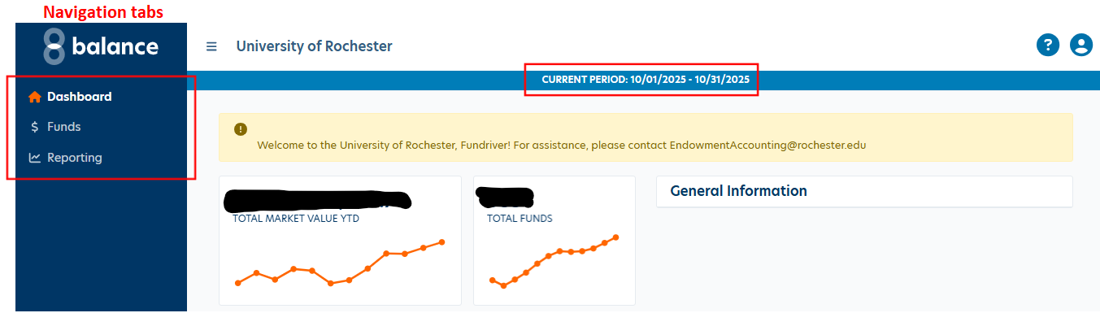

Funds Tab
When you select the navigation Funds tab, a list of all funds you are authorized to view will appear. You can search for specific funds by GLID or Name using the search bar.
To download the displayed data, use either the “Export XLSX” or “Export CSV” button on the righthand side of the screen.
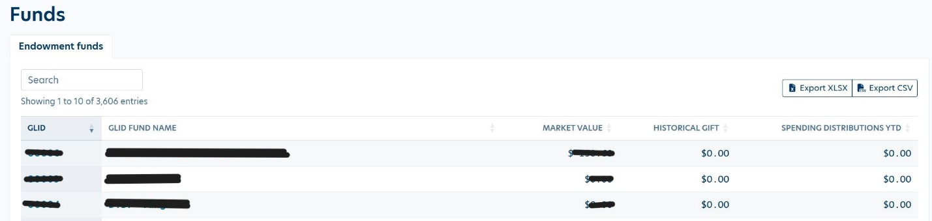

To view details for a specific fund, enter the GLID or Fund Name in the search box then select the fund in the results table. This will open the Fund Detail page, which includes key information such as fund activity, historical gift value, market value, inception date, department, and other important fund details.
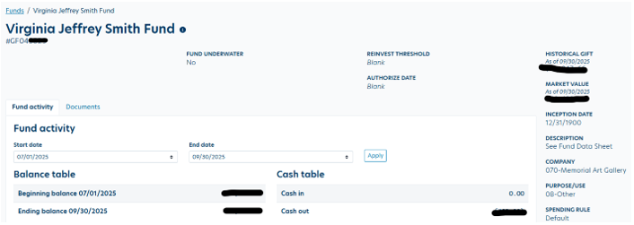
Back to Table of Contents.

Reporting Tab
Reporting > Summary
The Summary reporting folder includes fund-level and rollforward reports that can be used to review market value, contributions, transfers, distributions, investment performance, liquidation activity, and fund attributes. These reports are commonly used for stewardship, endowment review, and reconciliation support. Below is a list of the reports currently available:
Report Name | Report Description
Account Summary Stewardship Report by Fund | Provides a month-by-month summary for a single fund, including beginning market value, gifts, transfers, distributions, total return, ending market value, and historical gifts.
All Funds | Provides a summary of all funds available to the user, including an investment rollforward of beginning market value, contributions, realized and unrealized gains, income, transfers, distributions, and ending market value.
Endowment Fund Profiles | Provides a summary of all active endowment funds and related fund attributes available to the user. This report also includes the fund purpose description, funding status, and minimum funding level as of a selected point in time. The funding status of Fully Funded means the fund is budget eligible. The status of Underfunded means the minimum funding requirement has not yet been met. If a fund is underfunded, the minimum funding level is noted.
Endowment Funds | Provides a summary of endowment funds available to the user, including an investment rollforward of beginning market value, contributions, realized and unrealized gains, income, transfers, distributions, and ending market value.
Fund Statement | Provides a fund-level statement including fund number, purpose description as of a selected point in time, and an investment rollforward of beginning market value, investment performance, contributions, distributions, transfers, and ending market value. This report can be run for a single fund or all funds available to the user.
Planned Giving Summary | Provides a summary of planned giving funds available to the user, including an investment rollforward of beginning market value, contributions, income, realized and unrealized gains, transfers, distributions, ending market value, and ending contributed value.
When a specific report is selected, the system will prompt you to enter the required reporting parameters (e.g., Start Date, End Date, GLID, and/or Grouping Options). After entering the desired parameters, select “Run Report”.
Note: The Start Date should typically be set to the last day of the prior fiscal year 06/30/xx. Refer to screenshot below to view a sample report prompt screen.
Example: Report prompt screen for running the All Funds report for FY26 Q1:
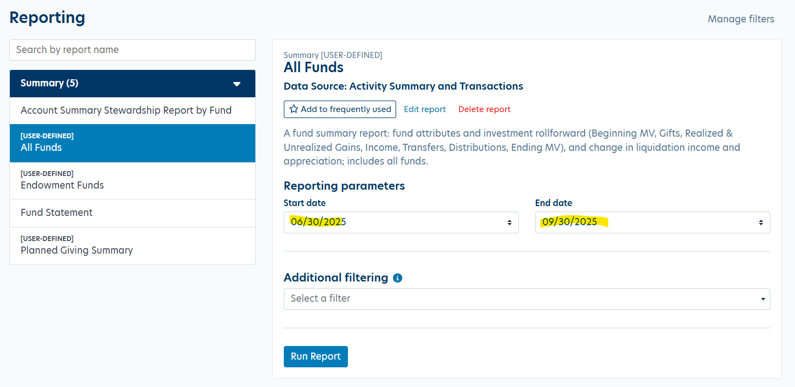

This action will open your report in a new browser tab. To save the report, select the “Save” button on the top toolbar. You can then choose to download the report in PDF, Excel, or Word format.
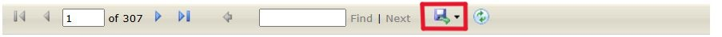

Reference Materials

Fundriver Fund Table
The Fundriver Fund Table identifies the major fund classifications used in Fundriver and how they generally relate to UR Financials FAO types, fund groups, and fund categories. This table is intended to help users understand how funds are categorized for reporting purposes.

Net Asset Classification | FAO Type | Fund Group | Fund Category | Notes
1-True Endowment | GF04/GF45 | Endowment | True Endowment | UR spending budget is liquidated to the related GF45xxxx FAO.
2-Funds Functioning as Endowment | GF04/GF45 | Endowment | Funds Functioning as Endowment (FFAE) | UR spending budget is liquidated to the related GF45xxxx FAO.
3-Term Endowment | GF04/GF45 | Endowment | Term Endowment | UR spending budget is liquidated to the related GF45xxxx FAO.
4-FFAE Temp Restricted Endowment | GF04/GF45 | Endowment | FFAE Temp Restricted Endowment | UR spending budget is liquidated to the related GF45xxxx FAO.
Secondary Pool - UR ST Investments | GF037xxx | Secondary Pool | UR ST Investments | Deposit or withdrawal requests should be directed to Endowment Accounting.
Secondary Pool - Affiliate Other LT Investments | N/A | Secondary Pool | Affiliate Other LT Investments | Deposit or withdrawal requests should be directed to Endowment Accounting.
Secondary Pool - Affiliate ST Investments | N/A | Secondary Pool | Affiliate ST Investments | Deposit or withdrawal requests should be directed to Endowment Accounting.
Secondary Pool - 457(f) | OP01xxx | Secondary Pool | 457(f) | Restricted to Endowment Accounting use only.
Charitable Gift Annuity Pool | GF03xxxx | Planned Giving | Charitable Gift Annuity | Restricted to Endowment Accounting use only.
Charitable Remainder Trust Pool | GF03xxxx | Planned Giving | Charitable Trust | Restricted to Endowment Accounting use only.
Non-Pooled Trust | GF03xxxx | Planned Giving | Charitable Trust | Restricted to Endowment Accounting use only.
Vanguard Trust Pool | GF03xxxx | Planned Giving | Charitable Trust | Restricted to Endowment Accounting use only.
JIP1 | GF03xxxx | Planned Giving | Charitable Trust | Restricted to Endowment Accounting use only.
JIP2 | GF03xxxx | Planned Giving | Charitable Trust | Restricted to Endowment Accounting use only.
JIP3 | GF03xxxx | Planned Giving | Charitable Trust | Restricted to Endowment Accounting use only.
DAF UR Only | GF03xxxx | Planned Giving | Donor Advised Fund | Restricted to donor-advised fund activity managed by Trusts and Estates and Endowment Accounting.
DAF Other Charities | GF03xxxx | Planned Giving | Donor Advised Fund | Restricted to donor-advised fund activity managed by Trusts and Estates and Endowment Accounting.
Other Investments | GF03xxxx | Other Investments | UR Other Investments | Restricted to Endowment Accounting use only.
None | N/A | External Fund | Schmitt Fund | Restricted to Endowment Accounting use only.

University Fundriver Accounting Crosswalk
The University Fundriver Accounting Crosswalk provides a general crosswalk between Fundriver activity, UR Financials ledger accounts, and how activity is generally reflected between GF03/GF04xxxx funds and related GF45xxxx spending FAOs.
This table is intended to help users understand where Fundriver-related balances and activity may appear in UR Financials reports. It should be used as a reference guide only. Questions regarding specific fund activity, balances, or reporting should be directed to Endowment Accounting at EndowmentAccounting@rochester.edu.
Financial Statement Line | Ledger Account Description | GF03/GF04xxxx | GF45xxxx
Assets
Cash and Cash Equivalents | 10100:Cash Adjustments | N/A | Prior year cash (surplus)/deficit
Investments Held for Long Term Purposes | 15250:Investments Appreciation or Depreciation | Endowment and Planned Giving market value | N/A
Investments Held for Long Term Purposes | 15400:Investments Contributed Value | Endowment and Planned Giving market value | N/A
Investments Held for Long Term Purposes | 15650:Investments Income Reinvestment | Endowment and Planned Giving market value | N/A
Short Term Investments | 10810:Operating Investments Appreciation or Depreciation | Operating investments market value | N/A
Short Term Investments | 10820:Operating Investments Contributed Value | Operating investments market value | N/A
Short Term Investments | 10830:Operating Investments Income | Operating investments market value | N/A
Liabilities
Accounts Payable and Accrued Expenses | 20350:Obligation for Deferred Gifts | Planned Giving fund liabilities | N/A
Deferred Revenue | 22000:Deferred Revenue | Planned Giving fund liabilities | N/A
Revenues
Gifts and Pledges | 42000:Gifts | Current year gifts | N/A
Interest Income and Appreciation of Operating Investments | 45000:Interest Income | Operating investments income and appreciation | N/A
Interest Income and Appreciation of Operating Investments | 45100:Realized Gains or Losses on Operating Investments | Operating investments income and appreciation | N/A
Interest Income and Appreciation of Operating Investments | 45200:Unrealized Gains or Losses on Operating Investments | Operating investments income and appreciation | N/A
Expenses
Operating Expenses | Ledger Accounts 5xxxx-6xxxx | N/A | Current year endowment spending
Non-Operating Activities
Investment Income | 90000:Investment Income | Endowment and Donor Advised fund income and appreciation | Current year endowment budget liquidation, booked 1/12 each month
Net Appreciation or Depreciation | 91000:Realized Gains or Losses on Long Term Investments | Endowment and Donor Advised fund income and appreciation | N/A
Net Appreciation or Depreciation | 91100:Unrealized Gains or Losses on Long Term Investments | Endowment and Donor Advised fund income and appreciation | N/A
Net Appreciation or Depreciation | 91400:Endowment Appreciation Liquidation | Endowment and Donor Advised fund income and appreciation | Current year endowment budget liquidation, booked 1/12 each month
Change in Valuation of Split Interest Agreements | 92300:Valuation of Split Interest Agreements | Current year change in valuation | N/A
Transfers | 93450:Transfers Other | Withdrawals and transfers | N/A

University Trial Balance Report Examples
The following examples illustrate how Fundriver-related activity may appear in the URF0947 Trial Balance – Company Level report for endowment principal and spending FAOs. These examples are intended to help users understand the relationship between the endowment principal account, related spending account, and Fundriver balances.

Endowment Principal Account GF04xxxx Example
The GF04xxxx principal account reflects the endowment fund’s long-term investment balances. These balances will agree to amounts reported in Fundriver for the selected period.
UR Financials Ledger Accounts 15250 + 15400 + 15650 = Fundriver Market Value
UR Trial Balance URF0947
Ledger Account | Ending Balance
15250:Investments Appreciation or Depreciation | 74,967.60
15400:Investments Contributed Value | 27,908.48
15650:Investments Income Reinvestment | 7,621.93
Total | 110,498.01

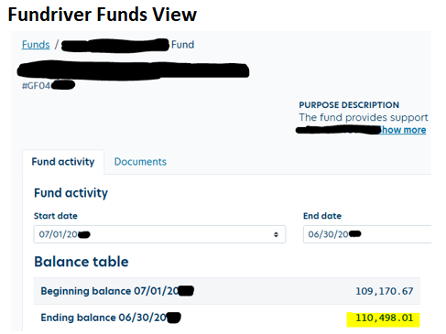

Endowment Spending Account GF45xxxx Example
The GF45xxxx spending account reflects current year endowment spending activity, budget liquidations, and cash carryforward activity.
The highlighted amounts below show how current year spending, budget liquidations, and cash carryforward activity are reflected in the URF0947 Trial Balance.
UR Trial Balance URF0947
Ledger Account | Beginning Balance | Debit Amount | Credit Amount | Ending Balance
10100:Cash Adjustments | (177.65) | 0.00 | 693.42 | (871.07)
61400:Travel and Conference | 1,646.40 | 1,282.08 | 0.00 | 2,928.48
61500:Professional Services | 0.00 | 500.00 | 0.00 | 500.00
65300:Interdepartmental Expense Transfers | 722.50 | 77.95 | 0.00 | 800.45
90000:Investment Income | (6,266.58) | 6,088.93 | 567.55 | (745.20)
91000:Realized Gains or Losses on Long Term Investments | 0.00 | 177.65 | 0.00 | 177.65
91400:Endowment Appreciation Liquidation | 1,413.93 | 745.20 | 6,513.93 | (4,354.80)
Total | (2,661.40) | 8,871.81 | 7,774.90 | (1,564.49)

Spending Account Activity Summary
Activity | Amount | Description
Prior year cash carryforward | (177.65) | Cash surplus
Current year expenses | 4,228.93 | Current year spending activity
Current year endowment budget liquidations | (5,100.00) | Budget liquidations
Cash reinvestment/(liquidation) | 177.65 | Cash reinvestment
Current year net activity | (693.42) | Year-end cash rollforward adjustment
End of year cash carryforward | (871.07) | Net cash surplus carried forward to the new fiscal year

Note: The annual endowment spending budget is liquidated 1/12 each month to fund the related GF45xxxx spending account. However, the full annual spending budget is available for use at the beginning of the fiscal year. Endowment GF45xxxx accounts may not be overdrawn by more than $10 at the end of the fiscal year. If a fund is overdrawn at fiscal year-end, funding entries must be completed during the preliminary June close.

Back to Table of Contents.

Frequently Asked Questions
Q1: Who should I contact if I have a question about my Fundriver access, navigating the site, or running reports?
A: Please contact the Endowment Accounting team at EndowmentAccounting@rochester.edu.
Q2: How do I reset my password?
A: Please refer to the “Resetting Your Password” section for step-by-step instructions.
Q3: When will the month be closed in Fundriver so I can run my reports?
A: For most of the year, Fundriver performance is integrated to the Post Close book on or before the 11th banking business day of the following month. Reports are available after the Fundriver close notification is sent by Endowment Accounting.
The year-end schedule differs slightly for July, August, and September because performance is held during the fiscal year-end audit period. July, August, and September performance is integrated to the September Post Close book on or before the 11th banking business day of October.

Back to Table of Contents.

