**Walkme Browser extension Manual installation steps:**

1. Click on the Start Button, and search for “Software Center”  
   **or**   
   Click on the Start Button and navigate to
   1. All Programs
   2. Microsoft System Center
   3. Configuration Manager
   4. Click on the “Software Center” icon

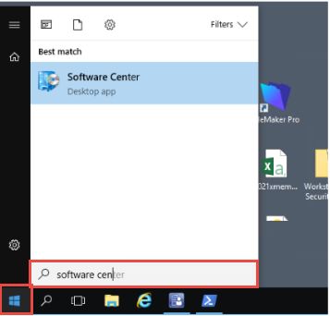

1. Once Software Center loads, search for and click on “WalkMe”

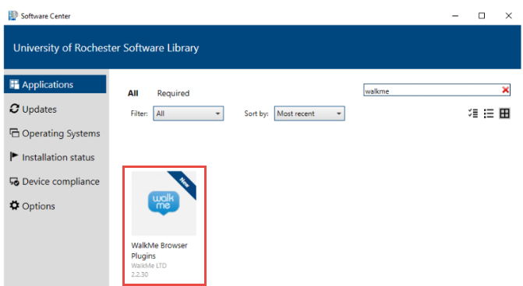

1. Click the Install button to begin installation

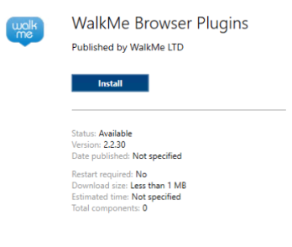

**Note:** If a web browser is already running (IE, Chrome, Firefox, Edge), you will receive a prompt indicating that the web browser session must be closed for the plugin installation to continue.

