Workday Procurement – Reporting and Analytics Guide

Contents

View My Role 4

View Cost Center Report by Cost Center 6

URF0876 View Spend Categories 8

Procurement Spend Category Audit Report 8

URF1040 Find Purchase Order Line Distributions (NCL) 8

My Requisitions (NCL) 8

URF0992 Find Supplier Invoice Lines (NCL) 8

URF1051 Find Supplier Invoice Requests (NCL) 9

| **Instructions** | **Details and Screenshots** |
| --- | --- |
| Home page:   * Use the UR logo to return to this Home screen * Use the Global Search field with keywords * Use the Inbox icon for Workday messages * Use the Procurement dashboard for frequently used tasks and reports | C:\Users\skraynik\AppData\Local\Temp\SNAGHTML196b07be.PNG |
| **Customize the Procurement Dashboard** | C:\Users\DFLOTT~1\AppData\Local\Temp\SNAGHTML13de88a6.PNG |
| **Reporting Icons** | C:\Users\skraynik\AppData\Local\Temp\SNAGHTML13943e75.PNG  **Export to Excel**: Save a spreadsheet version of the information on view.  **Filter**: Select options to narrow search results.  **View Grid Preferences**: Click to view/edit grid preferences.    **Toggle Fullscreen Viewing Mode**: Switch between fullscreen viewing. |
|  |  |

# View My Role

|  |  |
| --- | --- |
| **View My Role**   * Enter *View My Role* in the Search Box and Select the *View My Role Assignments* Report |  |

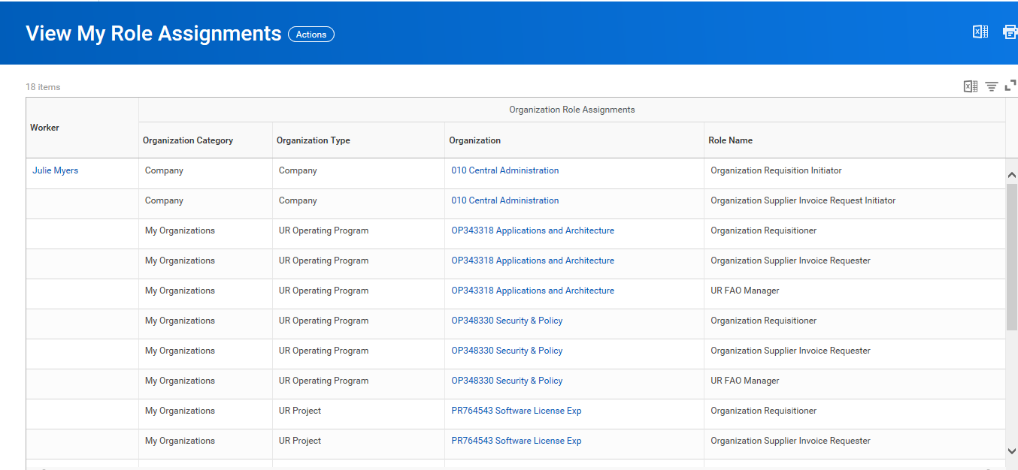

# View Cost Center Report by Cost Center

|  |  |
| --- | --- |
| **View Cost Center Report by Cost Center**   * Enter ***View FAO by Cost Center*** in the Search Box and Select the *View FAO by Cost Center* Report * In the Organization Box, Enter the Operating Program or FAO if you know it, or Click on My Organization or Cost Center to select yours from the list. * Once Organization is Entered, Click the Ok Button |  |

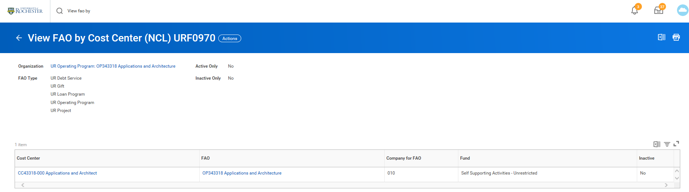

***Note****: If you don’t know your Cost Center look it up on the* [*View My Role Assignment Report*](https://rochester.box.com/s/t4dcp7e390wyojdthjfjsc0p0m5vxip5) *(3rd Column of Report) - Write Down Operating Program*

# URF0876 View Spend Categories

This report can assist with identifying acceptable Procurement Spend Categories for requisitions and SIR’s. It will also identify who the spend category will route to in Procurement.

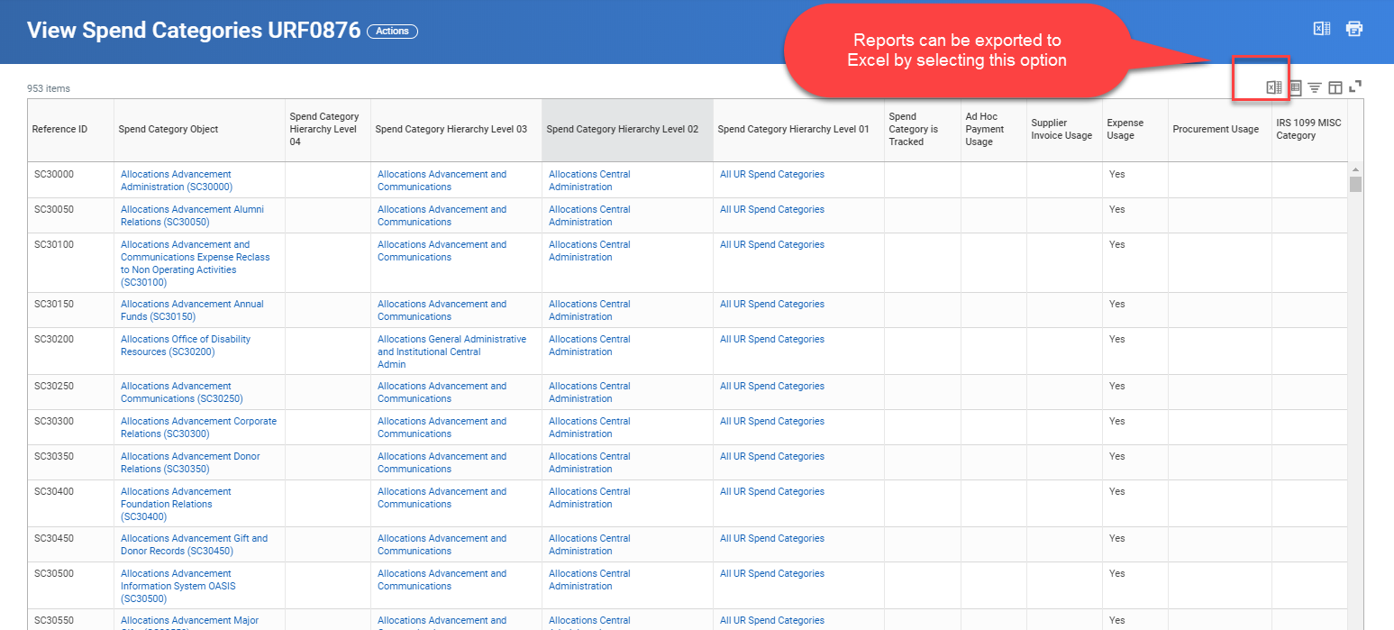

# Procurement Spend Category Audit Report

This report lists the spend category mapping and signature authority threshold for Assistant Category Managers (ACM), Category Managers (CM), and Senior Category Managers (SCM).

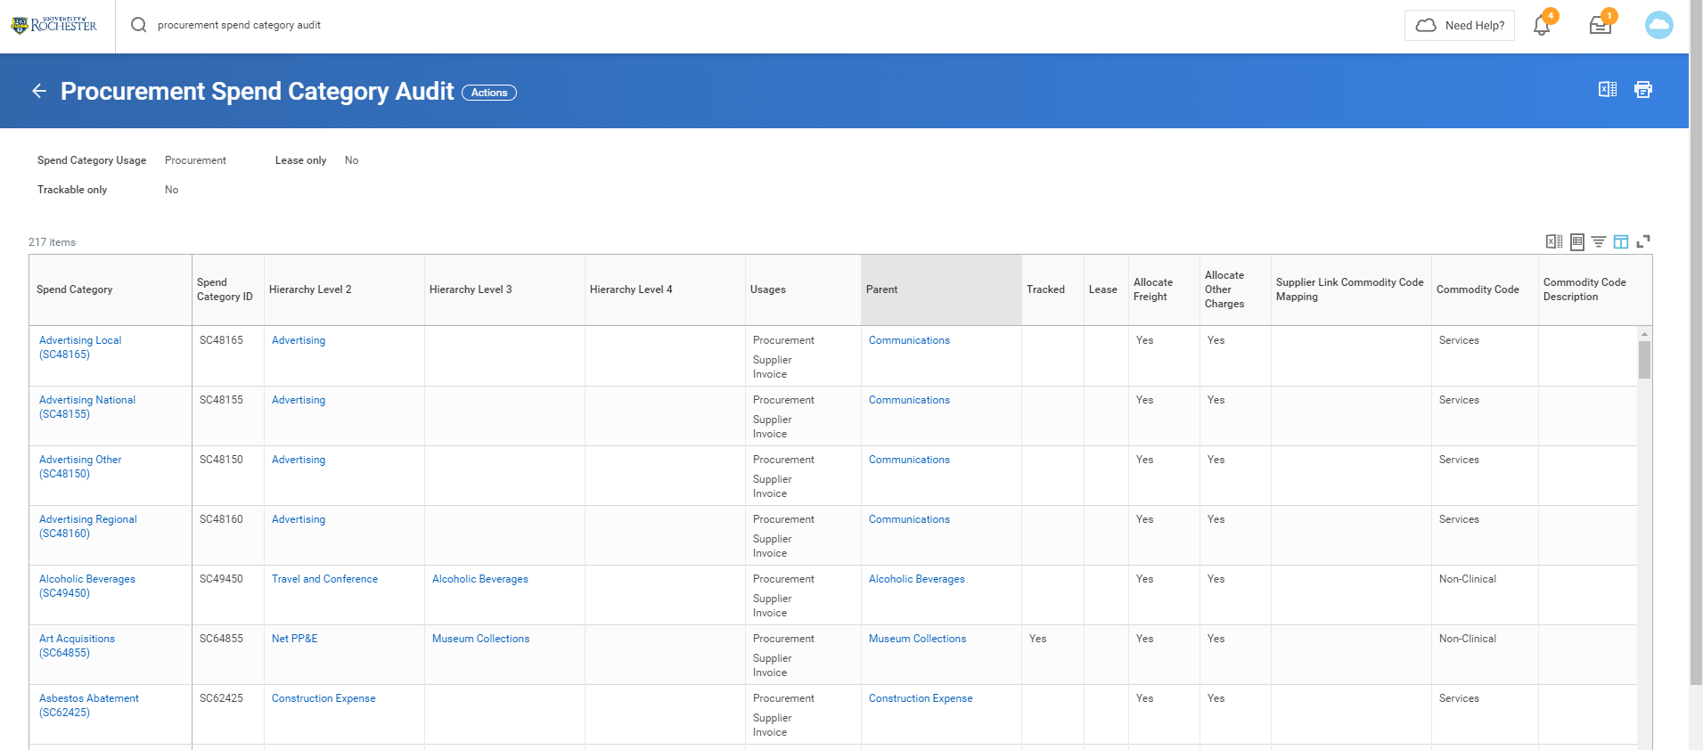

# URF1040 Find Purchase Order Line Distributions (NCL)

This report provides details for purchase orders that use a cost center to which you have access.

# 

# My Requisitions (NCL)

This report will bring up a list of your requisitions.

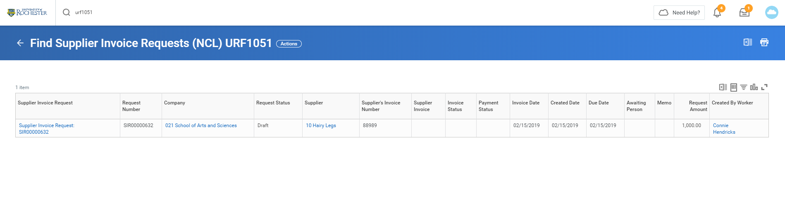

# URF0992 Find Supplier Invoice Lines (NCL)

This report will bring up 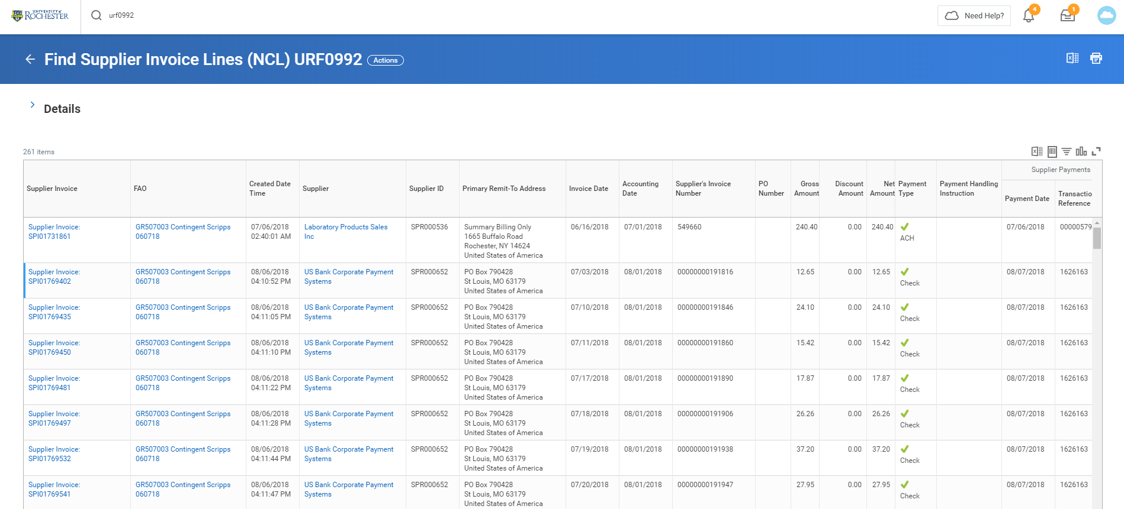a list of supplier invoices that use a cost center to which you have access.

# URF1051 Find Supplier Invoice Requests (NCL)

This report lists Supplier Invoice Requests (SIRs). 