**Workday Foreign and EFT Payment Questionnaire Guide for Requisition and Supplier Invoice Request Initiators**

**May 2019**

**Table of Contents Page**

**Understanding what transactions are detailed in this document 2**

**Initiator Responsibilities**

**Supplier Invoice Requests 3-5**

**Purchase Order Invoices**

Purchase Order invoice expected/presented in foreign currency **5**

Foreign-EFT Questionnaire **5-7**

Treasury Activities **7**

Send Back from Treasury **8**

**Accounts Payable Responsibilities 8**

**Understanding what transactions are detailed in this document**

***This document does NOT discuss F4 payments that are emailed directly from the department (Payroll, Human Resources, or Utilities) to Treasury.*** That process is not yet automated and the current process should be used.

Supplier Invoice Request (SIR) functionality in Workday is replacing the paper F4 Payment Request form. Departmental users initiate SIRs that go through a departmental financial approval process as well as review by Accounts Payable. AP then submits the SIR, which creates a Supplier Invoice. Additionally, Accounts Payable enters Purchase Order related Supplier Invoices.

Supplier Invoices (both SIR and PO) for which the Supplier Payment Type is EFT (electronic funds transfer) or Foreign Draft require completion of the new Foreign-EFT Payment Questionnaire. These invoices route to Treasury for payment processing. The questionnaire is necessary because it collects additional information that is required by our banks. Our banks require this information to both meet banking regulatory requirements and to better ensure prevention of payment fraud.

Supplier Invoices will route to the Treasury Specialist when the following conditions are met:

* Default payment type for the supplier selected is EFT or Foreign Draft

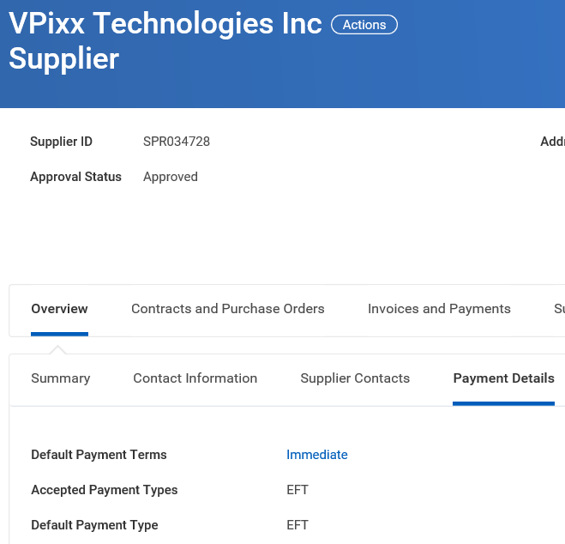

* + Note that SIR initiators cannot change the payment type being used on a SIR

OR

* Acceptable Use Questionnaire response indicates foreign currency or EFT request

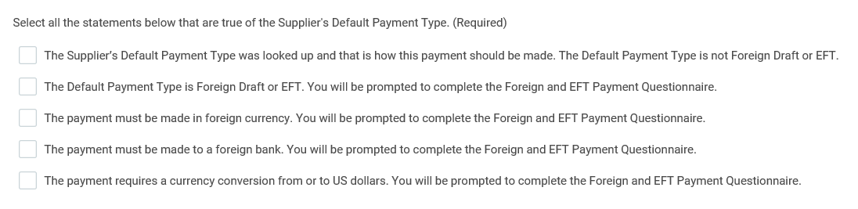

**Initiator Responsibilities**

**Supplier Invoice Requests**

Upon Submission of the Acceptable Use Questionnaire, Workday evaluates if the Foreign-EFT Payment Questionnaire should be triggered. If the Supplier Payment Type is EFT or Foreign Draft OR if the Acceptable Use questionnaire Payment Type question indicates, then the Initiator is prompted to complete the Foreign-EFT Payment Questionnaire:

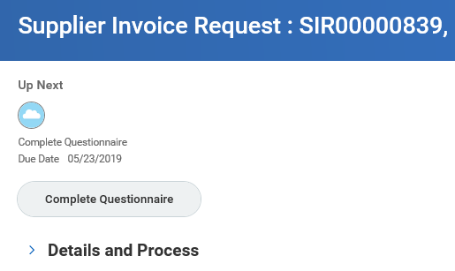

* Click on Complete Questionnaire
* Note the Help Text at the top of the questionnaire:

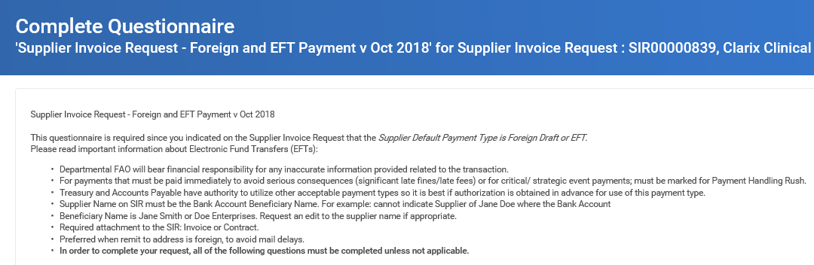

* + This questionnaire is required since you indicated on the Supplier Invoice Request that the *Supplier Default Payment Type is Foreign Draft or EFT.*

Please read important information about Electronic Fund Transfers (EFTs):

* + - Departmental FAO will bear financial responsibility for any inaccurate information provided related to the transaction.
    - For payments that must be paid immediately to avoid serious consequences (significant late fines/late fees) or for critical/ strategic event payments; must be marked for Payment Handling Rush.
    - Treasury and Accounts Payable have authority to utilize other acceptable payment types so it is best if authorization is obtained in advance for use of this payment type.
    - Supplier Name on SIR must be the Bank Account Beneficiary Name. For example: cannot indicate Supplier of Jane Doe where the Bank Account
    - Beneficiary Name is Jane Smith or Doe Enterprises. Request an edit to the supplier name if appropriate.
    - Required attachment to the SIR: Invoice or Contract.
    - Preferred when remit to address is foreign, to avoid mail delays.
    - **In order to complete your request, all of the following questions must be completed unless not applicable.**

If you forget to complete the questionnaire go to your Workday Inbox and the task will be available for you to complete:

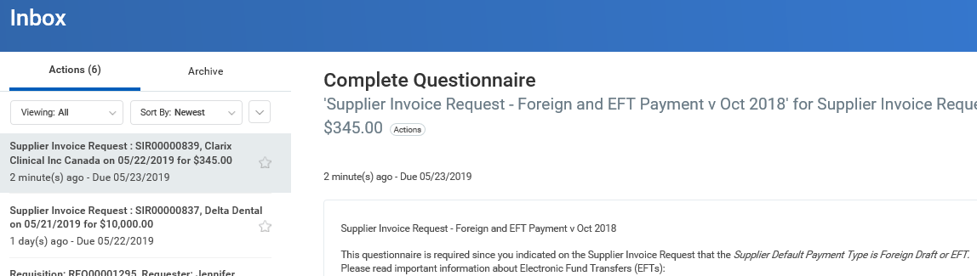

The Foreign-EFT Questionnaire questions are as follows:

* Please select one of the following payment types (EFT to US Bank, EFT to Foreign Bank, Check in Foreign Currency) - Required:
  + Enter EFT to US Bank, EFT to Foreign Bank, or Check in Foreign Currency
* If supplier has an account in a US domiciled bank, why is 2 day ACH not acceptable - Required?
  + If the supplier does not have a bank in the US, enter No US bank
  + Otherwise explain why a 2-day ACH (automated clearing house payment) is not acceptable
* Beneficiary name (account holder) - Required:
* Beneficiary mailing address if payment type is Foreign Draft - Required:
* Beneficiary email address - Required:
* Address where bank account is registered (street, city, state, country) - Required:
* Beneficiary bank account number or IBAN - Required:
* Please retype beneficiary bank account number or IBAN - Required:
* Beneficiary bank account SWIFT, BIC or ABA number - Required:
* Please retype beneficiary bank account SWIFT, BIC or ABA number - Required:
* What currency would you like payment to be made in - Required?

Note: in amount section below, please ONLY provide the amount in the known currency.

If needed, Treasury will handle currency conversion.

* Amount in USD:
* Amount in foreign currency:
* Payment due date (MM/DD/YYY) - Required:
* Provide transaction detail / business purpose (any additional information to be included with payment (e.g. invoice or PO number) - Required:
* Requester must verify banking instructions by phone with two different people. Email or other documentation is not acceptable.

Only voice verification is acceptable. If two (2) or more valid phone numbers cannot be provided then EFT payment type cannot be utilized.

Provide contact from which banking information was obtained - Required:

• Call #1 (date, time, Name of contact, phone number)

• Call #2 (date, time, Name of contact, phone number)

Click Submit when all appropriate questions are answered.

**Purchase Order Invoices**

**Purchase Order invoice expected/presented in foreign currency**

Consideration should be taken when creating a Requisition if it is known that invoices will be presented in foreign currency

* Create Requisition
  + Use oanda.com to convert foreign currency to USD using today’s date (date creating Requisition).
  + If have the invoice and the PO is not yet created, use the invoice date for the conversion.
* Invoice: AP will enter the invoice for the full amount of the PO
* Receipts: Requester should take care to ensure they enter receipts for only the amount they desire to pay if not expecting/desiring to pay the PO in full
* Questionnaire: When presented with the Foreign-EFT Payment Questionnaire, the Requester should ensure they clearly indicate the amount that should be paid, regardless of what was entered on the PO, invoice (by AP), invoice copy, or receipt.
  + **Treasury uses the questionnaire as the authoritative information about what to pay.**
  + The Foreign-EFT Payment Questionnaire will prompt you for the amount to pay. Please ensure this questionnaire response is accurate since it will be used regardless of what the PO, invoice copy, or invoice says to pay.

**Foreign-EFT Questionnaire**

When your PO-invoices are associated with a Supplier with the Payment Type of EFT or Foreign Draft, you will be prompted to complete the Foreign-EFT Payment Questionnaire.

A task will route to your Workday inbox after the invoice is matched. Keep in mind that you may be involved in resolving a match exception for the invoice and once that is resolved, the questionnaire task will appear in your Inbox.

After the invoice matches, the Requester gets an Inbox task to Review Documents:

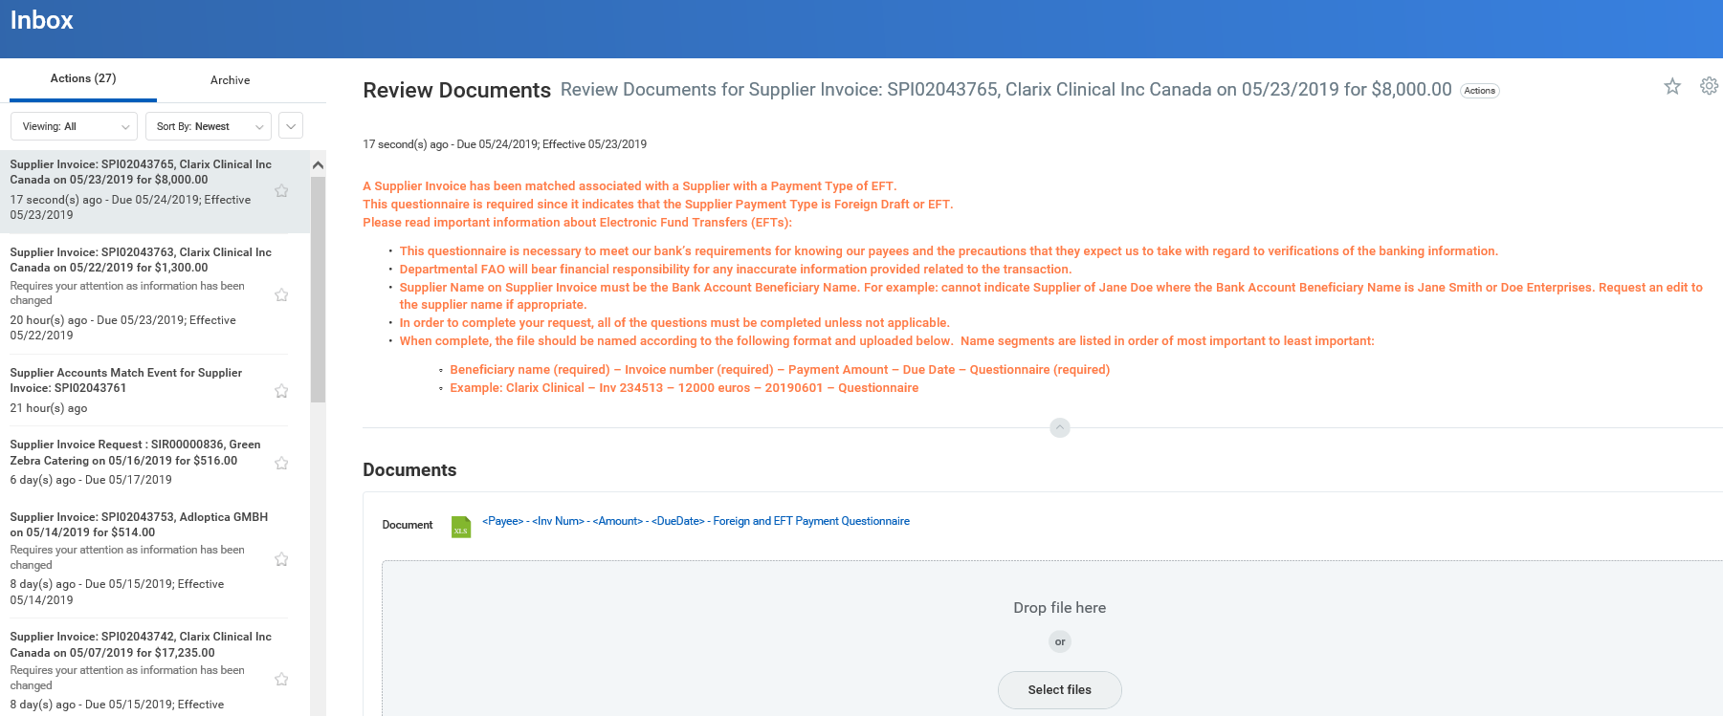

Notice the Help Text:

A Supplier Invoice has been matched associated with a Supplier with a Payment Type of EFT.

This questionnaire is required since it indicates that the Supplier Payment Type is Foreign Draft or EFT.

Please read important information about Electronic Fund Transfers (EFTs):

* This questionnaire is necessary to meet our bank’s requirements for knowing our payees and the precautions that they expect us to take with regard to verifications of the banking information.
* Departmental FAO will bear financial responsibility for any inaccurate information provided related to the transaction.
* Supplier Name on Supplier Invoice must be the Bank Account Beneficiary Name. For example: cannot indicate Supplier of Jane Doe where the Bank Account Beneficiary Name is Jane Smith or Doe Enterprises. Request an edit to the supplier name if appropriate.
* In order to complete your request, all of the questions must be completed unless not applicable.
* When complete, the file should be named according to the following format and uploaded below. Name segments are listed in order of most important to least important:
  + Beneficiary name (required) – Invoice number (required) – Payment Amount – Due Date – Questionnaire (required)
  + Example: Clarix Clinical – Inv 234513 – 12000 euros – 20190601 – Questionnaire
* Requester needs to open the Foreign and EFT Payment Questionnaire by clicking on the excel document.
* Requester needs to fill in the excel file Answer column for each question as appropriate.



* When complete, the file should be saved and named according to the following format (name segments are listed in order of most important to least important):
* Beneficiary name (required) – Invoice number (required) – Payment Amount – Due Date – Questionnaire (required)
* Example: Clarix Clinical – Inv 234513 – 12000 euros – 20190601 – Questionnaire
* Requester should upload the file

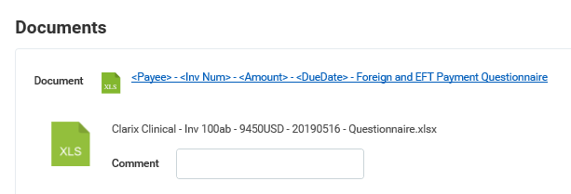

* Click Submit

The invoice then routes to the Treasury Specialist for payment processing.

Treasury Activities

For both SIR and PO-invoices, if Treasury has any questions or discovers errant information in the questionnaire, they will do an Invoice Send Back to Accounts Payable. Accounts Payable will send you an email with the questionnaire you completed as an attachment and indicate what information Treasury needs added/corrected.

* It is preferable that you put the added/corrected information in the excel questionnaire for PO invoices, especially if you expect future payments to the supplier, you can save and re-use the questionnaire as a starting point and just update it for new changed information rather than re-typing all responses again.
* Email the added/corrected information to AP.
* AP will attach your additional/corrected information to the Invoice and resubmit to Treasury.

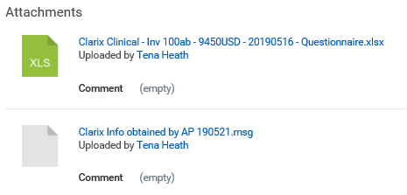

Send Back from Treasury

While Treasury can select the Requester for a Send Back, they have been instructed not to since Workday attempts to re-start the Match event instead of a simple routing for additional information to re-submit.

If the match event is awaiting your action contact AP. AP will email you the Foreign-EFT Questionnaire to complete. Email it back to AP. AP will need to Change the invoice, add the attachment and re-submit it to Treasury.

**Accounts Payable Responsibilities**

Before submitting the SIR-Invoice on for Treasury action, AP should ensure the Payment Type on the Supplier Invoice accurately reflects the Foreign-EFT Questionnaire selections:

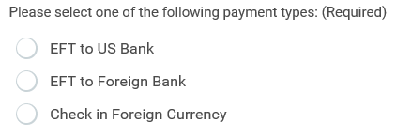

Payment Type = EFT for EFT to US Bank and EFT to Foreign Bank

Payment Type = Foreign Draft for Check in Foreign Currency

* If necessary, AP needs to work with a Supplier Admin to add the necessary Payment Type as Available to the Supplier record.
* Once available, AP should edit the Payment Type on the invoice as appropriate before submitting to Treasury.
* In addition, since AP is confirming payment type and currency, it is helpful to note foreign currency observations in the Activity Stream for Treasury and Cash users to see. Examples:

