UR Procurement – Create Receipts

Instructions | Details and Screenshots
Home page:  - Use the UR logo to return to this Home screen  - Use the Search field with keywords  - Use the Inbox for Workday messages  - Use the Procurement worklet for frequently used tasks and reports  - Create Requisitions  - Create Receipts  - Find Requisitions | 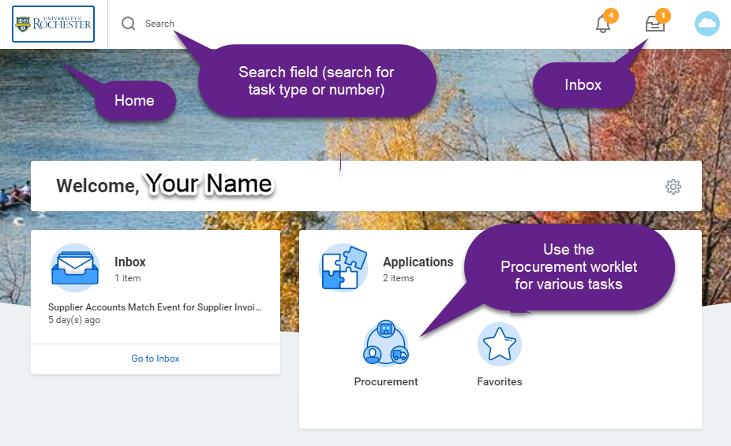
Rules | - The create receipt action is required for Goods-based orders over $2500.00. The supplier invoice will not be paid until a receipt is created.  - The create receipt action is required for all services-based orders, all grant (FAO=GR), and all capital, no matter the dollar value. The supplier invoice will not be paid until a receipt is created.  - The create receipt action is required when supplier invoice is Submitted and the Match Exception when Missing Receipts or there are not enough Receipts exceptions occur.  - The create receipt action is required when supplier invoice is Submitted and the Match Exception that Invoice Total Amount is greater than the Receipt.  - Once a receipt is approved, the receipt cannot be edited or corrected but can be cancelled. If a receipt needs to be corrected, the Requisitioner should contact the P2P Service Center to cancel the receipt. Then the Requisitioner can create a new receipt.
From the Procurement dashboard if you have Workday Roles assigned  Requisitioner  - Under Tasks, select <Create Receipt> and then search for order that is ready to be received  - Can use the My Open Requisitions report to review a list of orders and create a receipt from the purchase order.  - Can use the My Purchase Order and create a receipt from the purchase order (related action)  Requestors that do not have Workday Roles Assigned  - Click InBox to review POs that are ready to receive.  - Record the PO number to create a receipt in the step below.  - Enter <Create Receipt> in the Global Search Field and press Enter.  - The screens below will appear. Continue with the instructions below. | 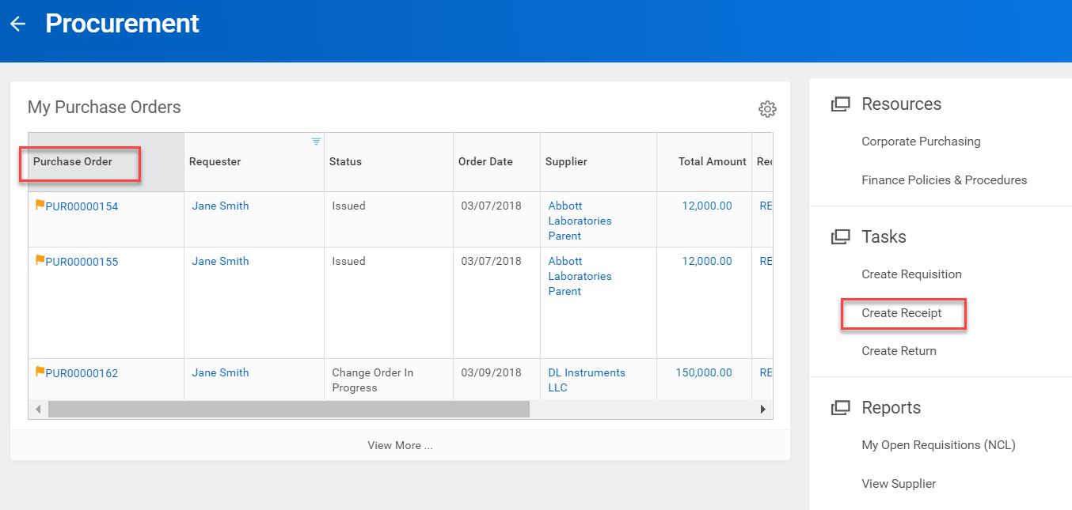  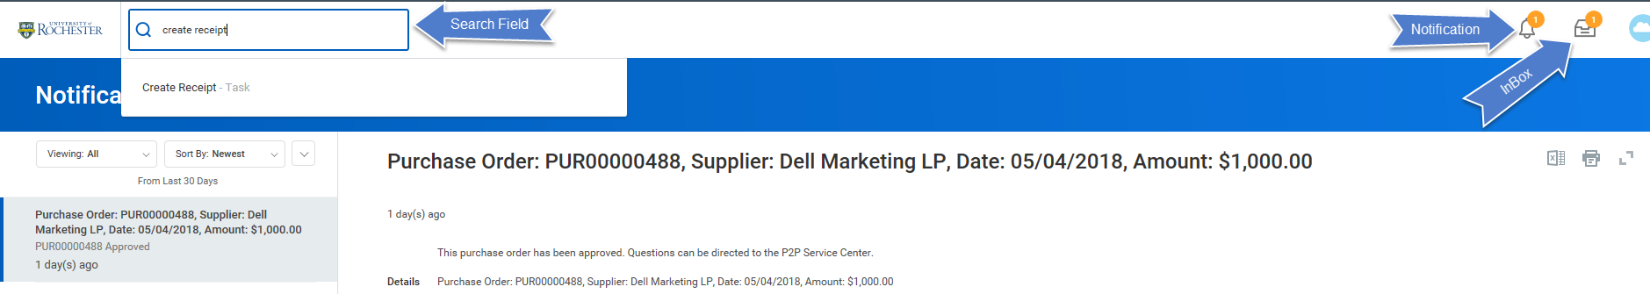
Requisitioners Select <Create Receipt> under Actions to search by purchase order or supplier contract  - Select the Purchase Order radio button and search for order either by typing the PO number or using the prompts  - If searching by supplier name, if there is nothing to receive for a given supplier, it will show No Items  - Use the Fully Receive checkbox if the order was fully received. This can be changed on the next screen if desired.  - Select <OK> | 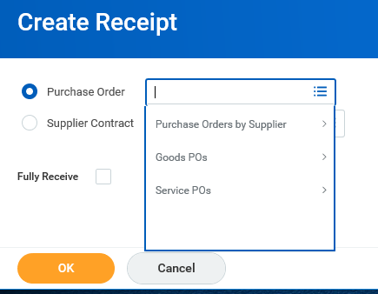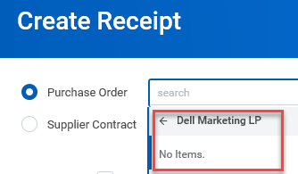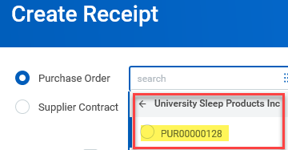  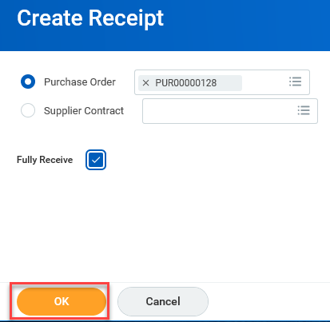
- Review the Summary area of the Create Receipt screen  - Scroll down to the line level details | 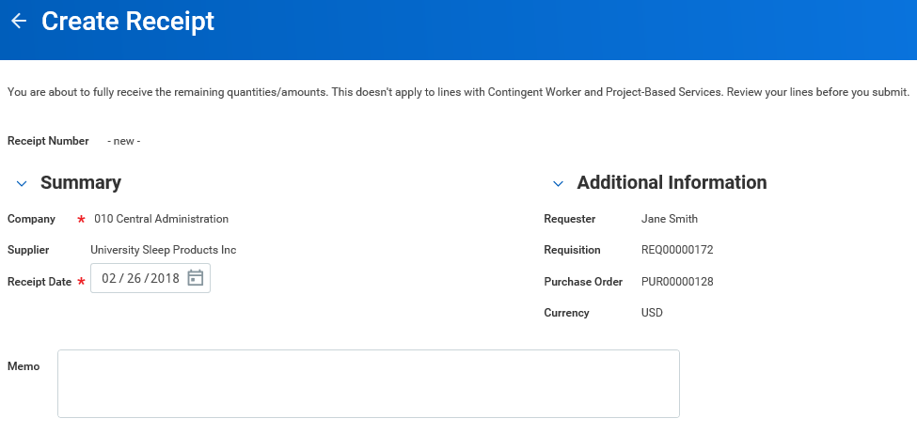
- Review the line level details. Enter the Quantity to Receive if necessary. | 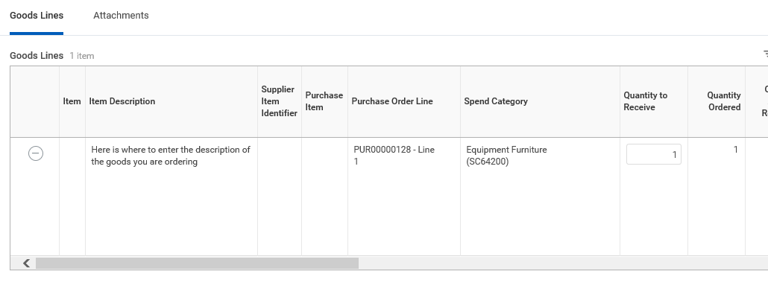
- Receipts do not require attachments, but you can attach packing slips if you wish to keep all of your documentation together.  - Select the Attachments tab and drag and drop (or choose the Select Files button) in order to add an attachment | 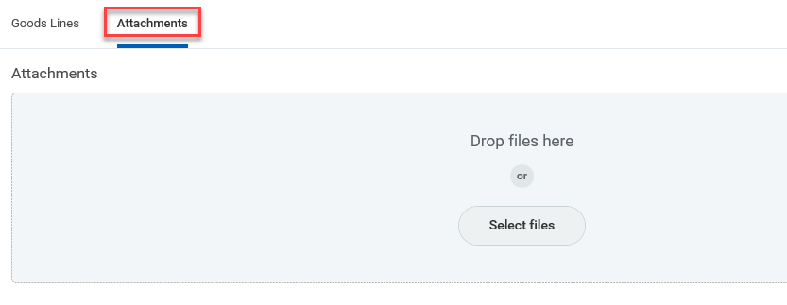
When ready, select <Submit> button | 
Once the receipt is submitted, the details can be viewed. Take note the receipt is approved.  Once a receipt is approved, the receipt cannot be edited or corrected but it can be cancelled. If a receipt needs to be corrected (or undone), the requisitioner should cancel the receipt and create a new one. | 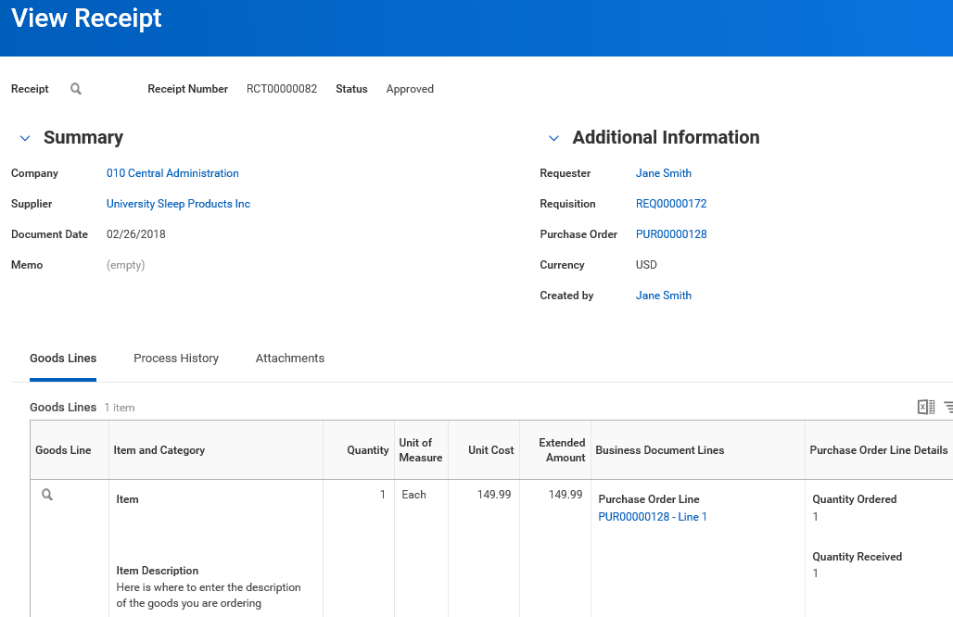
Match Exception for Missing Receipts or Not Enough Receipts  - Requesters will receive an inbox task for match exceptions for missing or not enough receipts.  - For goods or services that have been physically received or performed, navigate to the purchase order from the inbox task in order to create a receipt. | 