**P2P Grant Subcontract Reference Guide**

**for Supplier Invoice Requests**

December 2019

**Contents Page**

Creating the Supplier Invoice Request

Header Fields 1-5

Attachment & Line Details 6

Grant Subcontract Questionnaire 7-9

Review Step 10-11

Foreign and EFT Payment Questionnaire 12

Financial Approval 12-14

Remaining Steps 15-16

How to Find the Status of the Supplier Invoice Request: Who has it, When did it…?

17

Advanced User Tip: Identifying the Correct Workday Supplier for your Subcontract Invoice

18-20

**Creating the Supplier Invoice Request**

1. In Workday, navigate to the Create Supplier Invoice Request task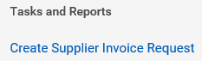
2. Read the Supplier Invoice Request Help Text, it is generic to all SIRs:

**Please review the Buying and Paying Guide available on the** [**UR Procurement > Reference Guides webpage**](https://www.rochester.edu/adminfinance/urprocurement/resources-support-training/resources/reference-guides/) **and the Supplier Invoice Request/F4 Acceptable Use List available on the** [**Accounts Payable > Forms webpage**](https://www.rochester.edu/adminfinance/finance/accounts-payable/forms/) **to ensure you are properly using the Supplier Invoice Request for payment.**

**In addition, if**

* **Payment is for services, royalty, study participation, or prize/award**
* **AND Payee is a US citizen or permanent resident**
* **AND your department has not previously sent the payee’s W9 to Accounts Payable**

**Then attach the W9 to this Supplier Invoice Request before submitting.**

1. **INVOICE DATE:** Enter an appropriate invoice date. Generally, this should be the date of the invoice provided or the last day of the billing period.
   1. For the final invoice, it is best to use the last day of the billing period to avoid Budget Date problems since the Budget Date for the transaction is derived from the Invoice Date field.
   2. Two examples of Invoice Date provided:

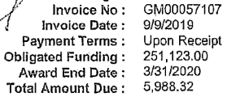

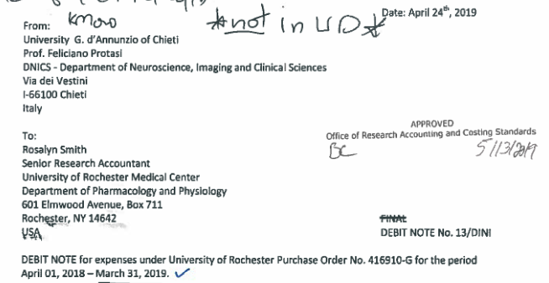

* 1. Example of no Invoice Date provided, so you should use the last date of the billing period.

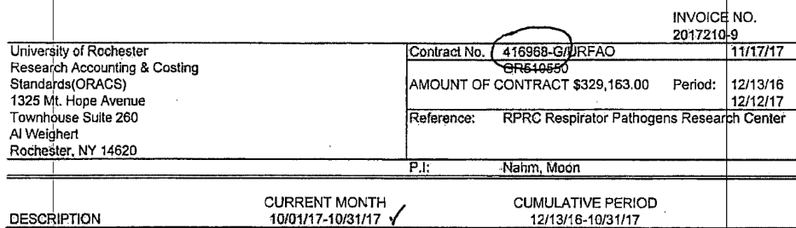

1. **Invoice Received Date:** This is an optional field. Enter the date the invoice was received from the supplier.
2. **COMPANY:** If you have access to multiple companies, be sure to enter the correct company for the GR that will be charged on the SIR.
3. **CONTROL TOTAL AMOUNT:** Enter the amount that is due to be paid.
4. **SUPPLIER**
   1. Select the correct supplier. This is the subaward recipient for the Grant being charged. To identify with certainty on your own, see the **Advanced User Tip: Identifying the Correct Workday Supplier for your Subcontract Invoice**
      1. If you enter the wrong supplier you will get this error message upon submission

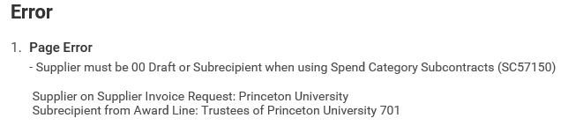

* 1. If there is no subrecipient on the Grant designated, then carefully select the appropriate supplier as there will be no validation to confirm it is accurate.
  2. Otherwise, use “00 Draft” in the Supplier field until you receive confirmation from ORACS what supplier to use.
     1. You should use the correct supplier on subcontract invoices moving forward and not continue using 00 Draft on subsequent invoices.
     2. If using 00 Draft scroll down to the Activity Stream and add a Comment indicating you are not sure which Princeton supplier to use

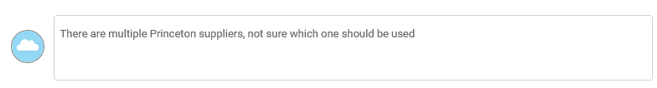

* + 1. This comment is visible to approvers and others viewing the transaction in Workday. It is helpful particularly to acknowledge this for approvers who may wonder why we are submitting something to be paid to “00 Draft”.



* + 1. Validations ensure no invoice can ever be completed (fully approved) or paid with the 00 Draft supplier designated.
  1. It is helpful to know ahead of time the Default Payment Type of the supplier being paid since if the payment type is EFT, then banking information and contacts will need to be documented in the Foreign and EFT Payment Questionnaire.

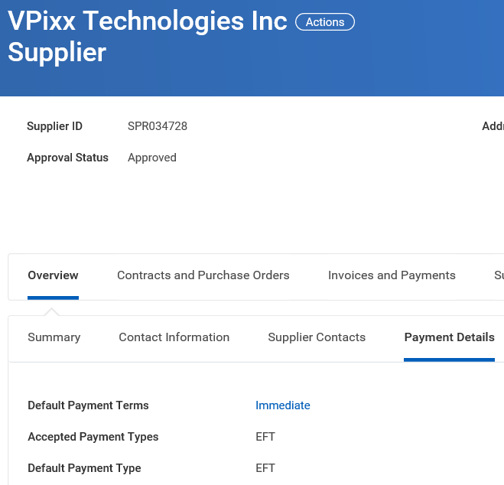

1. **SUPPLIER’S INVOICE NUMBER**: If an invoice number is provided on the invoice, enter it.



* 1. If no invoice # is provided, then enter the date of the invoice or the last day of the billing period in the format MMDDYYYY
  2. Example of no Invoice # and no invoice date so the last day of the billing period should be used and entered as MMDDYYYY, for this example you would enter 03312019

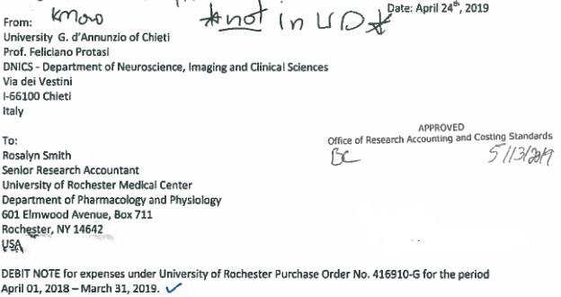

1. **Handling Code**: When the Supplier has a default payment type of Check Separate, it is helpful to add the Handling Code > Enclosure. Otherwise, no handling code should be entered.
   1. Generally, for check payments a copy of the invoice is included with the check payment to assist the recipient in getting the payment to the right person for deposit and payment application.
   2. Some grant subcontracts are paid via ACH. For these it is especially important to double-check the invoice date, invoice # and memo field for accuracy since those fields are passed with the electronic payment for the recipient to apply the payment correctly.
2. **HEADER MEMO**: Enter the GPO number; for example 417248G
   1. You cannot leave the Header Memo field blank when using SC57150. A validation will stop your submission and make you enter the Grant PO # in the Header Memo field.

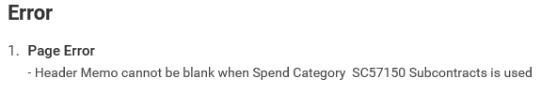

1. **ATTACHMENT**: Attach the subcontract invoice submitted by the supplier/subrecipient and any additional supporting documents as appropriate.
2. **LINE DETAILS**
   1. Change the line type to Service Line: There is no consequence to leaving it as a goods line, it is just good practice to properly identify the line correctly as a service (not goods) purchase.

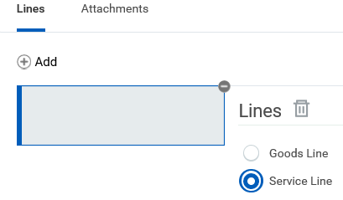

* 1. **Spend Category**: SC57150 should always be used for subcontract invoices.
  2. **Extended Amount**: Enter the amount that is due to be paid.
  3. **Additional Worktags**: Remember to enter the GR FAO in this field and allow the other worktag fields (Company for FAO, Cost Center and Fund) to auto-fill.
  4. **Internal Memo**: This field is required and cannot be left blank. This field is used to capture the business purpose of the SIR, therefore it is appropriate to indicate the request is for a grant subcontract and state the billing period. For example: Grant subcontract payment for 1/1/2020-1/31/2020

1. Remember to click Submit 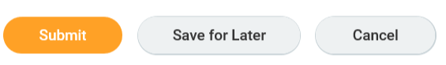
2. The initiator is then prompted to complete the Grant Subcontract questionnaire. Click on Complete Questionnaire.

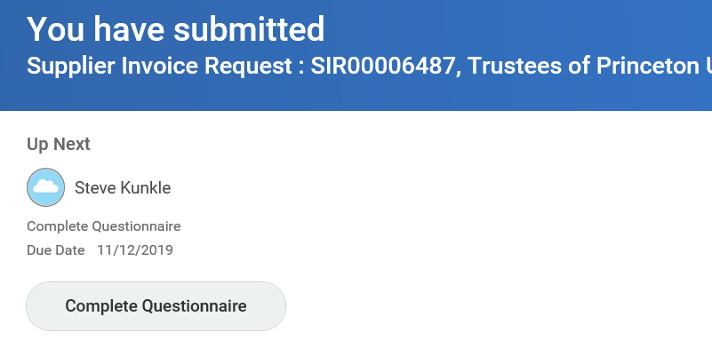

1. **GRANT SUBCONTRACT QUESTIONNAIRE**

Read the Help Text:



Supplier Invoice Request - Grants Subcontracts v 20191032

Based on Supplier Invoice Request selection of Spend Category SC57150 Subcontracts, the following questions must be completed.

If you are not submitting a Grant subcontract invoice, go back to your SIR to edit the spend category as needed so that you are prompted for the correct questionnaire and your SIR will route appropriately.

If you are submitting the FINAL subcontract invoice, ALL questions must be answered. In addition, you will not be able to send the SIR on for approval until all responses of Disagree are resolved. That is, you should not be submitting the final invoice until final reports and deliverables are submitted and you are satisfied with the performance of the subawardee.

**Questions**

* The first question helps address tax reporting informational needs since the payment is for services: 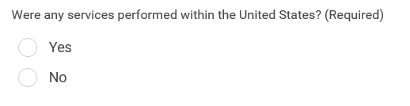
* The second question is asking if this is the final invoice for the subcontract:

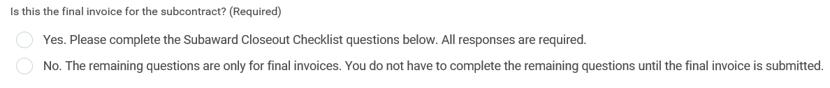

* The remaining questions are only required for the final invoice. The questions are the Subaward Closeout Checklist:

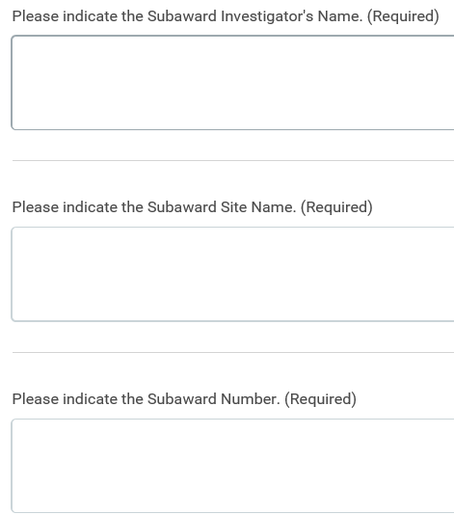

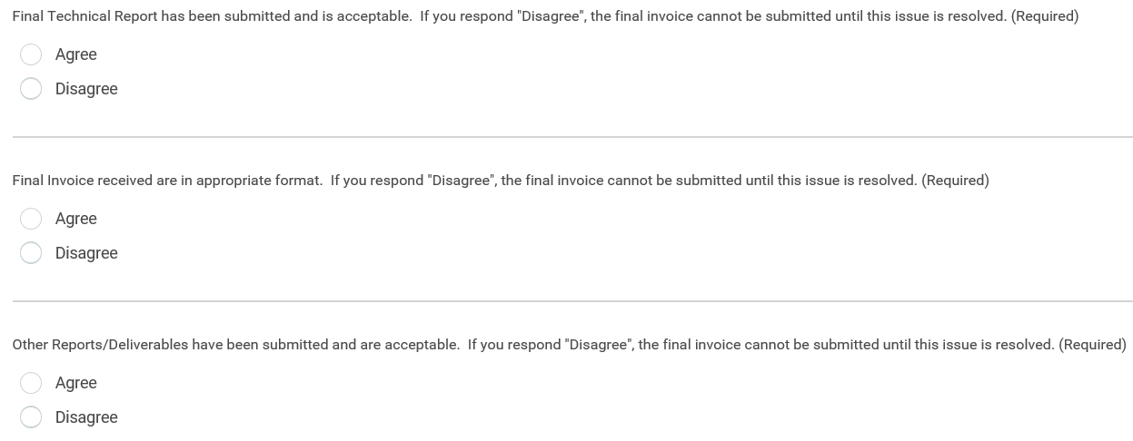

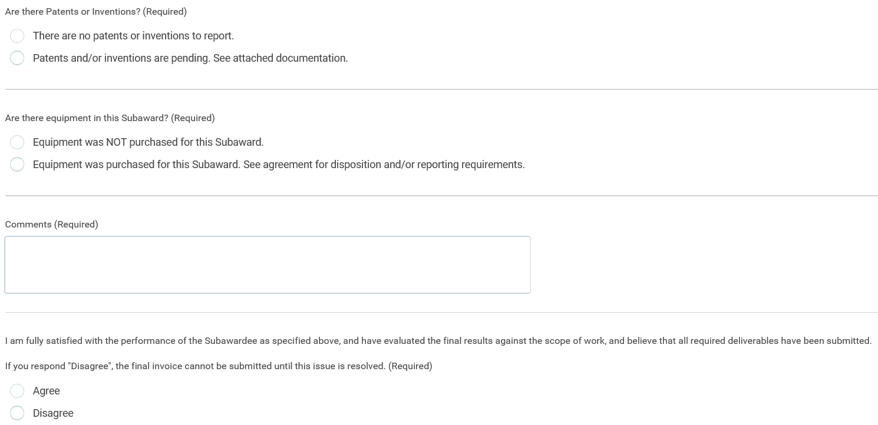

1. Remember to click Submit when finished with the questionnaire 

There are validations on your questionnaire responses to

1. Make sure all questions marked (Required) have a response
2. If you marked Yes, that this is the final invoice for the subcontract, that all the remaining questions, except for the open Comments box have a response.
3. If answered, make sure that all 4 of the questions with Agree/Disagree responses are marked Agree. Disagree responses are not acceptable and are indicative that you should not be submitting the final invoice. All subcontract issues must be resolved.

**REVIEW**: If one of these validations is triggered, the SIR will route back to you for resolution on a Review step:

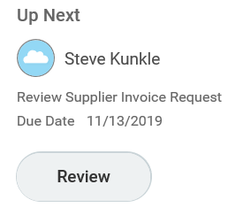

Click on Review

Read the Help Text:

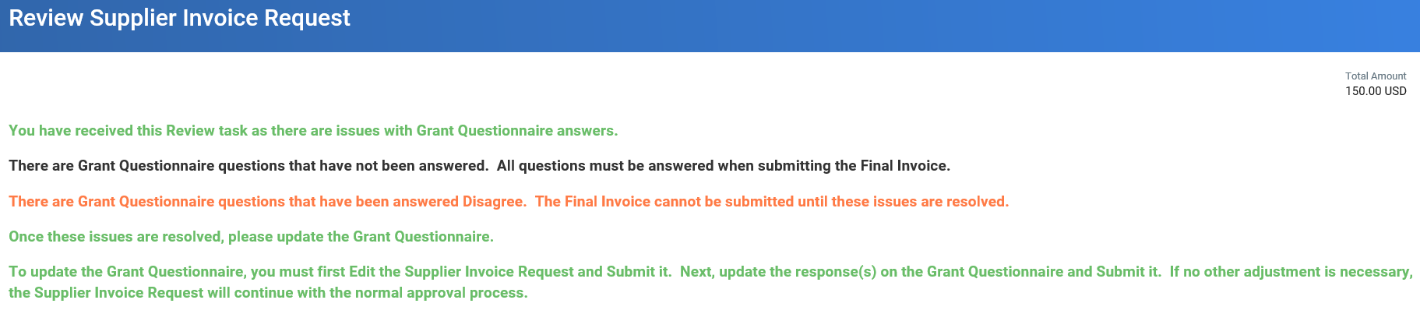

**You have received this Review task as there are issues with Grant Questionnaire answers.**

**There are Grant Questionnaire questions that have not been answered.  All questions must be answered when submitting the Final Invoice.**

**There are Grant Questionnaire questions that have been answered Disagree.  The Final Invoice cannot be submitted until these issues are resolved.**

**Once these issues are resolved, please update the Grant Questionnaire.**

**To update the Grant Questionnaire, you must first Edit the Supplier Invoice Request and Submit it.  Next, update the response(s) on the Grant Questionnaire and Submit it.  If no other adjustment is necessary, the Supplier Invoice Request will continue with the normal approval process.**

Merely clicking Approve on this Review step is not sufficient. As the Help Text describes, you must navigate to the SIR by clicking on the hourglass



Navigate to the related actions 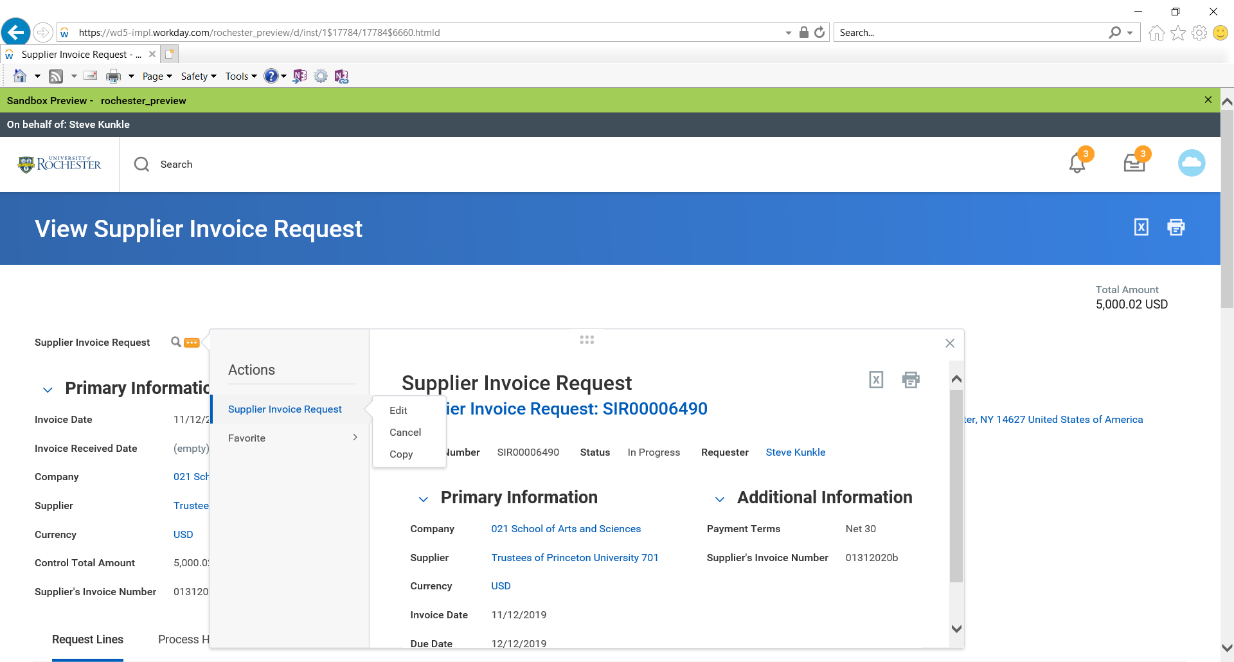for the SIR. Then select Supplier Invoice Request > Edit





Feel free to double-check the information you entered on the SIR for accuracy.

Click Submit when ready to move on to Edit your questionnaire responses



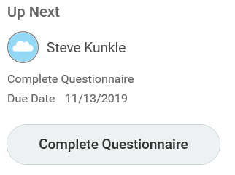

Click on Complete Questionnaire. The questionnaire opens up with your prior answers marked.

Update your questionnaire responses as appropriate. Click Submit when done.



The validations will recheck your responses and again send you back to the Review step if all the problems are not resolved.

If the questionnaire validations are not triggered then the SIR will move forward.

**Foreign and EFT Payment Questionnaire**: If the default payment type for the supplier is EFT or Foreign Draft, then you will be prompted to complete the Foreign and EFT Payment Questionnaire.

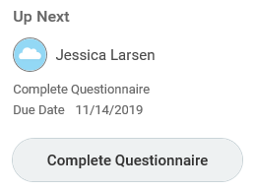

Please refer to the P2P Foreign-EFT Reference Guide on the [UR Procurement > P2P](https://www.rochester.edu/adminfinance/urprocurement/p2p-resources/) Self Help website for assistance as needed.

Upon successful completion of that questionnaire, if prompted, the SIR then moves forward with financial approval.

**FINANCIAL APPROVAL**

1. The first financial approval is the Principal Investigator. The PI is the equivalent of the FAO Procurement Manager financial approval on a non-grant procurement transaction. 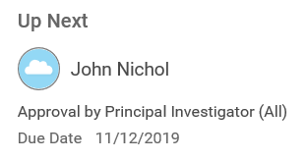

If no Principal Investigator is designated on the Grant, then the SIR will skip that step and route to the Lead Principal Investigator for Approval.

If there is no PI and no Lead PI designated on the Grant, then the SIR will route to the Cost Center Procurement Manager for Approval.

1. Approvers can see in these SIRs awaiting their action in their Workday Inbox.

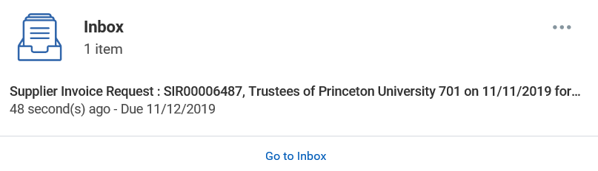

* 1. Immediate email notifications also go to each user on each step of the process as their step is reached.
  2. If the task is not completed, the user will get a daily email reminder called Workday Task Owner Alert that will list the transactions awaiting their action



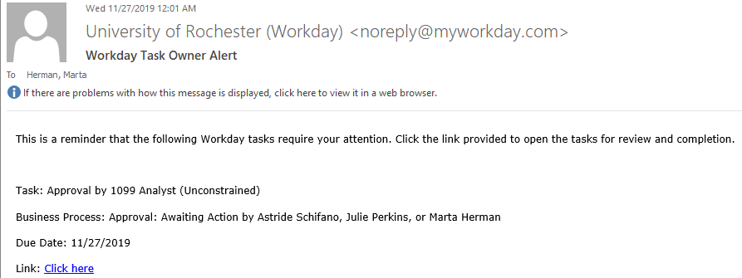

pprovers are able to view all SIR data entered, all attachments, as well as all the questionnaire questions and responses. Approvers are encouraged to exercise due diligence with their fiscal responsibility when approving SIRs. That is, approvers should not just click Approve.

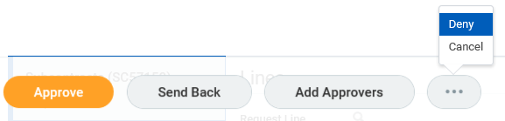

Approver action options include:

* **Send Back**:
  + When selecting Send Back a Reason is required.

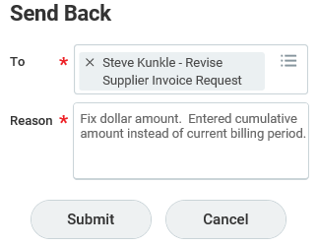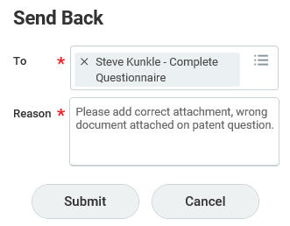

* + For lengthy follow up, something that cannot be clearly explained in the Reason box, it is best to follow up the Send Back with an email to the Send Back user selected.
  + Send Back Reasons are always viewable on the Process History for that transaction and include the user name who did the Send Back as well as the Process History including the Date and Time of the action (Send Back).
* **Add Approvers**: Optionally, in addition to your approval, you can add an additional, non-edit, approval step by selecting an additional approver for routing the SIR.
  + The additional approval will become a required step and potentially delay processing and payment.
* **Deny**:
  + Select this if the Supplier Invoice Request should be completely rejected, for example due to it being a duplicate payment.
  + A Reason is required and should describe why the invoice is being cancelled.
* **Cancel**:
  + Select this if you are not ready to action this invoice. Closing out of the screen or Workday and your internet browser completely accomplish the same thing.
  + Selecting this will keep the task in your Inbox.
  + This is not the same as canceling the invoice. You are merely canceling your task until a later time.
* **Approve**:
  + Select this after you have reviewed the transaction and approve it for payment.

1. Grant Subcontract SIRs will continue, as appropriate, routing up the financial approval hierarchy for the Grant’s Company according to the Procurement thresholds.

**ORACS REVIEW**

Once all financial approvals are obtained, the SIR routes to the UR Award Portfolio Specialist. This role is held by various staff in ORACS.

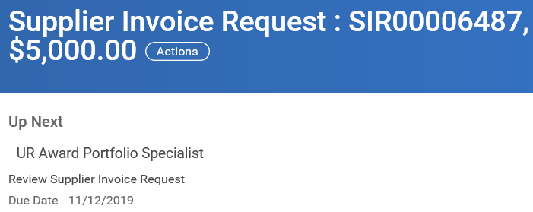

* ORACS may need to alter the SIR data and should add a comment to the Activity Stream noting the values changed for future reference. The Activity Stream is located just above the Process History towards the bottom of the Review Screen
* Ideally, the only information ORACS should need to change would be when the department selected 00 Draft supplier. For example, they would edit the Supplier and indicate in the Activity Stream:

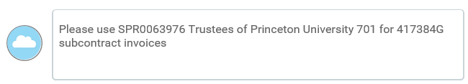

ORACS approval routes the SIR to AP

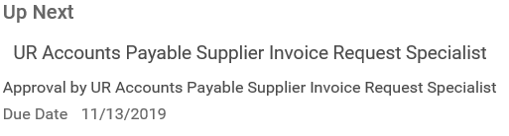

Their submission routes the SIR to the 109 Analyst to ensure any tax reporting configurations is resolved if necessary:

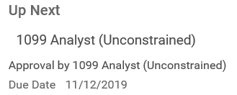

Their submission routes the invoice to another AP staff person who creates the invoice

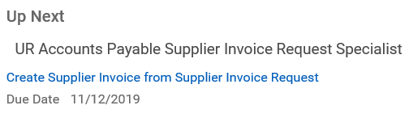

* At this step, for Suppliers with a default payment type of Check Separate, will need to add the Enclosure handling code if not previously entered by the initiator.

If the payment does not require Treasury (is not EFT or Foreign Draft) then the invoice automatically completes and is ready for settlement (payment) on its due date. Accounts Payable generally settles all invoice activity one business day prior to the Invoice Due Date.

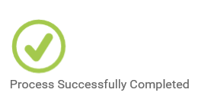

If the payment requires Treasury handling, the remaining process is

Treasury Specialist

Cash Specialist

Cash Manager

**How to Find the Status of the Supplier Invoice Request: Who has it, When did it…?**

Utilize the reports available in the **Procurement Dashboard**

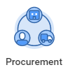

Such as **My Supplier Invoice Requests**

* Note the status of the SIR
  + **Draft**: Means it is awaiting your action. You may have forgotten to complete a SIR or click Submit.
  + **In Progress**: Means it is awaiting action from someone else.
  + **Approved**: Means an invoice was created and has moved on to payment processing.

Drill into a SIR’s **Process History** to get details:



* Note the step in status of Awaiting Action: On the far right is the name of the person and the role from whom the SIR is awaiting action.
  + You can see when they received the task by looking at the previous step completion date/time.

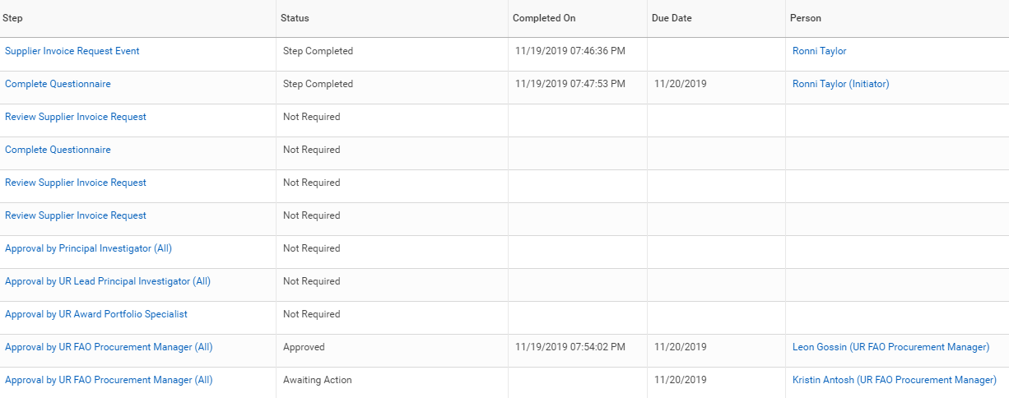

**Advanced User Tip: Identifying the Correct Workday Supplier for your Subcontract Invoice**

In Workday, navigate to the Award line for your Grant

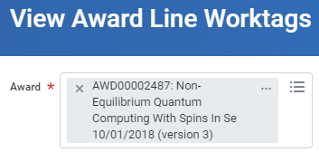

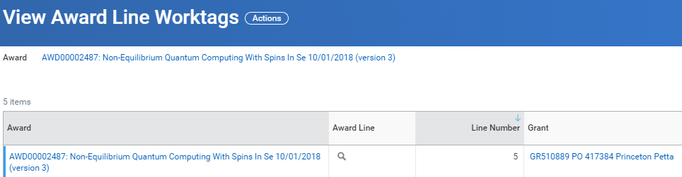

Drill into the award line and click on the Award Lines tab

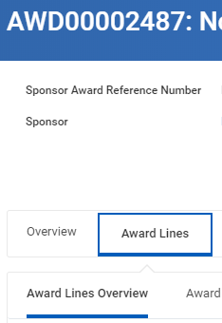

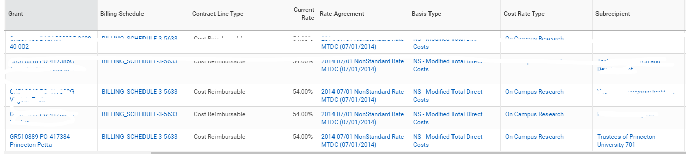

The Supplier is shown in the Subrecipient field. Note the name and click on the related action button to see a preview of the supplier along with the Supplier ID. The supplier ID is helpful since sometimes there are multiple suppliers (e.g., multiple Princeton University) set up for different reasons.

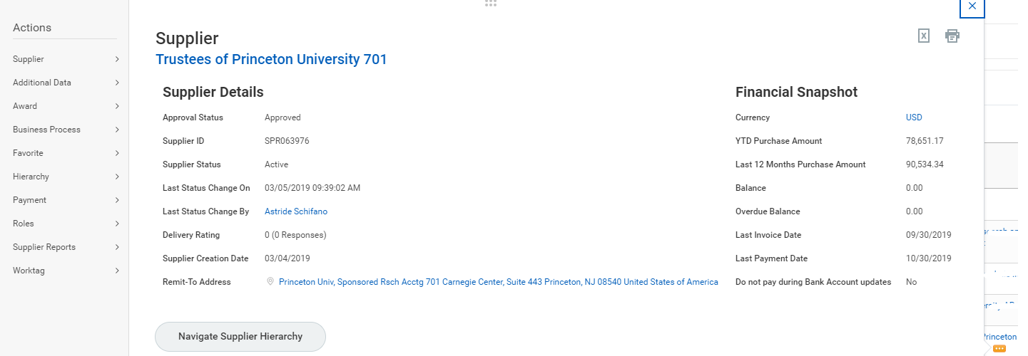

Some users also find it helpful to add the Supplier as a Favorite

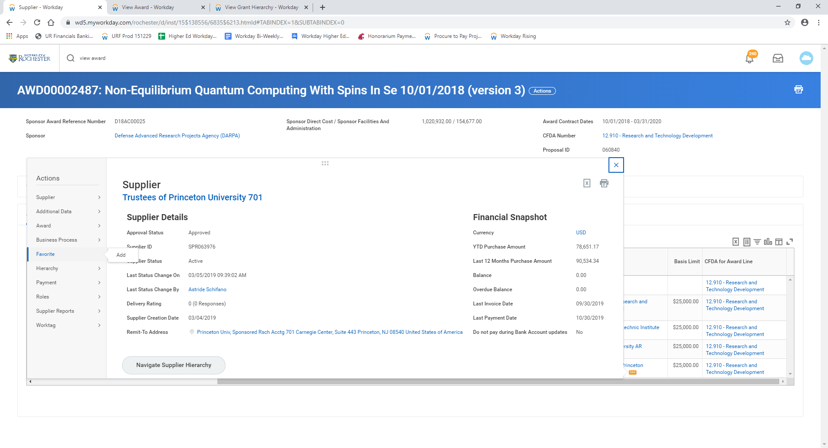

So that they can more easily select it on the SIR Supplier prompt

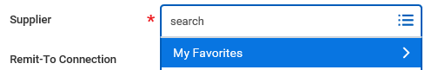

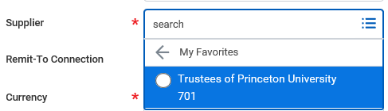

The supplier can easily be removed from your favorites list when no longer needed or helpful.

