**P2P Find Supplier Reference Guide**

This guide contains basic information and navigation as well as advanced guidance and details at the end for users that want more information.

**Searching for Suppliers**

Before initiating a Requisition or Supplier Invoice Request (SIR), it is recommended to search for and view the supplier record. This will help you understand:

* Does the supplier already exist in the system
* Can the supplier be used on a Requisition or SIR
* What are the supplier’s Payment Terms
* What is the supplier’s Default Payment Type
  + For Check payment types, what is the Remit To address where the check will be mailed
* If there is more than one similarly named supplier record, which record to use
* What is the supplier’s specific Supplier ID
  + How do I find this supplier easily when I need to use it

1. There are two easy ways to ***search*** for suppliers
   1. In the global search box, use the prefix “supplier:” along with at least three or more characters to begin your search. For example, to search on a supplier called Elsevier, enter the search as follows: supplier:elsevier and press enter.  Important: Click on Procurement in the Search Categories to ensure the system searches more efficiently for supplier records. Global searches default to Common, which sometimes will not return supplier records depending on the value entered.

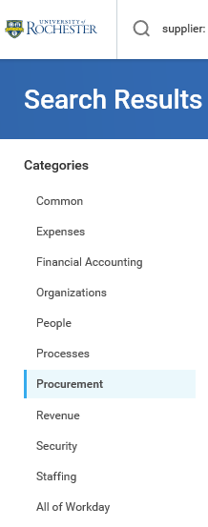

* 1. From any Supplier prompt, type at least three letters from the supplier’s name



1. The results are limited to suppliers containing the characters you entered.

**Machine generated alternative text:
Search Results 
Search Results 1 2 
Elsevier 7247 
Awnting 
Supplier 
Elsevier 6683 (Inactive) 
Elsevier 7247 
Elsevier Inc 9533 
Elsevier Science Philadelphia 
Elsevier Inc (Inactive) 
Elsevier Ltd 
Elsevier Parent Supp' i € 
Elsevier Inc 1600 (Inactive) 
All of WONdEy 
Elsevier Inc ARGI 
pplji€ 
Supplier 
Tip: try .leting ategory kft to **

* Note: As in the example above, when there are multiple supplier records for the same supplier, a display name is used that incorporates a reference to the numeric portion of the address or unit/department name. These unofficial descriptors are not the formal name of the supplier and are only used to visually differentiate between different records.

1. There are a variety of reasons why there might be multiple supplier records with similar names:

* Different Remit To address
  + Some suppliers have multiple valid remit to addresses
  + Students may use a local address for some payments and their home address for others.
* Different divisions within the supplier that have different contacts
* Different supplier altogether: For example there is a supplier Continuum in New York and another in California that have no relationship but have the same name.

Therefore, it is important to review the details of the supplier to ensure you are making an appropriate selection.

See the ***Advanced User Tips*** section at the end of this document for additional Searching Tips.

See the ***Advanced User Tips*** section at the end of this document for tips on requesting a new supplier.

**Previewing and Viewing the Supplier Record**

1. **Preview**: Hover your mouse over the supplier name. The orange related actions button 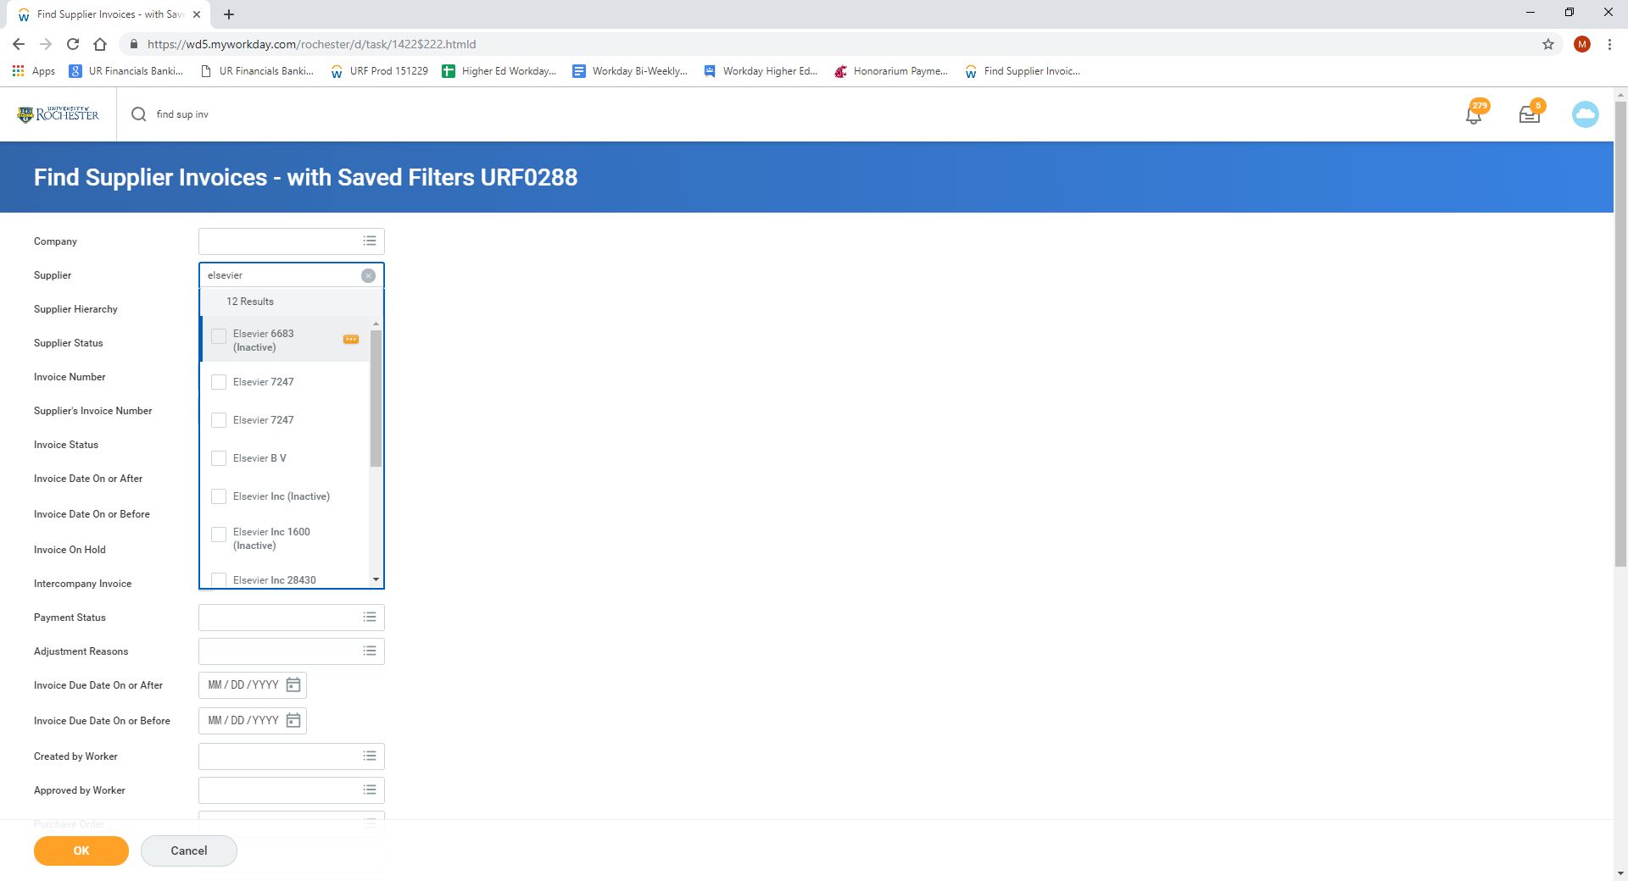 becomes available directly to the right of the name. Click on the related actions button to preview the supplier information. For example, below is the preview of Elsevier 7247.

Machine generated alternative text:
Search Results 1 2 
Elsevier 7247 
Actions 
Tip: try .leting 
Supplier Elsevier 7247 
Supplier Details 
StatÆ 
LEt StatÆ On 
LEt StatÆ By 
Supplie Date 
Remit-To Add 
SPR0052as 
Julie PeNins 
wyg,'2c1 S 
72'7 of A 

* + 1. From the Supplier Preview you can only verify the following information:
* The Remit To address for the supplier
* The supplier’s specific Supplier ID

You must View the supplier record to see the other important supplier details.

1. **View**: To view the supplier it is recommended that you open the record in a new browser tab, particularly if you want to compare multiple suppliers. Right-click on the supplier name and select See in New Tab



1. The following key information is now available:
   1. **Can the supplier be used on a Requisition or SIR**

* Supplier Group designations determine whether a supplier can be used on a Requisition or SIR.
* In addition, Parent supplier records cannot be used for SIRs or Requisitions. Do not select a supplier record with the word *Parent* in the title.
* Do not select any supplier record with Inactive in the title. If the name and address are those of your supplier but it indicates “Inactive”, submit an email to the P2P Service Center [Procurement_Service_Center@rochester.edu](mailto:Procurement_Service_Center@rochester.edu) explaining the re-activation request.
  + Supplier Group: **4 Qualified Supplier** indicates that the supplier previously qualified and can be utilized on a Requisition. However, the supplier may not be current with their certifications. If this is the case, then Purchasing will be following up with the supplier prior to approving the Requisition.
  + If you want to use the supplier on a Requisition but it is not in the 4 Qualified group, you must contact Purchasing to work with the supplier to submit the required documentation to obtain the qualified designation.

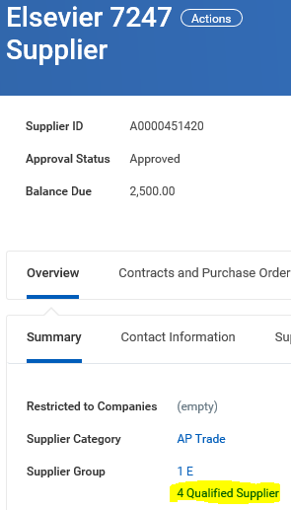

* + Supplier Group: **3 Marketing** indicates that Purchasing previously worked with the supplier to become qualified and therefore the supplier should be used on Requisitions, not SIRs.
    - If you did not create a Requisition prior to engaging with the marketing supplier and now have an invoice that needs to be paid, a Requisition will need to be submitted. Be sure to add a comment/memo that the PO is for services already rendered and will be used to pay an invoice, referencing the specific invoice # so that the supplier does not think you are requesting new services. Once the Purchase Order is generated from the Requisition, the department should write the PUR PO# on the invoice and mail the invoice to Accounts Payable who will process it for payment.

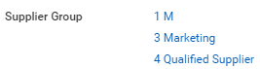

* + Supplier Group: **4-1 Unallowable for SIR** indicates suppliers that cannot be used on SIRs because they are Marketplace suppliers. Your order should have been placed through the P2P Marketplace, which provides for electronic invoicing. If you did not place your order this way, you will need to create a Requisition for a non-catalog line. Be sure to add a comment/memo that the PO is for a prior order and will be used to pay an invoice, referencing the specific invoice # so that the supplier does not think you are placing a new order. Once the Purchase Order is generated from the Requisition, the department should write the PUR PO# on the invoice and mail the invoice to Accounts Payable who will process it for payment.

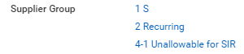

* 1. **What are the supplier’s Payment Terms**
* Understand that invoices are paid based on the due date caluclated from the Invoice Date using the Payment Terms for the supplier.
* The University’s standard/default payment terms for all qualified suppliers is Net 30 unless their Payment Type is AMEX BIP for which Net 1 Payment Terms have been negotiated.
* Invoices are settled for payment 1-2 business days prior to the calculated due date. For an invoice that is past due, the invoice is settled in the next settlement run.
* If you feel the supplier’s Default Payment Terms are not correct, contact the P2P Service Center to initiate the change/update.

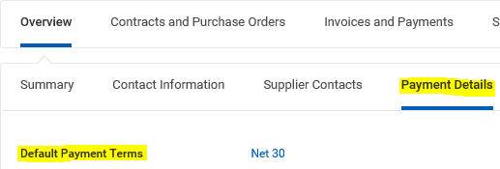

* 1. **What is the supplier’s Default Payment Type**
* Click on the Payment Details tab.
* If submitting a Supplier Invoice Request, note the Default Payment Type for responding to the Acceptable Use Questionnaire question.
* ACH (automated clearing house) and AMEX BIP (American Express Buyer Initiated Payment) are electronic payment types that are preferred.
* When utilizing suppliers with EFT or Foreign Draft as the Default Payment Type, you will be prompted to complete the Foreign and EFT Payment Questionnaire on your PUR invoices and SIRs.
* If your supplier has provided you with banking information for electronic payment or you would like Acocunts Payable to pursue ACH payments with a supplier please email the [AccountsPayable@finance.rochester.edu](mailto:AccountsPayable@finance.rochester.edu) email box with your request and supplier contact information so that they can complete the required verifications.

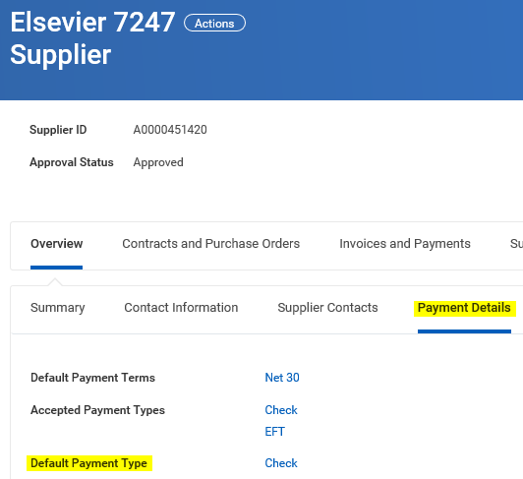

* 1. For Check payment types (Payment Types that include “Check” in the name) the **Remit To address** where the check is mailed.
* Whether using the supplier on a Requisition or Supplier Invoice Request, chose the supplier with the **Contact > Address** designated with the **Remit To** for your supplier.
* If you are not sure what the remittance address of the supplier is and there are multiple suppliers in Workday to choose from, contact the P2P Service Center for assistance.

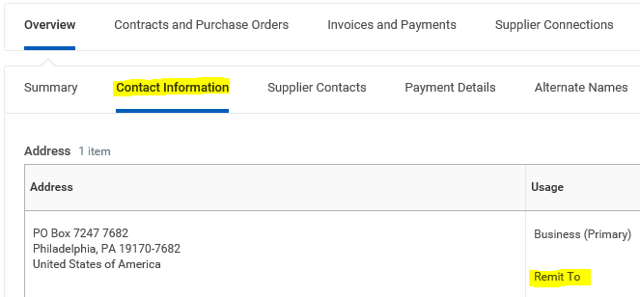

* If you find the Supplier with a name match but the address is different and you believe the company or individual has moved, initiate a change to update the Supplier record address by selecting the Related Action Change Supplier Contact Information and entering the new address.

See the ***Advanced User Tips*** section at the end of this document for additional information on how to request a change to a supplier’s contact information.

* 1. **What is the supplier’s specific Supplier ID**
* Knowing the Supplier ID of the supplier you want can be helpful if there are multiple suppliers with similar names

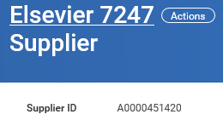

* In lieu of typing in the supplier’s name in a Supplier prompt, you can type in the Supplier ID to ensure you are selecting the desired supplier.



See the ***Advanced User Tips*** section at the end of this document for information on how to make the supplier easier to find as a Favorite.

**Advanced User Tips: Searching**

1. Do not exclude search results by entering too much of the name. If you type too much when searching the supplier that is set up will not show in your search results.
   1. The supplier name in the system may be spelled differently, even incorrectly.
   2. Example: Let us say you are searching for Julie Fish. Do not type “Julie Fish”. Julia Fish is set up in Workday and you will not find Julia Fish if you search for Julie.
2. Some suppliers have common values in their names so for these you’ll need to include the more descriptive name component when searching
   1. Example: There are over 300 suppliers with “Rochester” in the name. If you are searching for Country Club of Rochester search for “country club”. If you are searching for Rochester Public Library search for “public library”.
   2. Example 2: There are over 500 suppliers with “University” in the name. Instead of searching for “university of…” just put in the specific name excluding university. For example, search for “cornell” or “baylor” etc.
   3. Using less common values will return a shorter list of results quicker.
   4. Search functions will time out after approximately 30 seconds. Do not give up before Workday does.
3. Sometimes you will see a short address or usage identification in the display name for the Supplier.
   1. If at first you are unable to locate your supplier by name, try entering the numeric portion of the address.

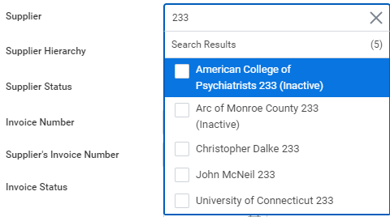

* 1. Alternatively, try entering another descriptive usage or department. For example: Searching for “connecticut” might not work if it has been abbreviated and you are looking for the animal science department:

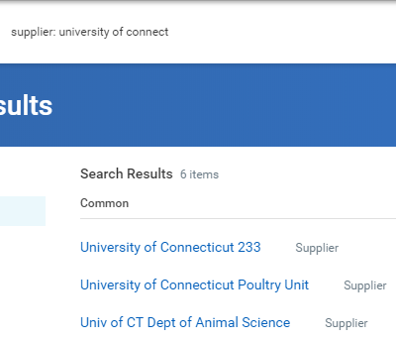

* 1. For these suppliers, Accounts Payable sets up the appropriate remittance name so that the Supplier Name appears correctly on check and remittance information.
  2. The descriptive display name is intended to help ensure users in AP, Purchasing, and departments that the correct Supplier is being used. Contact [AccountsPayable@finance.rochester.edu](mailto:AccountsPayable@finance.rochester.edu) if you would like to suggest a helpful display name.
  3. It is rare, but sometimes there are individuals with the same name and extra research is needed to determine if a supplier is the same or different than the one you are searching because they may have moved one or more times.
* If you think you see a duplicate supplier record, the same supplier with the same address as 2 or more separate listings, contact the P2P Service Center [Procurement_Service_Center@rochester.edu](mailto:Procurement_Service_Center@rochester.edu) to ask that they inactivate any duplicates.

**Advanced User Tips: Requesting a new Supplier**

* Important: Before submitting a Supplier Request, search for an existing supplier record to avoid duplication.
* This process should only be used for suppliers to be used on Supplier Invoice Requests.
* If the supplier will be utilized on Requisition/Purchase Order, contact the P2P Service Center [Procurement_Service_Center@rochester.edu](mailto:Procurement_Service_Center@rochester.edu) to start the Supplier Qualification process and do not submit a Supplier Request.
* There is a step-by-step reference guide for the Create Supplier Request process located on the UR Procurement website, please click [here](https://www.rochester.edu/adminfinance/urprocurement/p2p-resources/).
* Justification is required:
  + Include a brief explanation of what the supplier is being paid for to help speed processing. Examples: For award payment. For study participant payment. For guest speaker honorarium. To reimburse travel expenses. For conference registration. For performance payment. For event fees. For professional membership dues.
  + Standard processing of Supplier Requests is 3 business days or less. If you are working on a short timeframe in which payment is required, be sure to indicate the urgency in this field. For example: Supplier payment required ASAP this week. Or specify the date.
* Attachment is required: Attach documentation that substantiates the name and remittance address of the supplier to receive payment.
  + For a supplier that has provided an invoice, attaching the invoice is sufficient. The invoice will also need to be attached to the Supplier Invoice Request.
  + Where an invoice is not provided, email or other correspondence (letterhead, agreement) from the payee that confirms the name and address is sufficient.
  + For tax-reportable payments, including payment for services, royalties, and prize/award payments, a W9 is required documentation for new suppliers. A W9 may not be necessary for study participant payment.
* Supplier remittance address: Include a complete remittance mailing address. Be sure to mark the box for Primary.
* If it is known whether the supplier has access to Protected Health Information, add the Supplier Classification > Protected Health Information. If not known, do not add any Classifications.

**Advanced User Tips: Requesting an update/change to a Supplier’s Contact Information**

If you feel the supplier’s Remit To address is not correct, you should initiate an update:

1. Click on the **Actions** button next to the supplier’s name
2. Hover over the related action list item called Supplier
3. Click on **Change Supplier Contact Information**

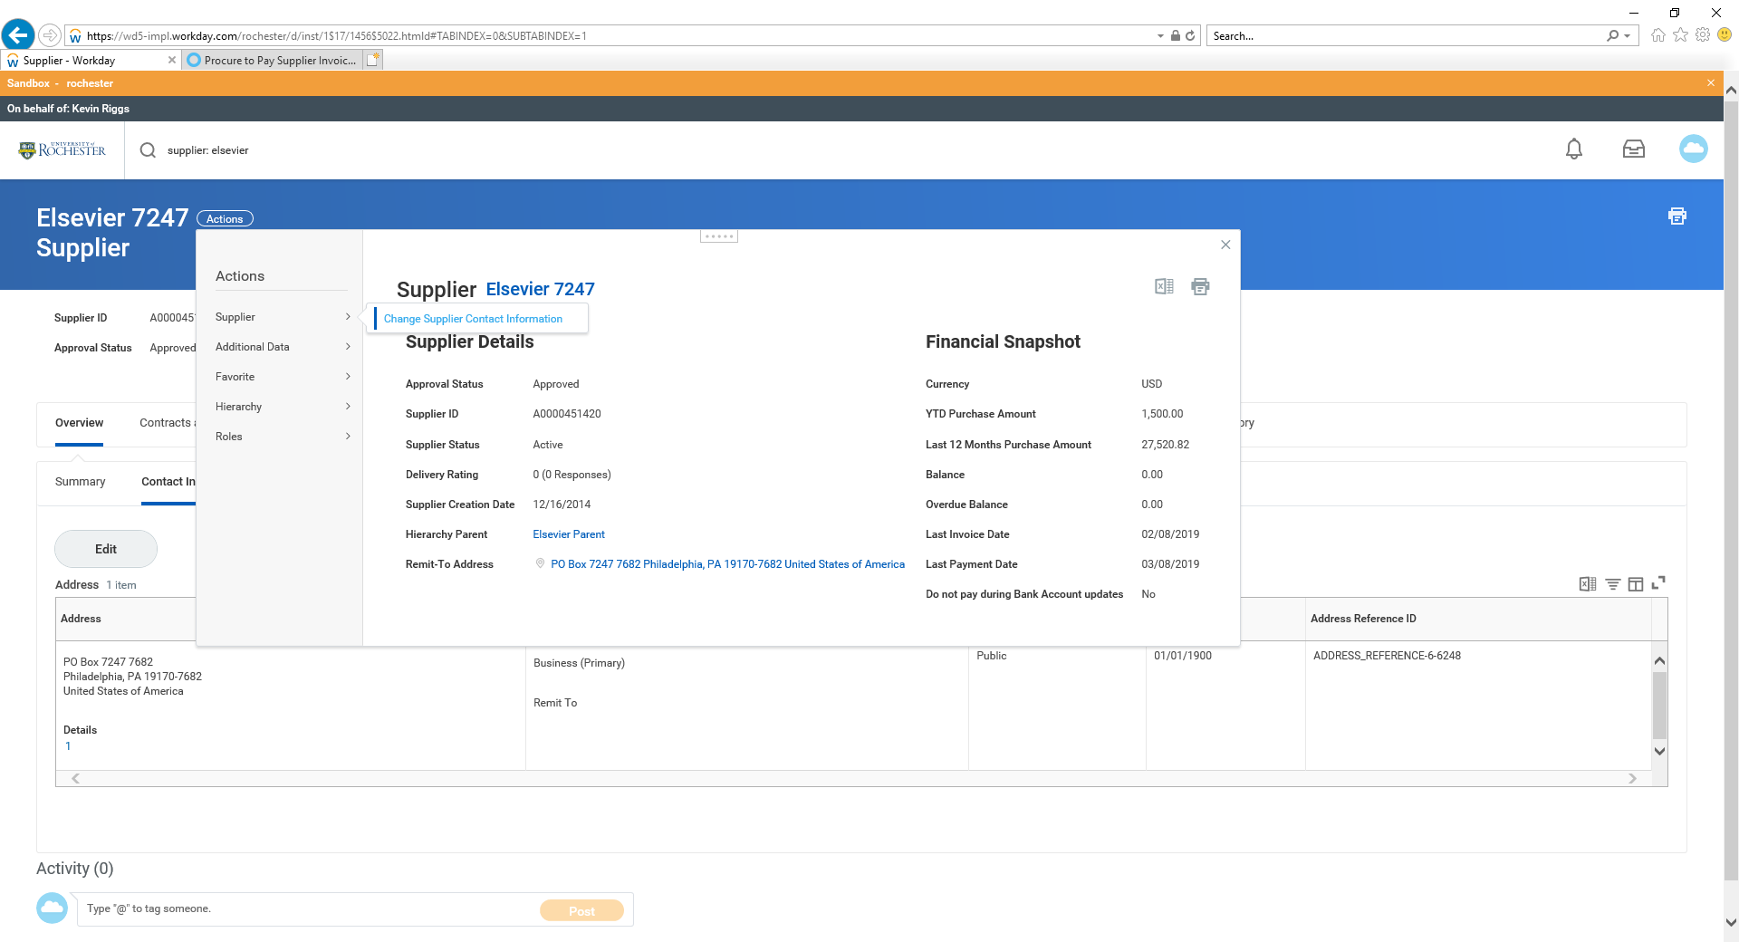

* + This task should only be used to update supplier contact information: remittance address, phone or email.
  + Other updates to supplier records, including if the Supplier is designated as Inactive, should instead be submitted via email to the P2P Service Center [Procurement_Service_Center@rochester.edu](mailto:Procurement_Service_Center@rochester.edu) explaining the re-activation or other request.

1. Confirm that you want the designated address changed and click **OK**

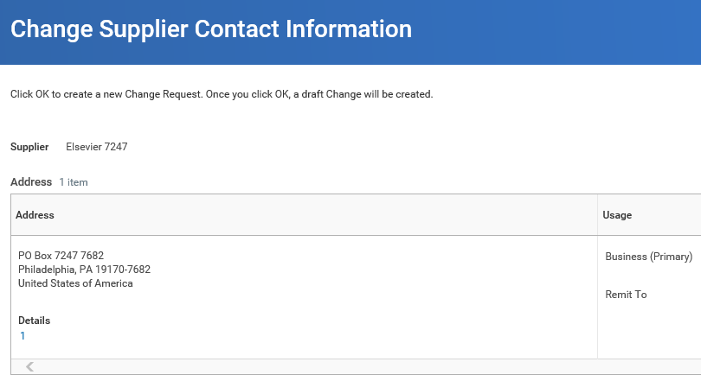



1. Enter the required information
   * Enter today’s date in the Effective Date field or the actual date of the address change if known.
   * Edit the Remit To address fields and add a Comment if an explanation is needed but do **NOT** change any other address fields.

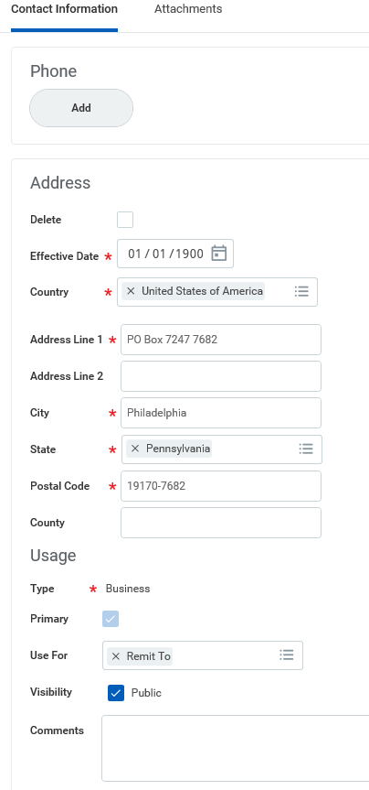

* + Documentation supporting the address change is required to be attached on the Attachment tab
  + Attach documentation that substantiates the contact information for which you are submitting this change request.
    1. For a supplier that has provided an invoice, attaching the invoice is sufficient. The invoice will also need to be attached to the Supplier Invoice Request.
    2. Where an invoice is not provided, email or other correspondence (letterhead, agreement) from the payee that confirms the name and address is sufficient.

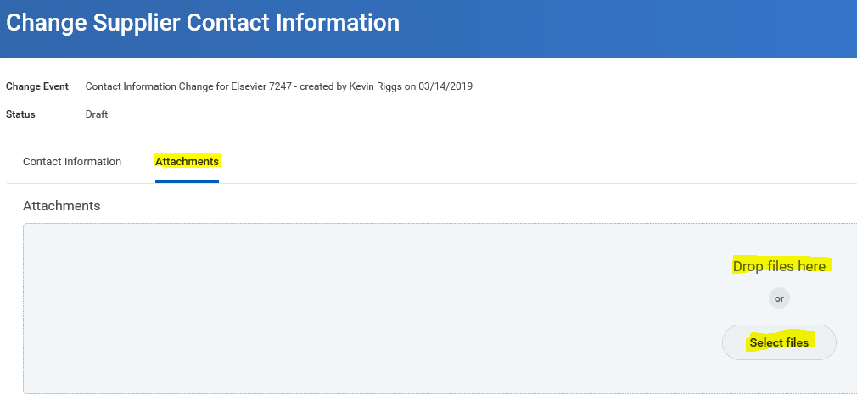

Alternately, you can contact the P2P Service Center [Procurement_Service_Center@rochester.edu](mailto:Procurement_Service_Center@rochester.edu) or email the [AccountsPayable@finance.rochester.edu](mailto:AccountsPayable@finance.rochester.edu) email with the updated remit to address.

**Advanced User Tips: Making the Supplier a Favorite**

Some users find it helpful to add the Supplier as a Favorite, which is done from the Supplier’s related actions: Favorite > Add

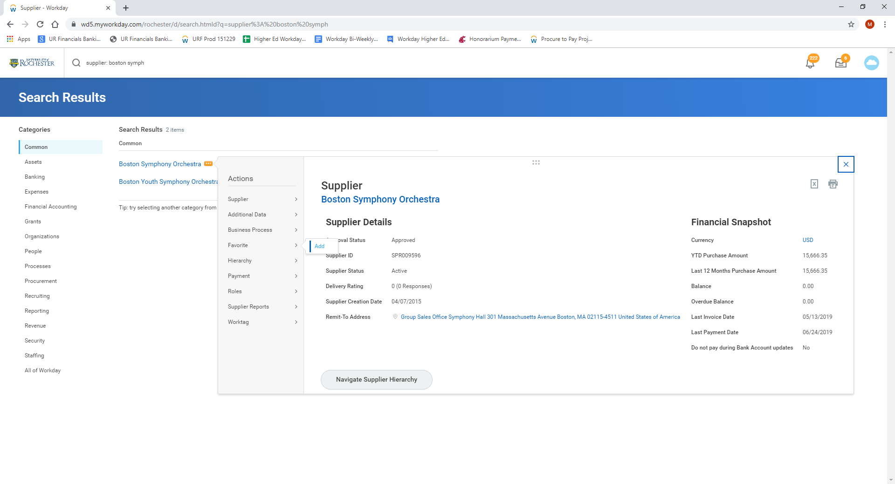

Once added as a Favorite, it is easier to find the supplier on any Supplier prompt:

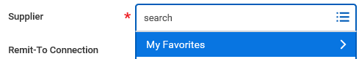

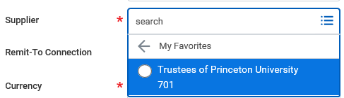

The supplier can easily be removed from your favorites list when no longer needed or helpful. This is also done from the Supplier’s related actions: Favorite > Remove

