**P2P Invoice from Receipt Reference Guide**

* Use this process anytime you want a specific paper invoice to be matched/paid with a specific receipt. Examples:
  + If you want to ensure that receipts and invoices are aligned/matched as you intended
  + If you have multiple unpaid invoices and one or more invoice should not be paid
* Do not use this process if the invoice is already in Workday, which may have an open match exception for the invoice needing receipts. In this situation, Accounts Payable already has the invoice so you should not send another copy to them with receipt info.
  + Put another way, this process does not work and cannot be used when Accounts Payable receives the invoice electronically or when AP receives the paper invoice from the supplier prior to the department sending it to AP.
  + When entering a receipt to resolve a match exception, not only does AP already have the invoice, but also your creation of a receipt in Workday triggers a process that ***immediately*** attempts to match any/all open invoices for that PO to the Receipt that was just created.

1. **First, Create a Receipt in Workday**
   * There are resources on the UR Procurement website if you need guidance <https://www.rochester.edu/adminfinance/urprocurement/p2p-resources/>

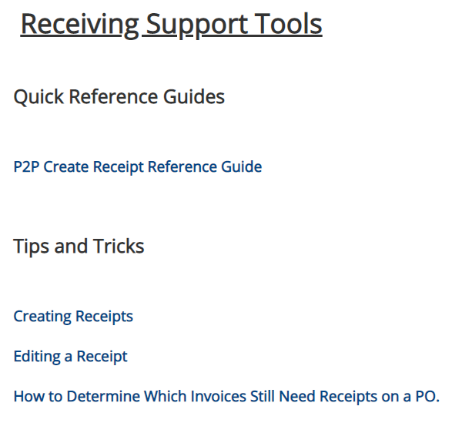

* + Note that you can create a single receipt for each invoice or you can create a single receipt for multiple invoices associated with the purchase order.
  + ***Best Practice***
    - When creating a receipt for a specific invoice or group of invoices, after entering Line receipt information, navigate to the Create Receipt > Information tab

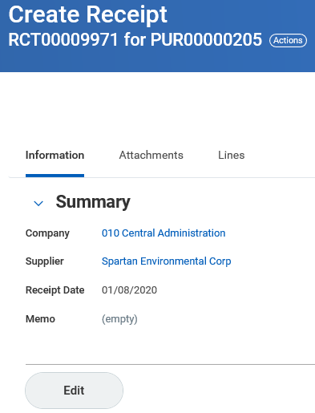

* + - Click on Edit
    - In the Memo field enter the Supplier’s Invoice Number(s)

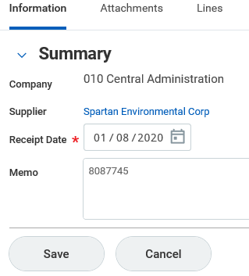

* + - Click Save to save the edited data on the Information tab.
    - Remember to click  to submit your receipt information.
  + When complete, note the RCT#

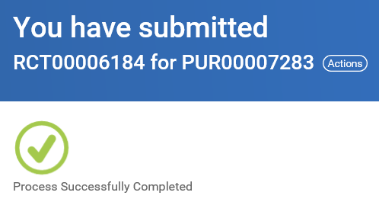

1. **At the top of the paper invoice(s), clearly write the RCT #.** Example:

**RCT00006184**

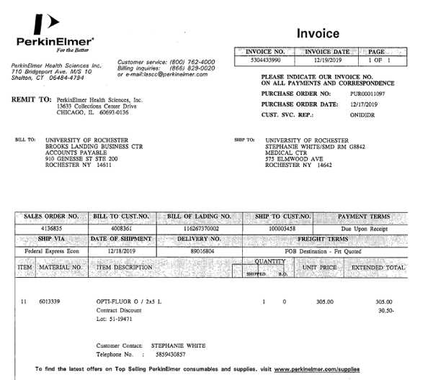

1. **Mail the invoice to Accounts Payable at BOX 278958**
   1. Remember: if a Match Exception routed to you and is awaiting action in your Workday Inbox, Accounts Payable already has the invoice and you should **not** print and send another copy to them. Only send the invoice to AP if it is not in Workday yet.

***Advanced tip:*** Use the **Purchase Order Invoice Matching Balances (NCL) URF1053** report to help identify purchase orders for which receipts and/or invoices are missing.

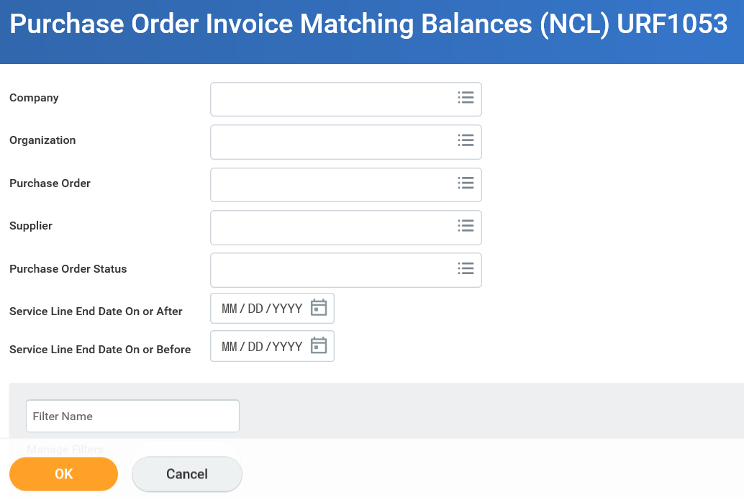

* 1. Enter the purchase order number and click OK
     1. If you want to see all POs you have reporting access to, including those submitted by others.

***Advanced tip:*** If you ran the report for multiple purchase orders, sort the Balances > Invoice Extended column Ascending to find out which POs have invoices exceeding the receipted amounts.

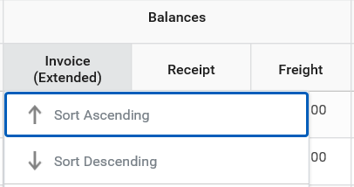

* 1. If there is a red diamond (negative amount) in the Invoice column, check your inbox for Invoices with Match Exceptions to add receipts as appropriate.
  2. If there is a red diamond (negative amount) in the Receipt column, that just means the purchase order has not been receipted in full and does not require action if the goods have not been physically received or services performed.

