UR Procure to Pay – Marketplace Checkout

Instructions | Details and Screenshots
Access the Marketplace:  - Connect supplier website (“conn supp”)  - Click OK to confirm your credentials, add your ship-to address, and your FAO number (Worktag). Call the P2P Center if you need help finding your ship-to address. 275-2012  - Choose Connect | 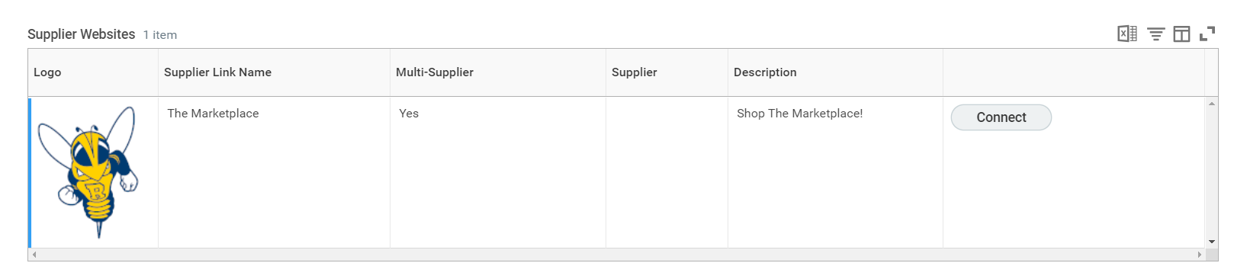
Rules | - Requisition for non-catalog (in Workday) and catalog goods (Marketplace) separately  - Shop & checkout for each Supplier
The Marketplace (Jaggaer) | 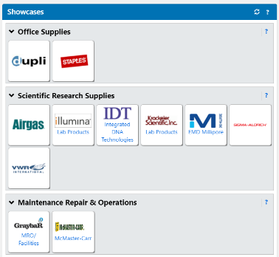  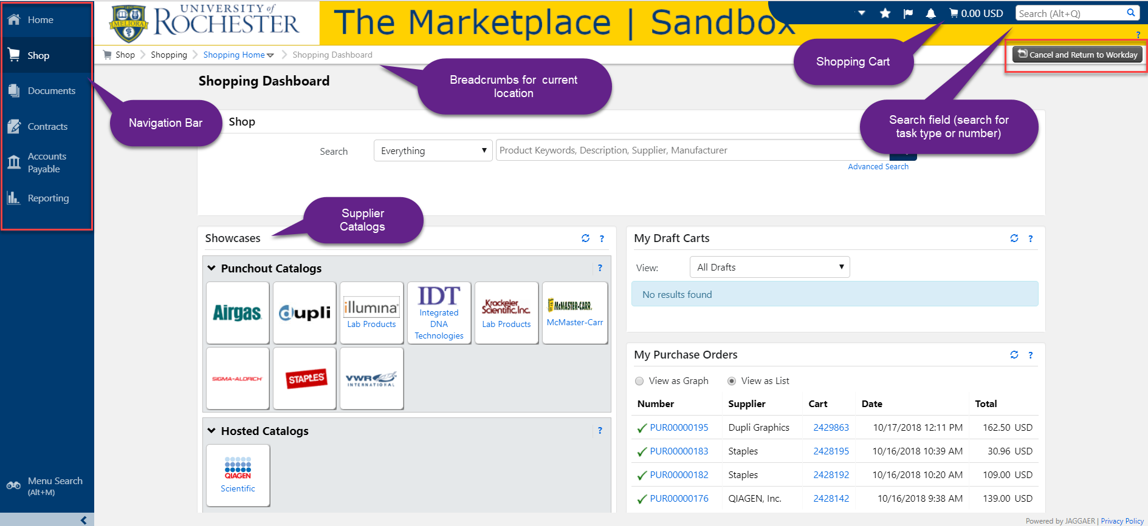
Process a Punchout Cart  - View Cart Details  - Send to Workday  - In Workday, Checkout | 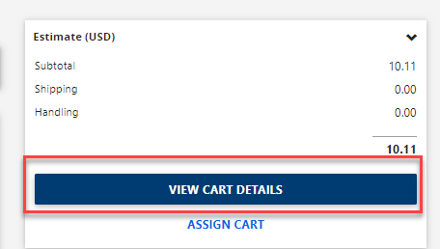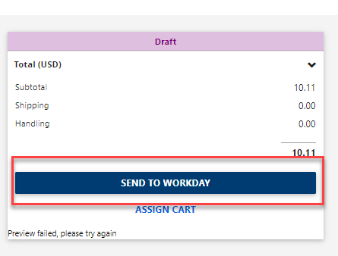
Process a Hosted Cart  - Click on Cart and Checkout  - Send to Workday | 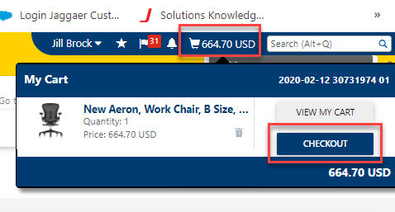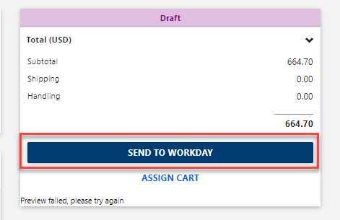
- In Workday, Checkout  - Confirm each line has a spend category. If not, add one at checkout. | 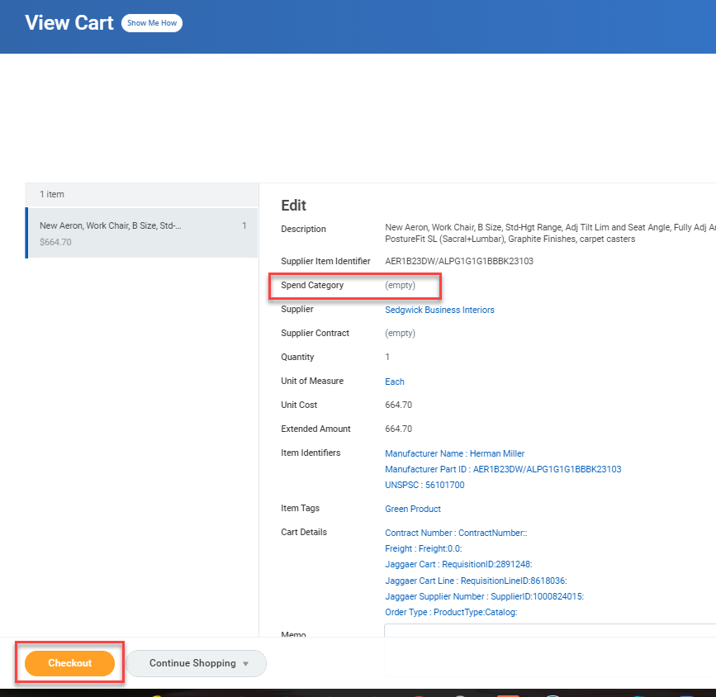
- Information  - Some Suppliers (with automated data interchange) will not process the memo from catalog orders.  - Internal memo is provided in the approval workflow.  - Estimated Freight Amount can be added if known. | 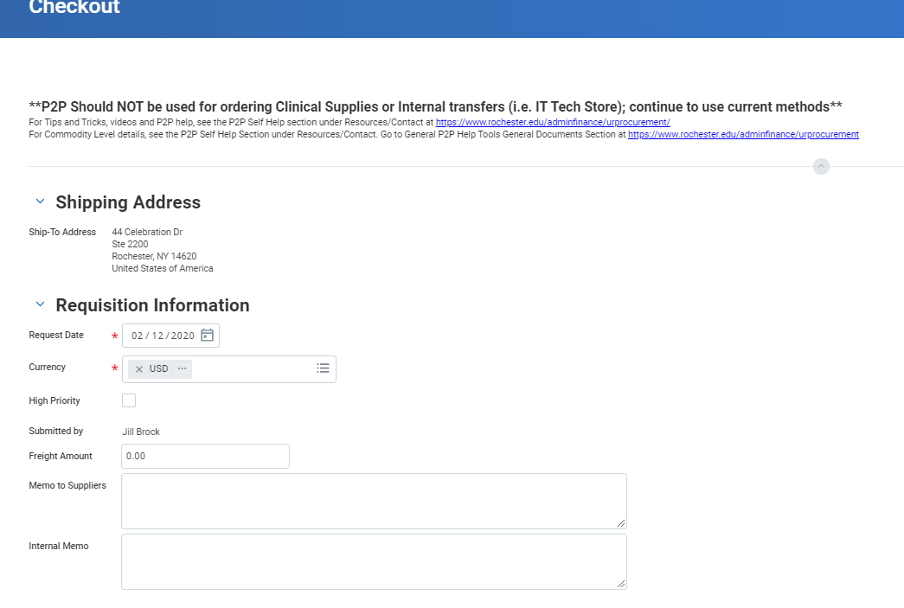
- Attachments | Catalog goods > $50,000 require a business justification.
- Spend Categories can be added to each line as needed. You can change a company number on one line for a Multi-Company Requisition. Change the FAO or enter splits to the far right of the line. | 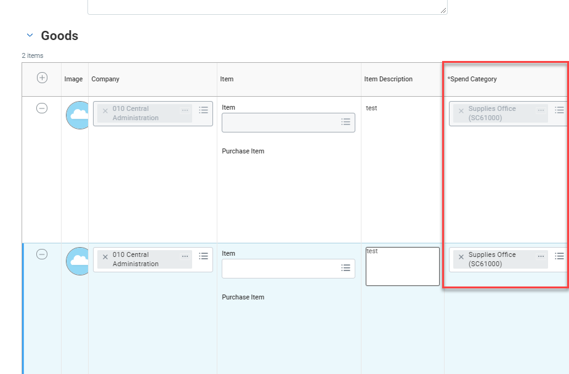
- Review and Submit  - The Order Type will be: Punchout or Catalog (for Hosted)  - The Item Tags may be: Green, Hazardous, Radioactive | 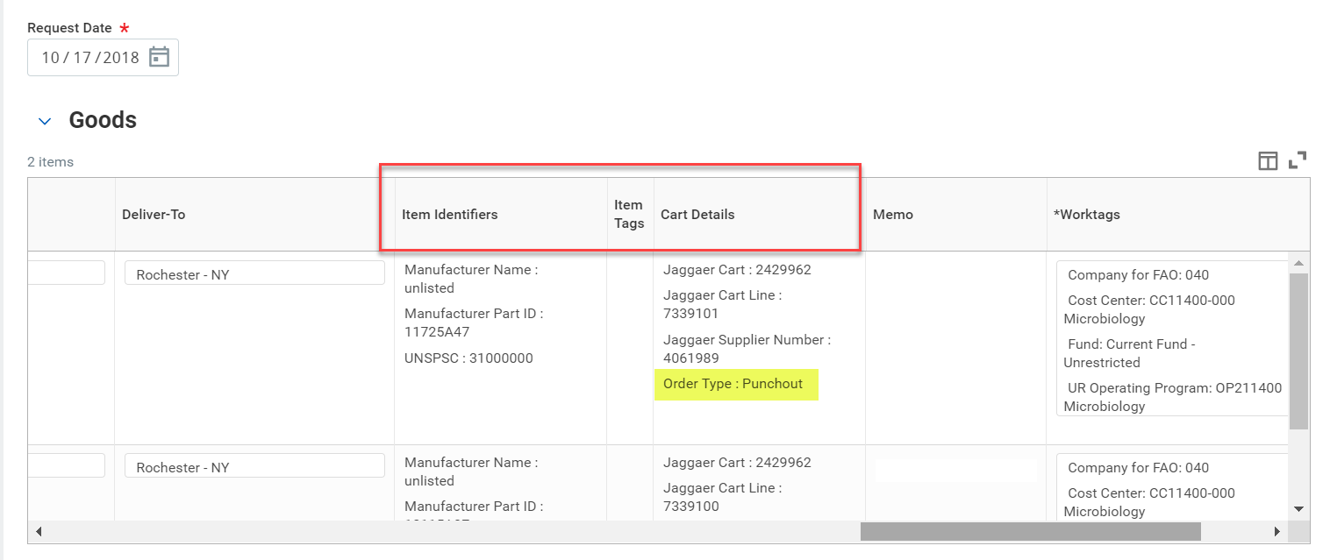
- Once the requisition has been approved and a purchase order created, review the document in the Marketplace (Jaggaer) by entering the number (PURxxxxxxxx) in the search window or looking at the My Purchase Orders list. | 