Workday Procurement – Create Requisition for Non-Catalog Goods or Services

Instructions | Details and Screenshots
Home page:  - Use the UR logo to return to this Home screen  - Use the Global Search field with keywords  - Use the Inbox icon for Workday messages  - Use the Procurement dashboard for frequently used tasks and reports  - Create Requisition | 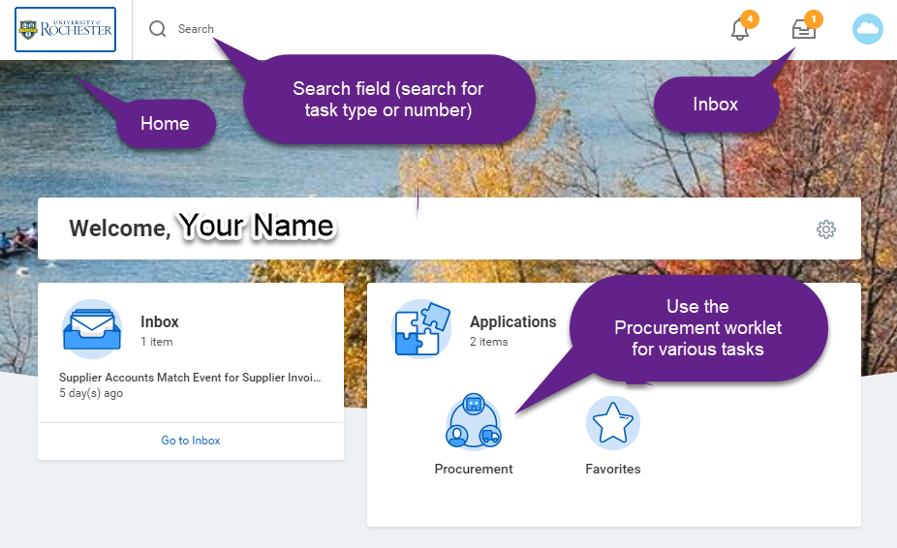
Rules | Enter all line items from the quote  Only 1 company per requisition line (can have multiple FAOs within the same company)  Upon final workflow approval the requisition becomes a Purchase Order (PO) and will be sent to the supplier
From the Procurement dashboard, choose Create Requisition and enter the required information  - Select the appropriate Company – one FAO on the requisition must match this Company  - Change Requester name if doing the requisition on behalf of someone  - Add the Ship-to Address. It is best to search with a building name or room number. Call the P2P center if you are unable to find your address.  - Add your commodity and FAO, this will default to all lines, but can be changed on the lines.  - Select <OK> | 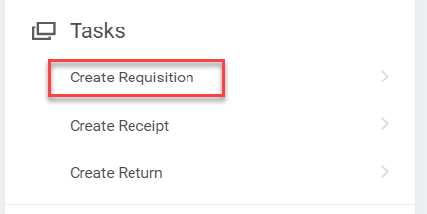  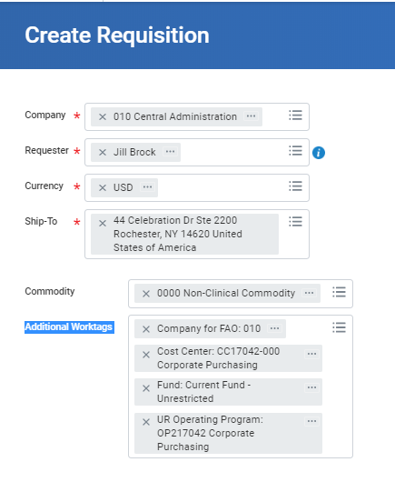
- For non-catalog requisitions, select <Request Non-Catalog Items>.  - To copy a previous non-catalog requisition or to order from a pre-defined template (covered later in this guide), select <Add from Templates and Requisitions> | 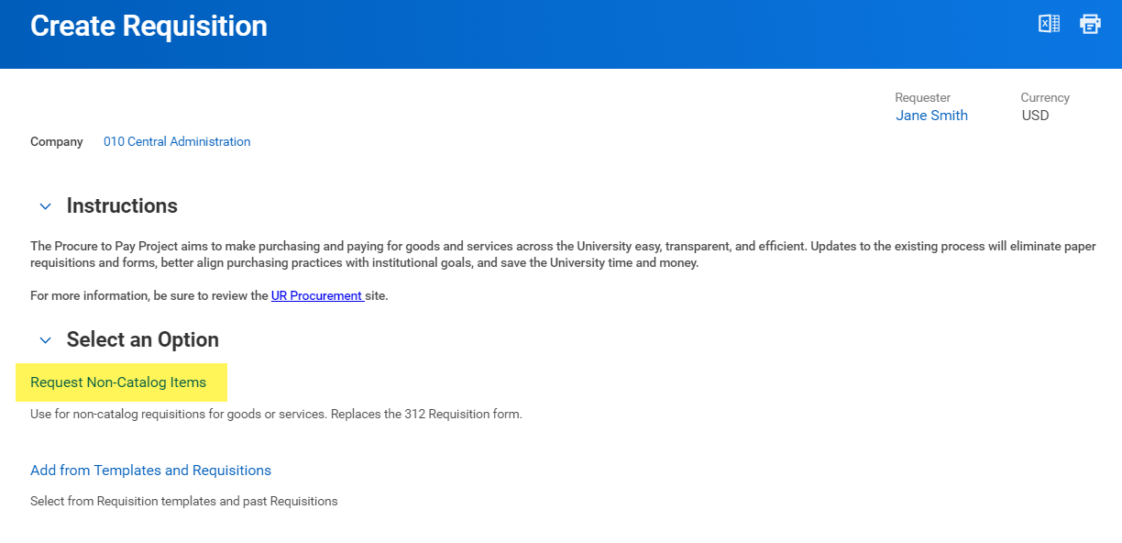
Non-Catalog Request Type: Goods vs Services  - The Non-Catalog request type will default to Request Goods  - Be sure to change the radio button selection to switch for requesting Service | 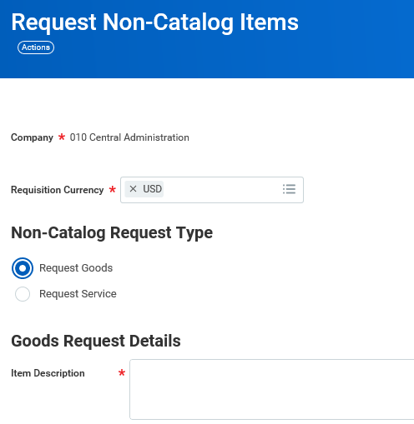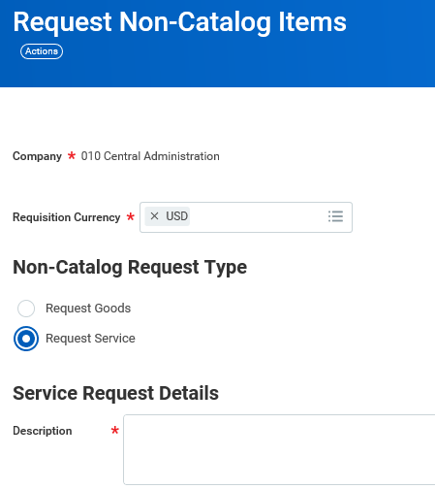
Request Non-Catalog Items – Goods vs Service continued  - Shown are two samples  - Include the quote number in the item description, if applicable  - Spend Category can be searched by a partial name or the spend category number, beginning with SC  - Choose an existing supplier. The supplier field cannot be left blank. If you cannot find your Supplier, direct the supplier to register via the Supplier Qualification Website and contact the P2P Service Center to let them know the supplier will be registering. You can either cancel your requisition or complete it to the end and save it for later. | 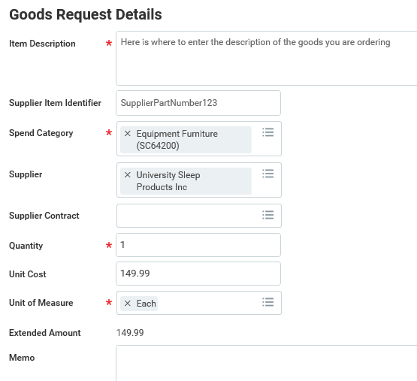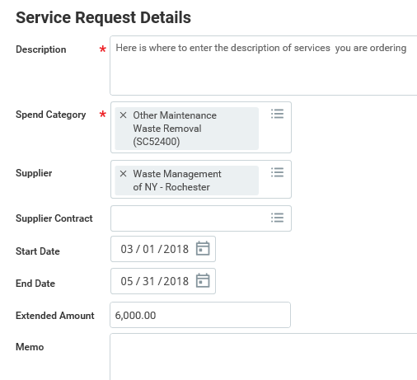  Goods request has a quantity, unit cost and Service request has a start date, end date and extended amount  unit of measure. Include the supplier part#, mfg#,  lot# or serial# in the Supplier Item Identifier field.  https://www.urmc.rochester.edu/purchasing/supplier/qualification.cfm
Select <Add to Cart>  An Add to Cart Box will appear. | 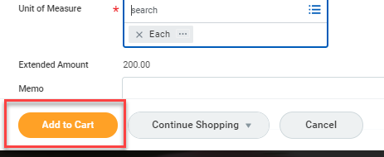  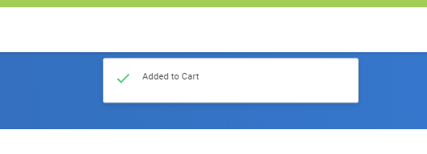
Can fill in another line if additional lines are needed  - If additional lines are needed, repeat the above step  - If additional lines are needed for different suppliers, the req will split into multiple purchase orders. Therefore it is recommended to hold off and finish the current request for a given supplier  - If no additional lines are needed, select the shopping cart icon | 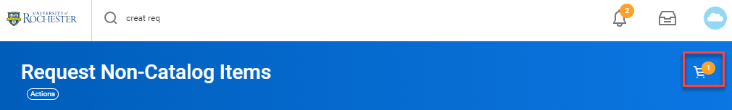
- The shopping cart contains the lines that have been added  - Select <Checkout> | 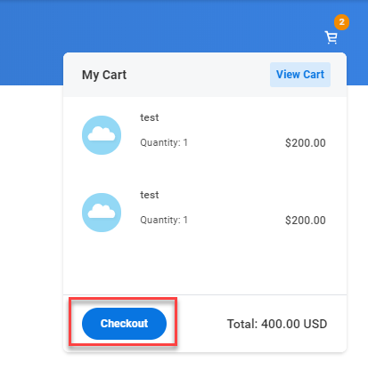
The Header of the checkout section allows you to add freight and a memo to the supplier or an internal memo that will be seen by approvers and Purchasing. | 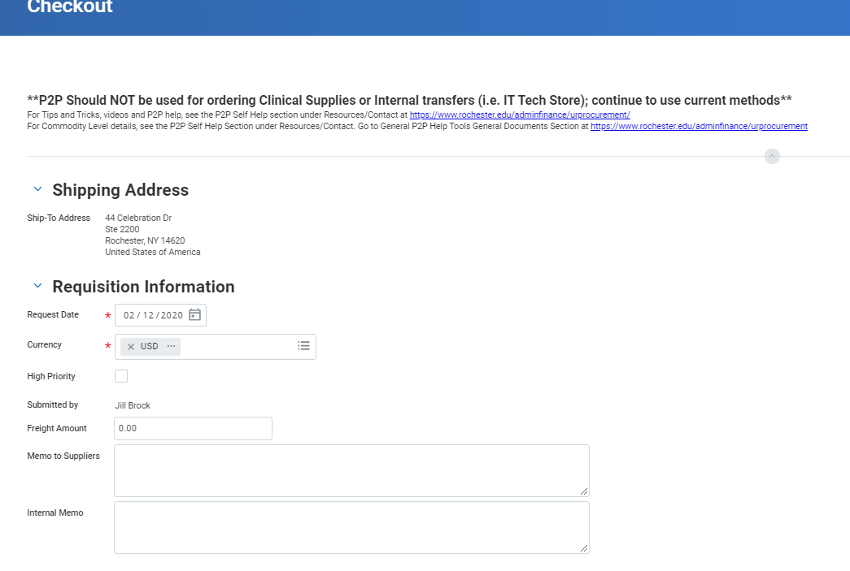
- If doing a Multi-Company requisition you can change the Company number at the far left of the line. | 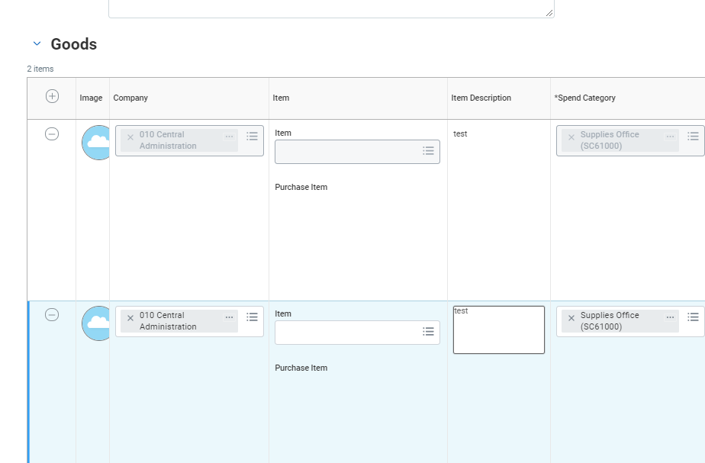
- FAO numbers and splits can be changed/entered at the far right of the line.  - A Requested delivery date can be added for expedited shipping. Additional charges may be incurred. | 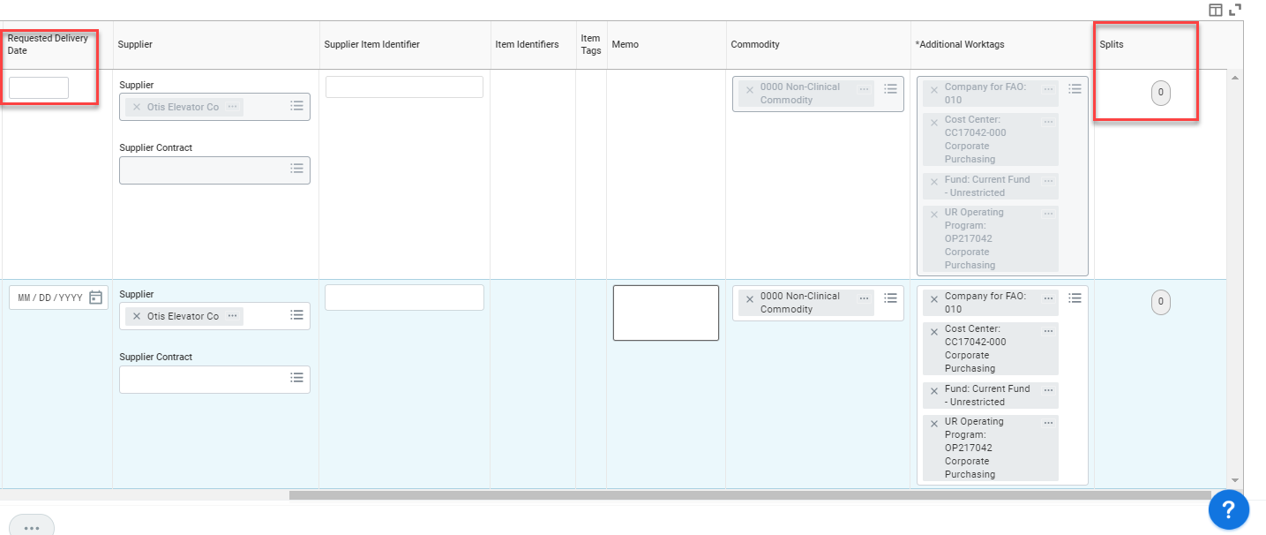
- Attachments can be added by clicking the arrow next to the word Attachments under the lines. Choose Select files.  - After adding attachments you can click Submit or Save for Later if you need to come back to the requisition. | 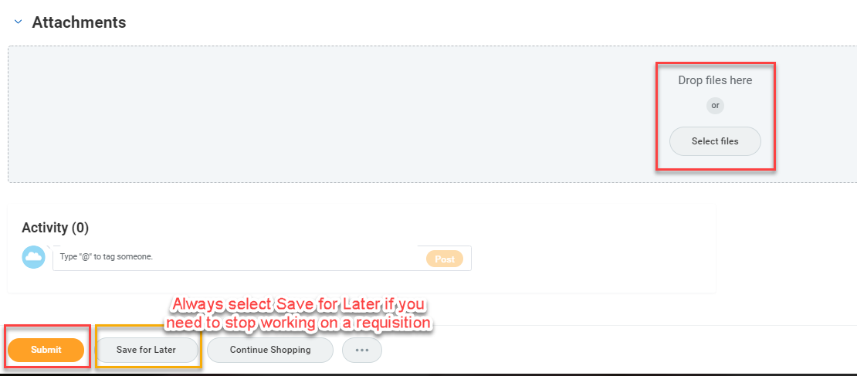
- Compete Questionnaire  - If you have no errors you will be prompted to complete a short questionnaire. Click on the Complete Questionnaire button. | 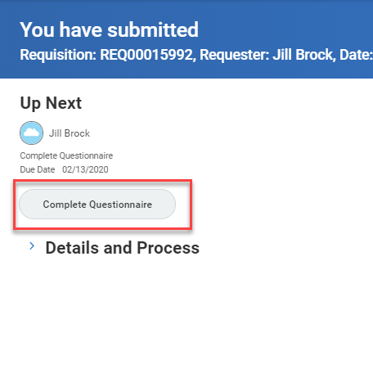
- Answer the questions and click Submit when finished.  - You will see a message telling you that you have submitted the questionnaire. Your requisition may complete, or it may tell you who is up next for approvals. | 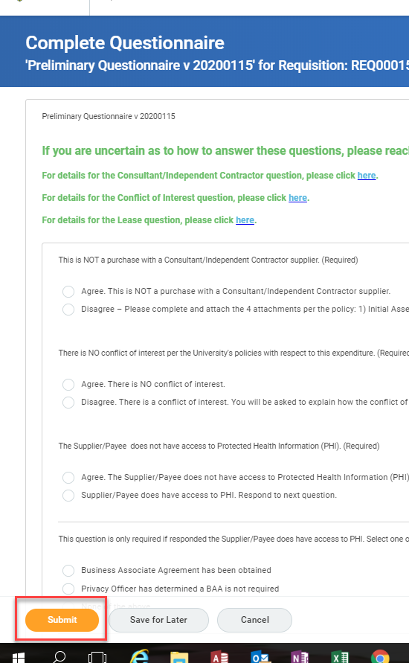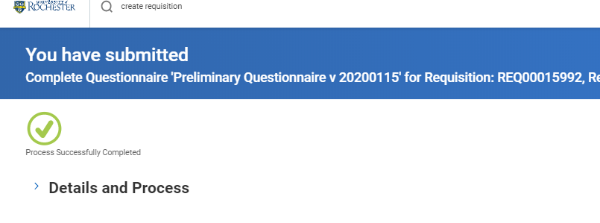
Requisition Templates can be set up for frequently used.  - From the Global Search field, enter <create requisition> and press Enter to search. | 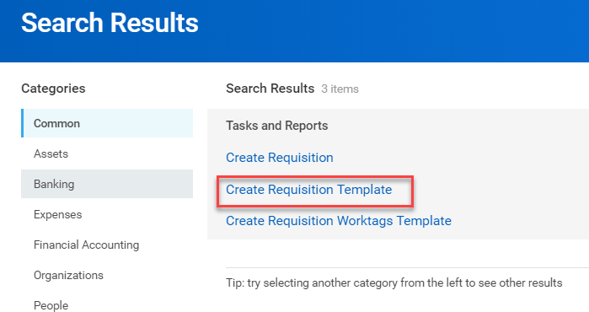
Enter a Requisition Template Name for this template  - Goods lines and/or Services lines can be added  - Select the + icon to add lines for the template | 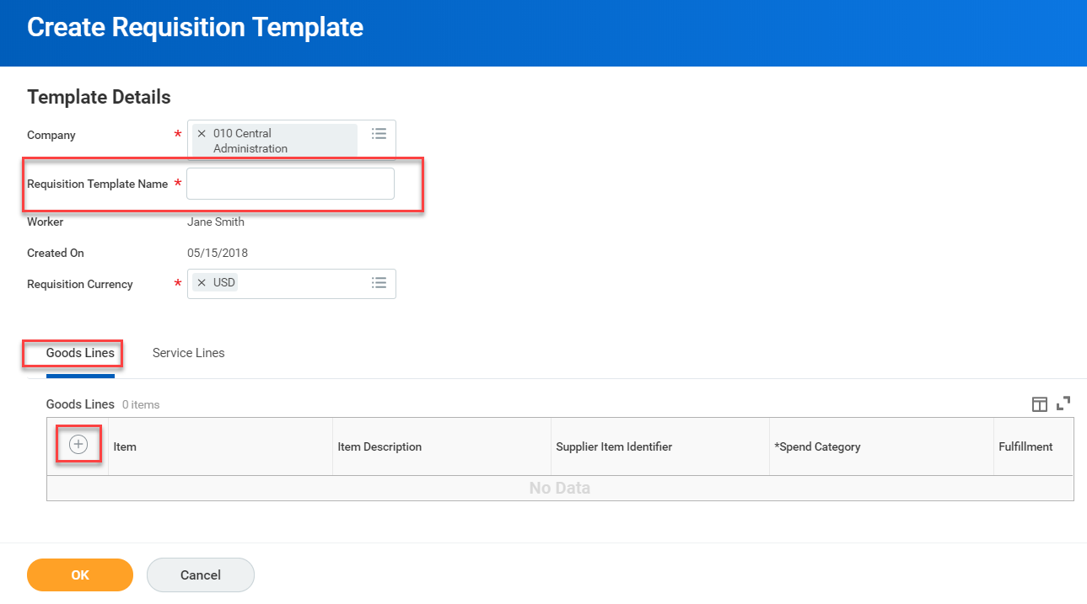
For the purpose of this guide, we will show a Services line for temporary personnel with a specific supplier.  - Do not enter an Extended Amount since this can be customized each time you order using the template  - Do not enter Ship-To Adress or Contact or Deliver-to since this can be customized each time you order using the template  - For the Worktags field, search on your FAO and select <Enter>. All related worktags will populate. | 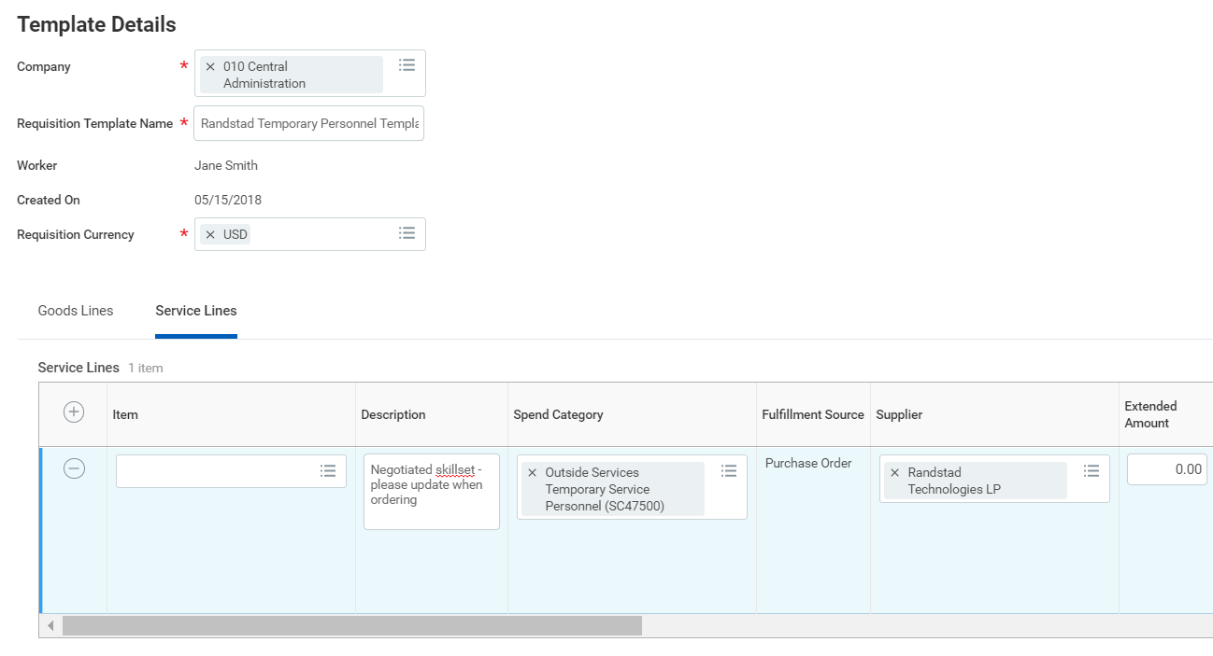 Scroll to the right to fill in more fields…  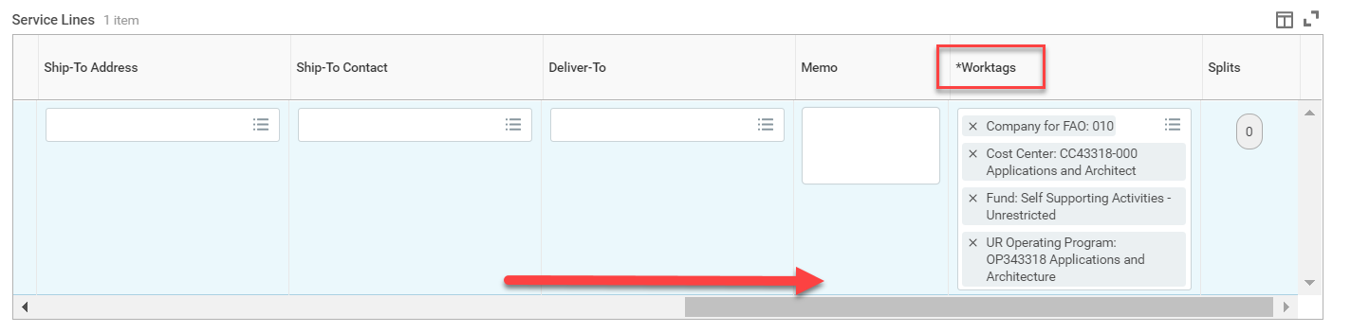
Select <OK> when done. | 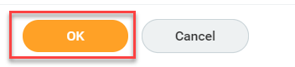
To order using the new template, or to copy a previous requisition, select the <Create Requisition> option, update the information if necessary.  - Select <Add from Templates and Requisitions>. | 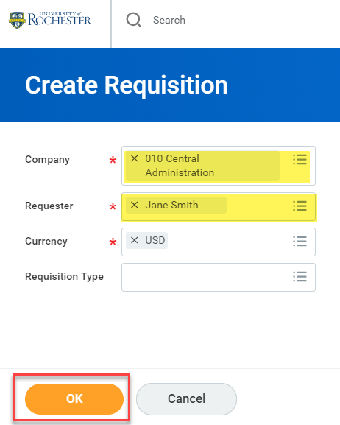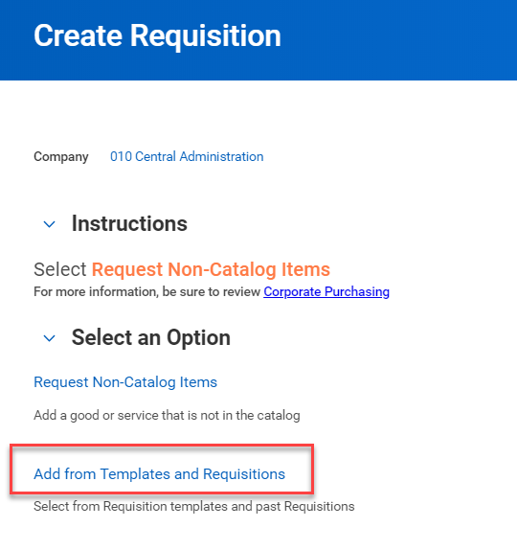
From this screen, you can order from an existing template or create a copy of a past requisition.  - Select the checkbox next to the template from which to order. When selected, it will take you to your Cart where you can continue the checkout process.  - Select <Add to Cart>  - You can also copy a past requisition by selecting the checkbox and selecting <Add to Cart> | 