**P2P Study Participant Payment Reference Guide**

**for Supplier Invoice Requests (and Paper F4)**

March 2020

**Contents Page**

Payments to Research Subjects for Incentives/Participation Policy 1

HIPAA Compliance 1

Social Security Number/Personal Identifying Information (PII) 1

Creating the Supplier Invoice Request

Header Fields 2-3

Attachment & Line Details 3-5

Questionnaire 6

Review Step 7-8

**Policy**

Before committing to paying study participant payments, familiarize yourself with the [Payments to Research Subjects for Incentives/Participation Policy](https://www.rochester.edu/adminfinance/finance/wp-content/uploads/2017/03/ResearchSubjectPayments.pdf).

**HIPAA Compliance**

Research participants are considered a sub-set of the University’s patient population and covered by the same protections as set forth in the [HIPAA Policy](http://sites.mc.rochester.edu/departments/hipaa/hipaa-policy-manual/). This document has been prepared to assist departments with HIPAA compliance for study participant payments. General guidance:

1. Use of the University’s Bank of America study payment card program is the preferred mechanism for paying study participants. Special considerations must be made for study participants that are nonresident aliens. Check payment via Accounts Payable Supplier Invoice Request or paper F4 Payment Request form is least preferred. Contact Kathy King-Griswold at [Kathy.king-griswold@rochester.edu](mailto:Kathy.king-griswold@rochester.edu) or 585-275-6968 for more information about the University’s Bank of America study payment card program.
2. When submitting a Supplier Invoice Request or F4 to AP to pay a study participant, the only detail that is necessary to reference in the Business Purpose or memo fields is to very generically indicate the payment is for study participation. **Departments should not include any study-identifying information**. We realize the FAO or grant designated on the form for charging the expense may contain descriptors that can identify the study, however the FAO is required for payment.

**Personal Identifying Information Compliance**

In alignment with the [Social Security Number/Personally Identifiable Information Policy](https://tech.rochester.edu/policies/ssn-pii-policy/), Accounts Payable collects Social Security Numbers (SSN) and Personal Identifying Information (PII) in Workday only as necessary to comply IRS tax reporting requirements. In conjunction with the Payments to Research Subjects for Incentives/Participation Policy, department are required to obtain a W9 and/or tax ID number for individuals receiving payments $275 or more per calendar year per protocol. Study participants that are nonresident aliens are subject to different guidelines based on IRS requirements. **The W9/tax ID number should not be obtained or submitted if not required**.

**Creating the Supplier Invoice Request (SIR)**

1. In Workday, navigate to the Create Supplier Invoice Request task
2. Read the Supplier Invoice Request Help Text, it is generic to all SIRs:

**Please review the Buying and Paying Guide available on the** [**UR Procurement > Reference Guides webpage**](https://www.rochester.edu/adminfinance/urprocurement/resources-support-training/resources/reference-guides/) **and the Supplier Invoice Request/F4 Acceptable Use List available on the** [**Accounts Payable > Forms webpage**](https://www.rochester.edu/adminfinance/finance/accounts-payable/forms/) **to ensure you are properly using the Supplier Invoice Request for payment.**

**In addition, if**

* **Payment is for services, royalty, study participation, or prize/award**
* **AND Payee is a US citizen or permanent resident**
* **AND your department has not previously sent the payee’s W9 to Accounts Payable**

**Then attach the W9 to this Supplier Invoice Request before submitting.**

1. **INVOICE DATE:** Enter the date of the visit or study event the participant is being paid for.

* If the participant is being paid for more than one visit/event, enter the date of the most recent visit/event.
* If not aligned with the Supplier’s Invoice Number, Accounts Payable will edit one or both as appropriate and send you an email about proper entry in accordance with this guide.

1. **Invoice Received Date:** This is an optional field. Enter the date used in the Invoice Date field.
2. **COMPANY:** If you have access to multiple companies, be sure to enter the correct company for the GR that will be charged on the SIR.
3. **CONTROL TOTAL AMOUNT:** Enter the amount that is due to be paid.
4. **SUPPLIER**

* The supplier is the study participant.
* Guides are available to help you review the contact information of the Supplier to ensure you are selecting the right person to be paid. On the [UR Procurement > P2P Self Help site](https://www.rochester.edu/adminfinance/urprocurement/p2p-resources/):
  + Supplier Invoice Request Support Tools > Tips and Tricks > ***How to preview a supplier record (before you create your SIR)***
  + General P2P Support Tools > Quick Reference Guides > ***P2P Find Supplier Reference Guide***
* If you are unable to locate your study participant as a Supplier, use the guide at Supplier Invoice Request Support Tools > Quick Reference Guides > ***P2P Create Supplier Request Reference Guide***

1. **SUPPLIER’S INVOICE NUMBER**
   1. Even though there is no invoice associated with study participant payments, this field is utilized to take advantage of Workday’s automated duplicate invoice validation.
   2. Enter the date used in the Invoice Date field in this format: MMDDYYYY



* 1. If not aligned with the Supplier’s Invoice Number, Accounts Payable will edit one or both as appropriate and send you an email about proper entry in accordance with this guide.

1. **Handling Code**: This field is optional. No handling code should be entered for payments mailed out to study participants.
2. **Header Memo**: Since the Supplier’s Invoice Number field is not blank, no entry is needed in the Header Memo field. The Header Memo field is printed on the remittance portion of the check. You may optionally want to enter “Study Payment” or some generic reference so that the study participant understands what the check is for when they receive it.
   1. Additional descriptors can be entered, however caution should be used so as to remain HIPAA compliant. For example, it is acceptable to include the sponsor identifier, initials, participant ID or other reference.
   2. **IMPORTANT**: It is not acceptable to enter
      1. participant’s medical record number (MRN)
      2. reference to the type of study or involvement such as “infectious disease”, “tissue samples”
      3. reference viruses or conditions such as “rota”, “addiction”
   3. If not entered in accordance with this guide, Accounts Payable will edit out the unacceptable entries, usually changing it to “Study Payment” and send you an email about proper entry in accordance with this guide.
3. **Attachment**: **Do not** include ANY attachment on study participant payments unless required.
   1. Attachment is not required when using these Spend Categories:

* Human Subjects Inpatient Service Charges (SC48400)
* Human Subjects Other (SC48450)
* Human Subjects Outpatient Service Charges (SC48500)
  1. **W9 or any documentation with tax ID/social security number should only be attached for individuals receiving payments $275 or more per calendar year per protocol AND Accounts Payable does not already have their tax ID number or you have not previously submitted their W9/tax ID number.**
     1. Accounts Payable will detach the W9 or attachment with tax ID for storage/reference in their official repository.
  2. Any other support the department would like to attach must comply with the guidance provided for the Header Memo/Internal Memo guidance
  3. Any attachment or page of an attachment that is not in accordance with this guide will be removed by Accounts Payable and send an email about appropriate attachment support.

1. **LINE DETAILS**
   1. Best practice is to change the line type to Service Line: There is no consequence to leaving it as a goods line, it is just good practice to properly identify the line correctly as a service (not goods) purchase.

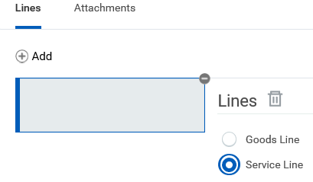

* 1. **Spend Category**: These are the appropriate study participant spend categories:
     1. ***Human Subjects Inpatient Service Charges (SC48400):*** Human Subject Inpatient Service Charges outside of the standard of care and priced using effective federal rate agreement, MTDC exclusion.
     2. ***Human Subjects Other (SC48450):*** Used for a variety of other Human Subject charges, including human subject payments, clinical and outpatient services paid from industry-sponsored trials, MTDC inclusion.
     3. ***Human Subjects Outpatient Service Charges (SC48500):*** Human Subject Clinical Lab charges and any hospital and professional fees in eRecord, priced using effective federal rate agreement, MTDC exclusion.
  2. **Extended Amount**: Enter the amount that is due to be paid.
  3. **Additional Worktags**: Remember to first enter the GR FAO in this field and allow the other worktag fields (Company for FAO, Cost Center and Fund) to auto-fill. Do not fill in the Company for FAO, Cost Center, or Fund; allow them to fill in after the FAO is entered.

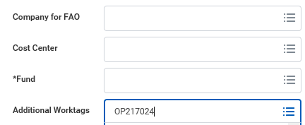 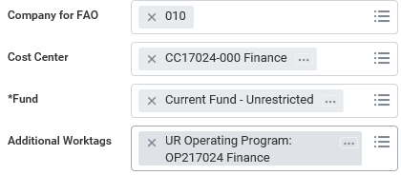

* 1. **Internal Memo**: This field is required and cannot be left blank. This field is used to capture the business purpose of the SIR.
     1. For Accounts Payable purposes, it is sufficient to enter Study participant payment: 
     2. Additional business purpose explanations can be entered, however caution should be used so as to remain HIPAA compliant. For example, it is acceptable to include the sponsor identifier, initials, participant ID or other reference.
     3. **IMPORTANT**: It is not acceptable to enter
        1. participant’s medical record number (MRN)
        2. reference to the type of study or involvement such as “infectious disease”, “tissue samples”
        3. reference viruses or conditions such as “rota”, “addiction”
     4. If not entered in accordance with this guide, Accounts Payable will edit out the unacceptable entries and send you an email about proper entry in accordance with this guide.

1. Remember to click Submit



1. The initiator is then prompted to complete the Acceptable Use questionnaire. Click on Complete Questionnaire.

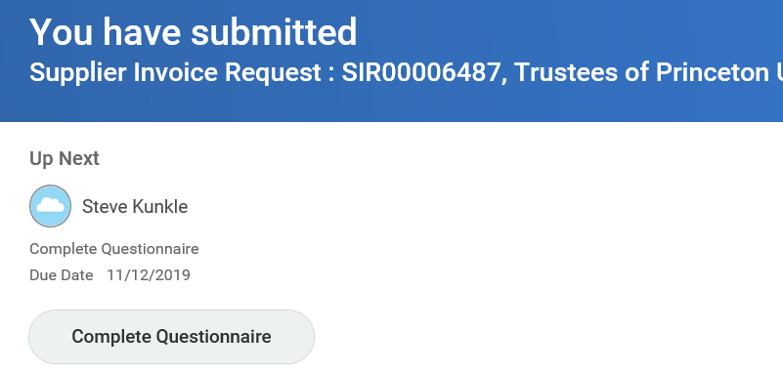

1. **ACCEPTABLE USE QUESTIONNAIRE**

For study participation payments, the following answers are appropriate:

Answer Agree to the following questions:

 

      

Pcard 



Supporting documentation 

Payee type 

Default Payment Terms 

Payment is for study participation 

Answer the subsequent 4 questions as appropriate.

* Citizenship Question: answer as appropriate.
* Is the Payee a US Citizen or Permanent Resident: If select No, provide the payee’s email address and expect 30% to be withheld from payment as required by the IRS. Payment may be delayed depending on responsiveness of payee.
* Services performed in US: answer as appropriate
* Independent Contractor: 
* W9 previously sent to AP: select Yes if accurate/appropriate or which has a required branching question: Enter the calendar year to date payments to this participant in this study, including this payment: enter whole dollars, for example: 

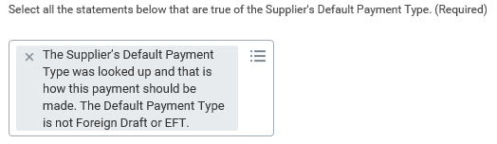

Questions that are not marked required do not have to be answered.

Remember to click Submit when finished with the questionnaire 

There are validations on your questionnaire responses to ensure there is no conflicting responses between your SIR and Questionnaire and within your Questionnaire.

If the questionnaire validations are not triggered then the SIR will move forward for financial approval.

**REVIEW**: If one of these validations is triggered, the SIR will route back to you for resolution on a Review step:

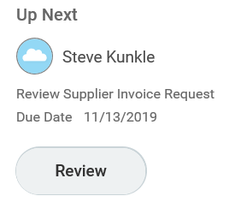

Click on Review

Read the Help Text:

Merely clicking Approve on this Review step is not sufficient. As the Help Text describes, you must navigate to the SIR by clicking on the hourglass



Navigate to the related actions 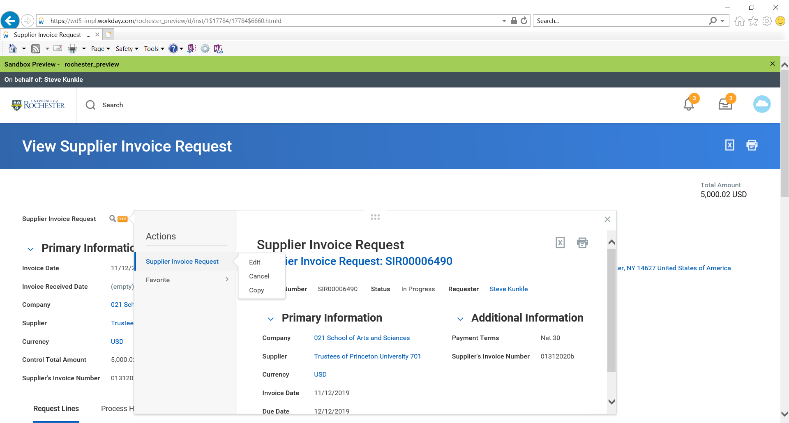for the SIR. Then select Supplier Invoice Request > Edit





Feel free to double-check the information you entered on the SIR for accuracy.

Click Submit when ready to move on to Edit your questionnaire responses



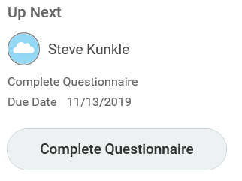

Click on Complete Questionnaire. The questionnaire opens up with your prior answers marked.

Update your questionnaire responses as appropriate. Click Submit when done.



The validations will recheck your responses and again send you back to the Review step if all the problems are not resolved.

If the questionnaire validations are not triggered then the SIR will move forward for financial approval.