UR Procurement – Equipment Maintenance

Instructions | Details and Screenshots
Home page:  - In the Global Search Bar type Create Requisition.  - Click on the Create Requisition task. | 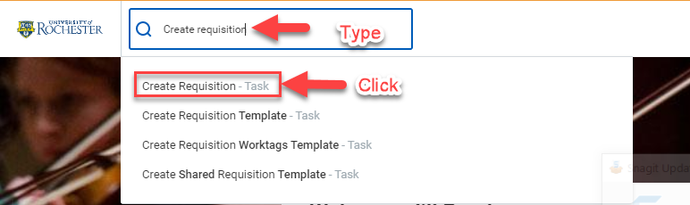
- Confirm that the company code will match at least one FAO you intend to use on the requisition.  - If you are doing the request on behalf of someone else, remove your name and type their name.  - Confirm or search for the correct Ship to address.  - Add the appropriate commodity. Capital for Equipment Maintenance.  - Type the appropriate FAO in the Additional Worktags field. You can change or adjust them at checkout.  - When you have filled in all the fields, Click <OK>. | 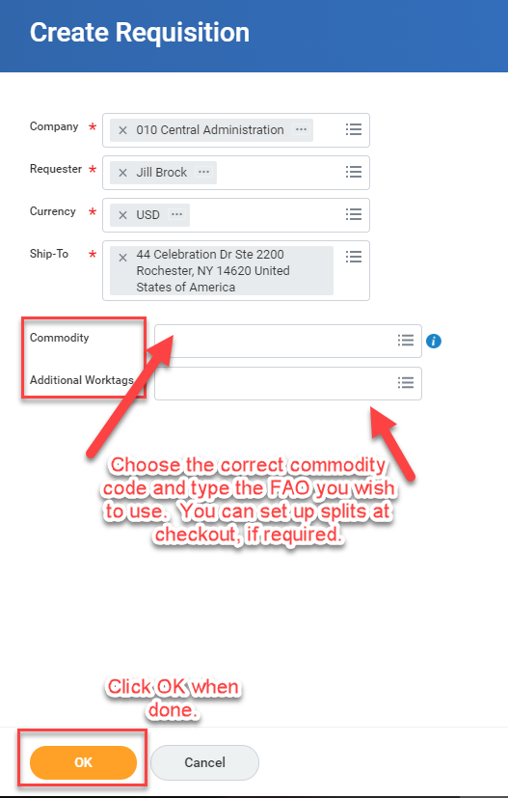
- Select Request Non-Catalog Items option. | 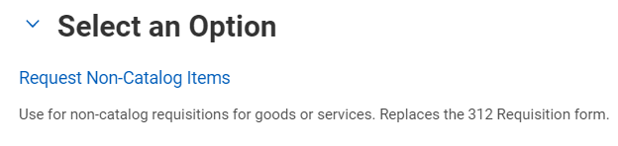
Request Non-Catalog Items:  When creating a requisition for  Equipment Maintenance  you will use the Service Non-Catalog Request Type | 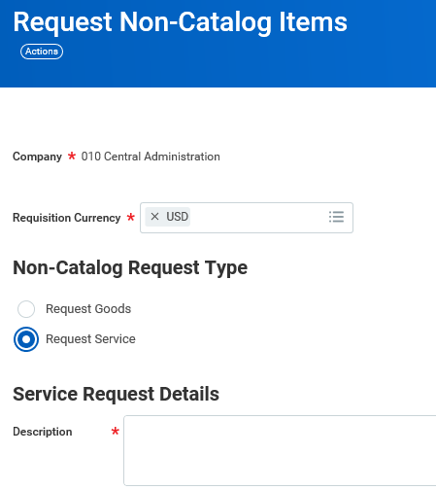  *The request type will default to Goods, so be sure to change the selection to Request Service.
Service Line Details:  Remember to switch Non-Catalog Request Type to “Request Service”  - Description – Provide the agreement details. Description of equipment and the model and serial #.  - Spend Category  - Supplier – Supplier Name.  - Start Date – Beginning date of agreement/contract.  - End Date – Anticipated end of agreement/contract.  - Extended Amount – Dollar value of agreement/contract  - Memo – This is up to the individual Requestor as an internal note.  - Add to Cart – It will show item has been added to cart (upper right of page). | 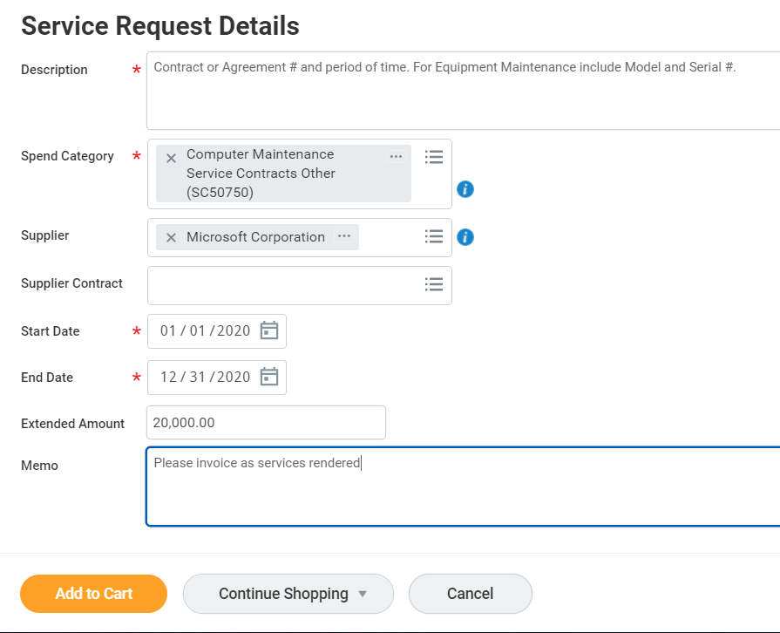
Checkout:  Now you will have one item in your cart and you are ready to Checkout.  - Click on the <Cart>.  A window will appear with the items you have added.  - Click <Checkout> | 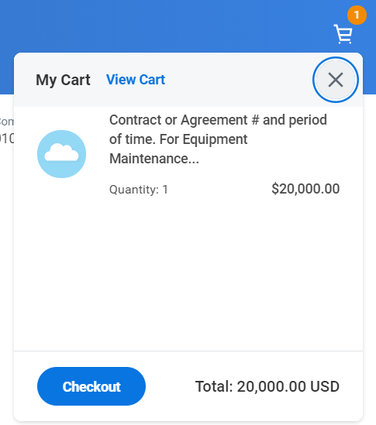
Checkout:  This is the Final Review before you Submit. Here you will verify that the Following information is correct.  - Shipping Address – Make sure you have entered a valid address.  - Requisition Information – Here you can add a Memo to Suppliers or an Internal Memo (suppliers will not have visibility, but approvers will see comments).  - Goods – You can alter any information to the Goods Line.  - Services – You can alter any information to the Service line.  - Attachments – You will need to add an attachment or attachments to this requisition. The following are required documents. (Supplier Quote/contract, Capital Data Sheet, Supplier Price Justification Conflict Information Form ($25,000 or greater), any other correspondence. These attachments should be uploaded separately). | 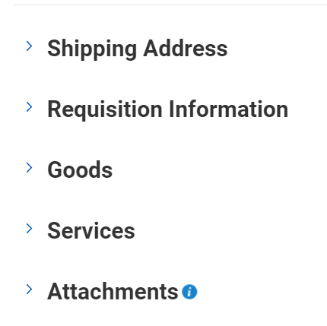
Checkout:  Attachments – Are added by clicking the arrow next to the word “Attachments” under the lines.  Choose “Select files”.  Locate the files on your computer that need to be added and add them as separate attachments by Double Click to upload. Use the “Upload” button to add additional documents if needed.  After adding attachments you can click Submit  or  Save for Later if you need to come back to the requisition. | 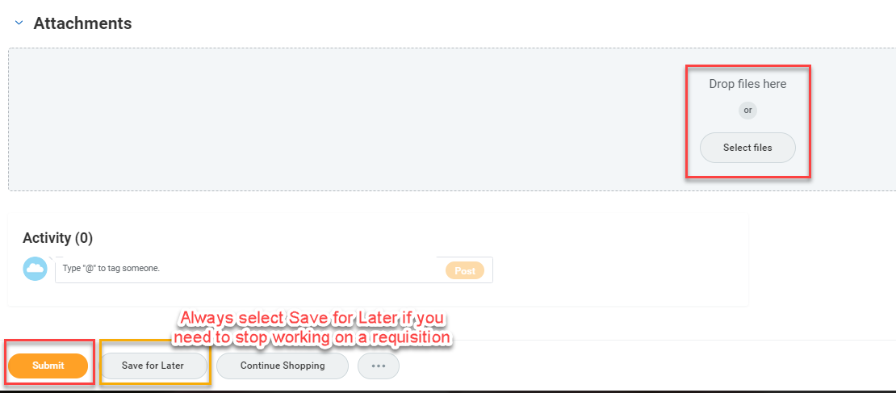
Complete Questionnaire:  - If you have no errors you will be prompted to complete a short questionnaire.  Click on the Complete Questionnaire button. | 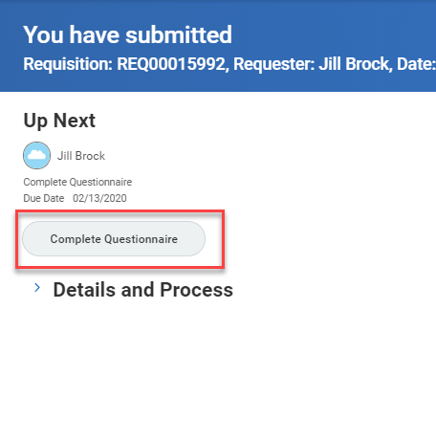
Instructions | Details and Screenshots
- Answer the questions and click Submit when finished.  - You will see a message telling you that you have submitted the questionnaire.  Your requisition will tell you who is up next for approvals. | 