Workday Procurement – Create Requisition from a Prior Non-Catalog Requisition

Instructions | Details and Screenshots
Home page:  - Use the UR logo to return to this Home screen  - Use the Global Search field with keywords  - Use the Inbox icon for Workday messages  - Use the Procurement dashboard for frequently used tasks and reports  - Create Requisition | 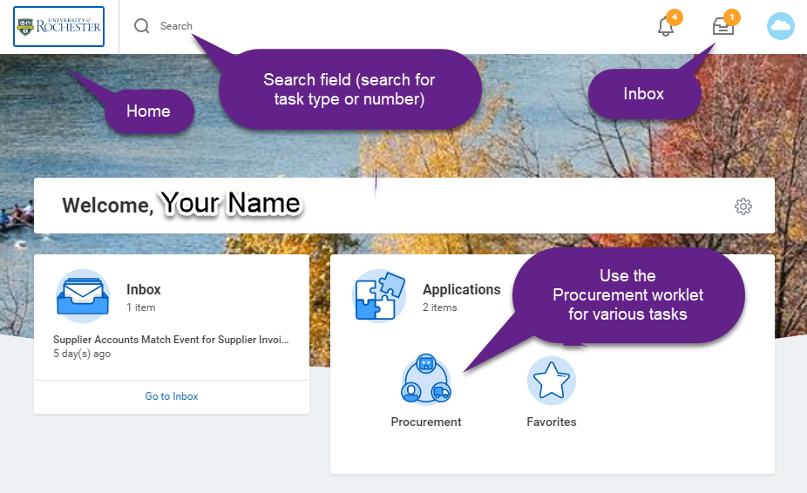
Rules | Enter all line items from the quote  Only 1 company per requisition line (can have multiple FAOs within the same company)  Upon final workflow approval the requisition becomes a Purchase Order (PO) and will be sent to the supplier
From the Procurement dashboard, choose Create Requisition and enter the required information  - Select the appropriate Company – one FAO on the requisition must match this Company  - Change Requester name if doing the requisition on behalf of someone  - Add the Ship-to Address. It is best to search with a building name or room number. Call the P2P center if you are unable to find your address.  - Add your commodity and FAO, this will default to all lines, but can be changed on the lines.  - Select <OK> | 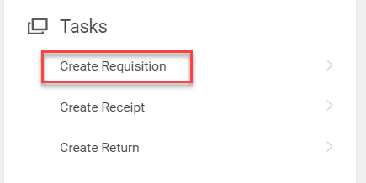  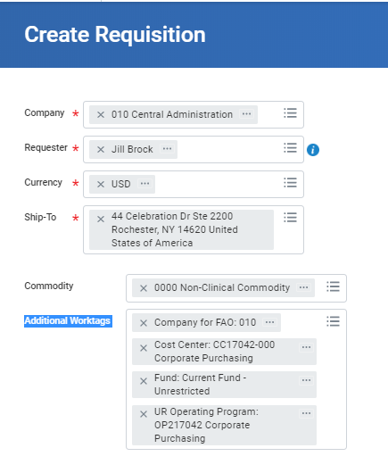
- To copy a previous non-catalog requisition select <Add from Templates and Requisitions> | 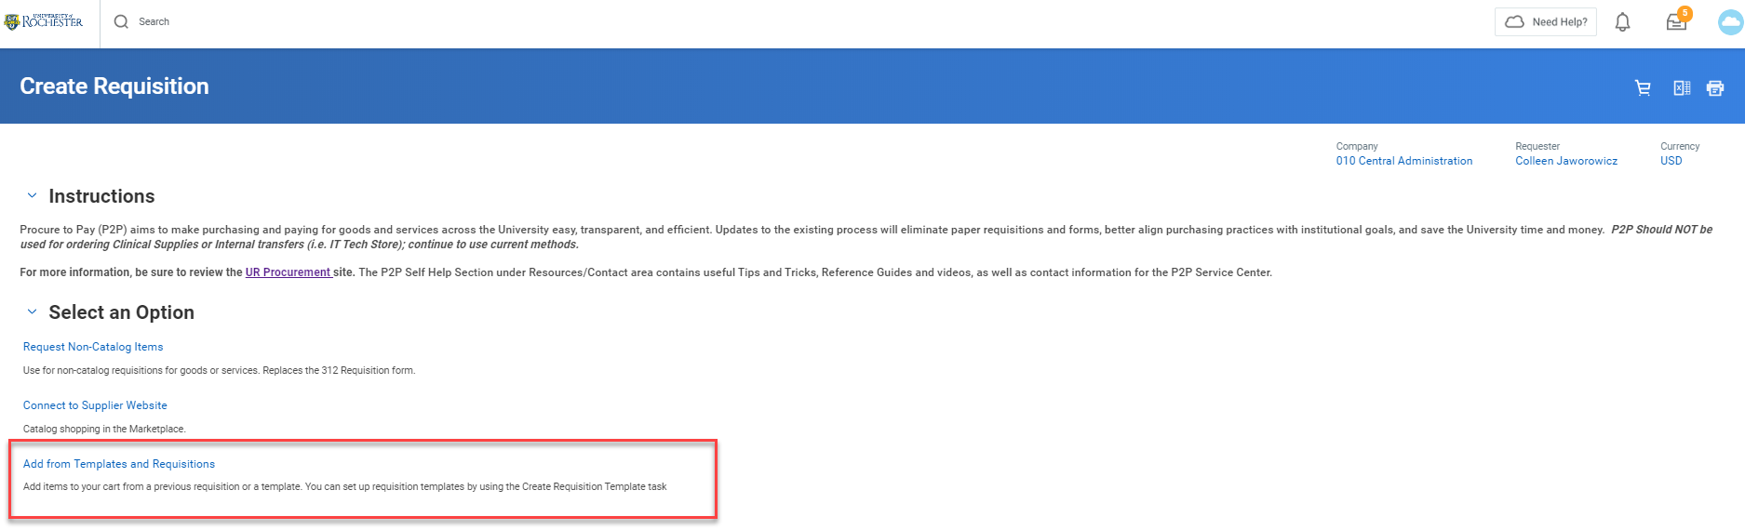
- Search for the requisition by clicking at the top of the Requisition column and typing the number in the <Value> field. Click <Filter>. | 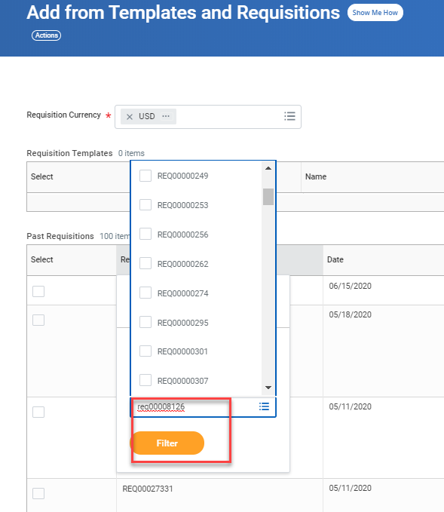
- Check the box for the requisition and then click <Add to Cart>. | 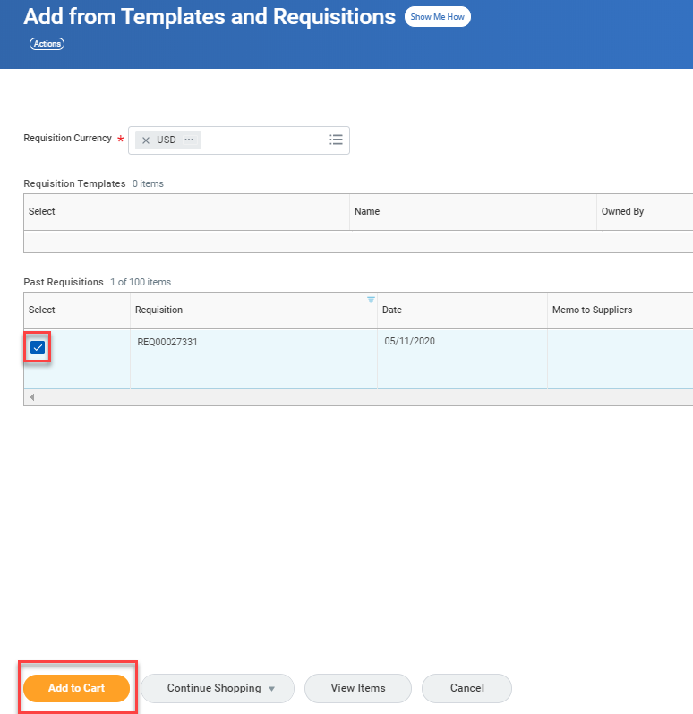
Check for accuracy.  - In the cart screen you can modify the description, price and memo fields.  - Click to each line for adjustments, as needed.  - When complete, click <Checkout>. | 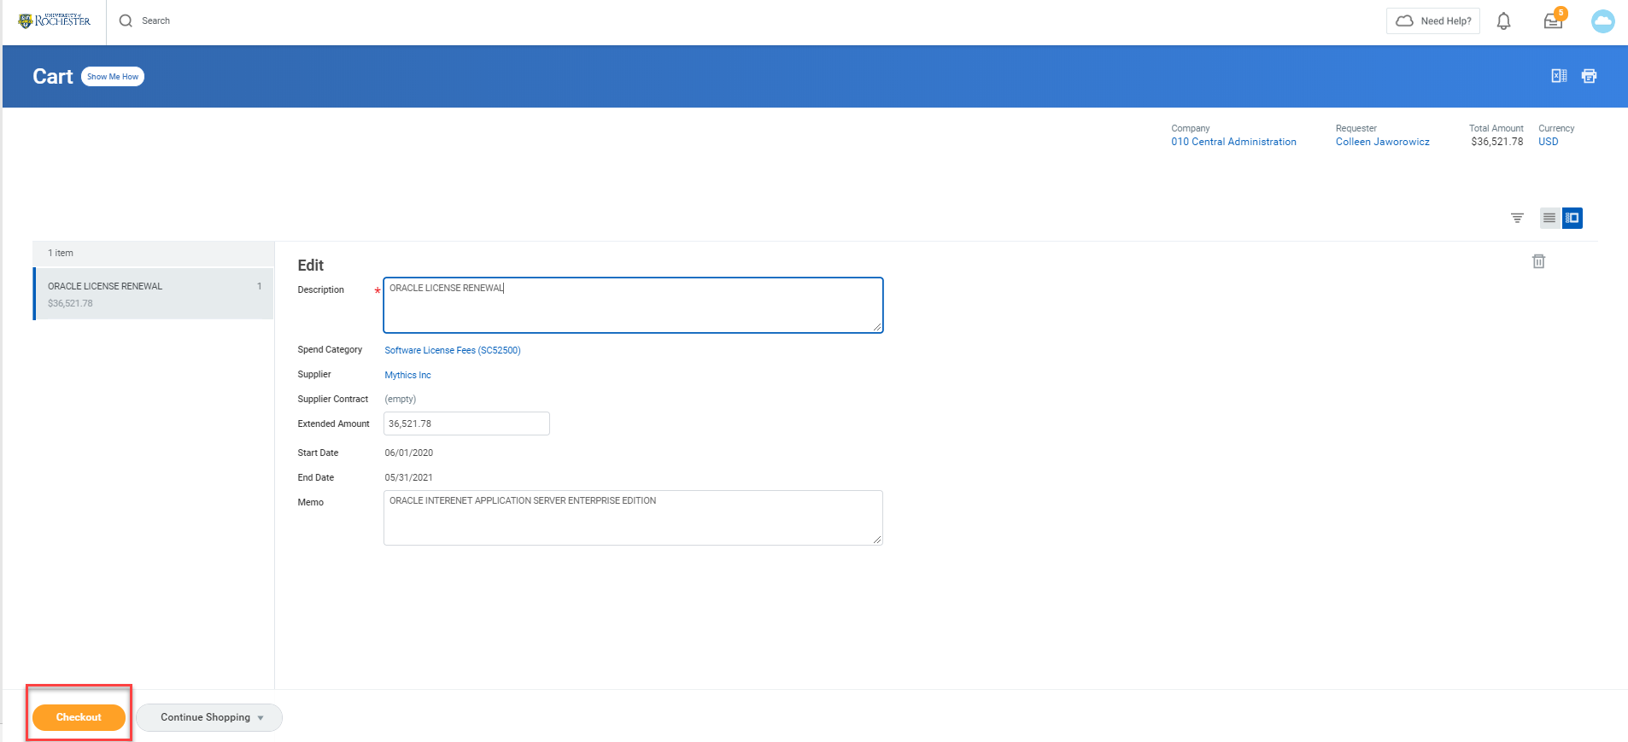
Anything can be edited on the checkout screen.  - If additional lines are needed, click on the plus sign at the top of the lines. Fill in as appropriate.  - Click on the arrow next to the word Attachments to add supporting documentation  - When complete, click <Submit>. | 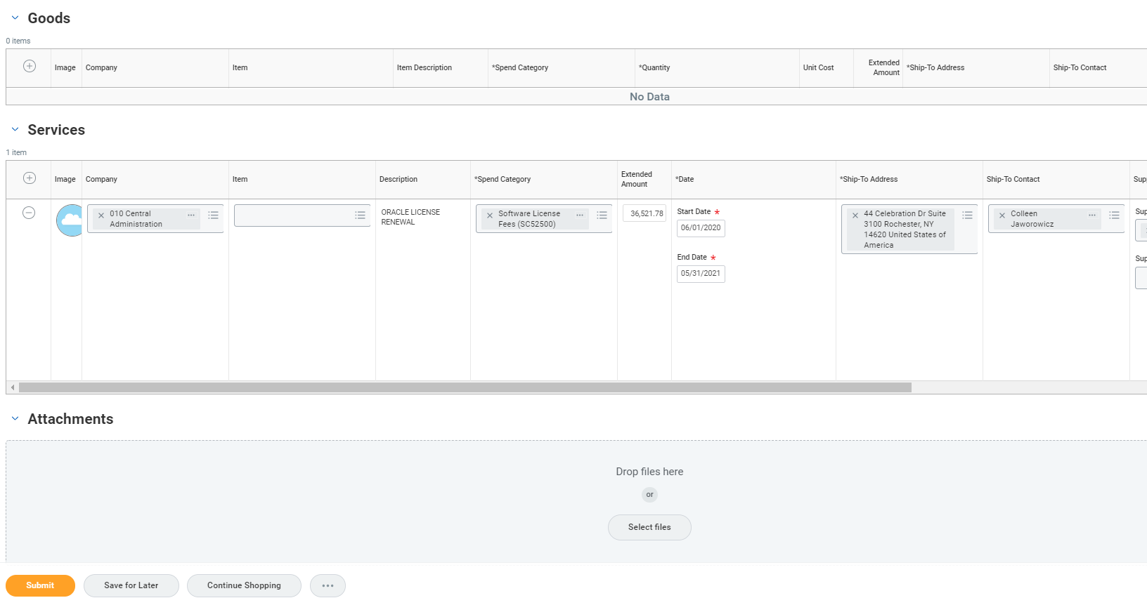
- Click on <Complete Questionnaire> to finalize submitting the requisition. | 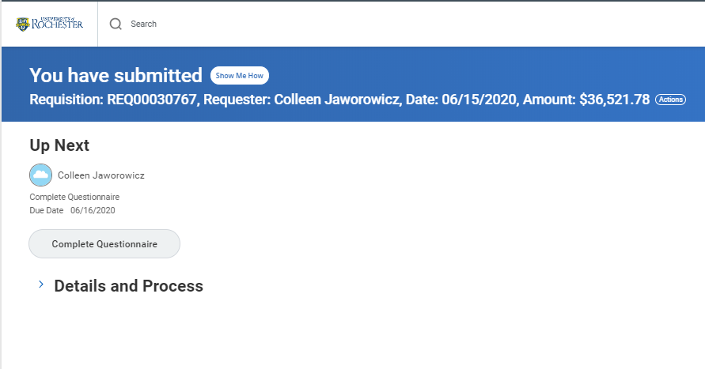
Answer the questions as appropriate and click on <Submit> when complete. | 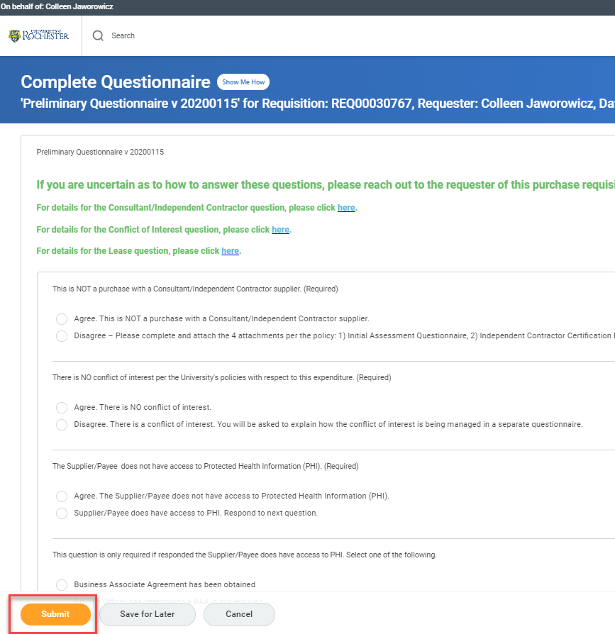
The system will tell you that you have successfully completed the questionnaire and will indicate to whom the transaction has routed. | 