UR Procurement – Create Return (Reverse Receipt)

Instructions | Details and Screenshots
Home page:  - Use the UR logo to return to this Home screen  - Use the Search field with keywords  - Use the Inbox for Workday messages  - Use the Procurement worklet for frequently used tasks and reports  - Create Return | 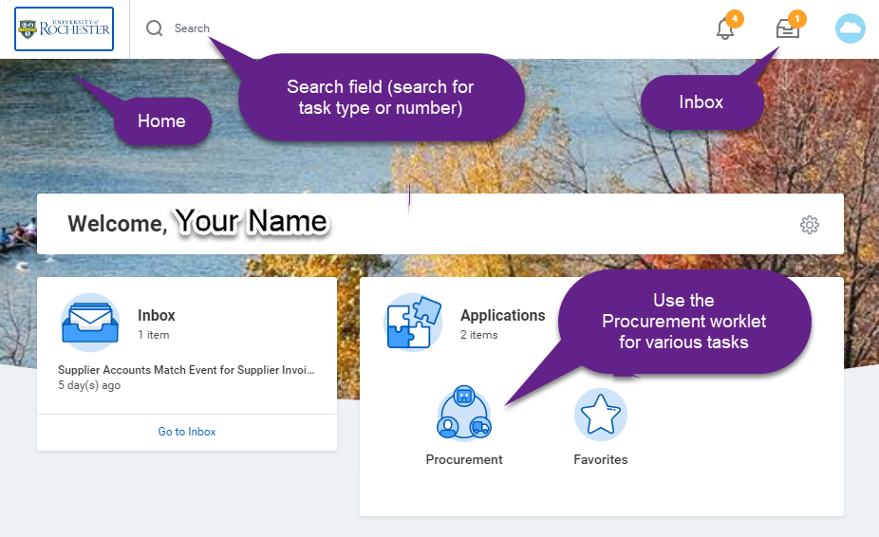
Rules | - Before initiating the return, contact the supplier for a RMA Number and return instructions. Do not proceed without an RMA. Creating a return in Workday only cancels a receipt and does not send any information to the supplier. You must reach out to the supplier directly in order to arrange a return.  - A return can only be created if there are one or more receipts.  - A return can only be created for goods lines.
From the Procurement dashboard  - Select <Create Return> and then search for order that needs to be returned  - Can also use the My Open Requisitions to review a list of orders and create a receipt from the purchase order, this will be shown later in this document. | 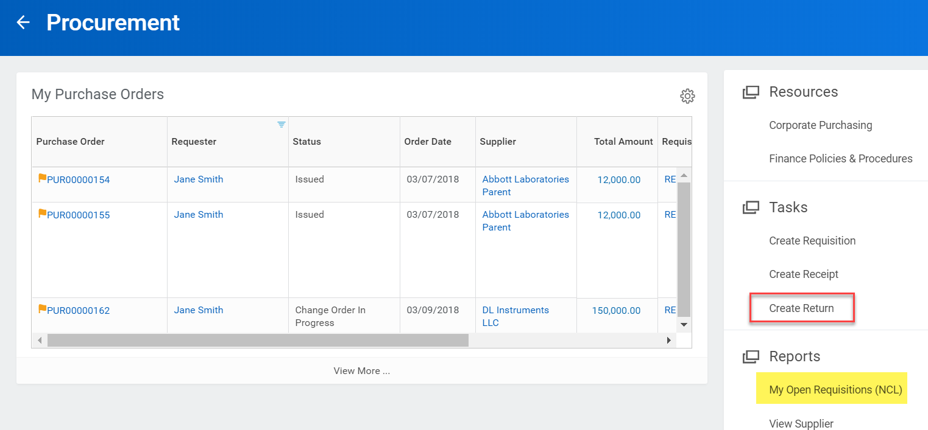
After selecting <Create Return> search by purchase order, supplier contract, or Receipt as indicated.  - Select the Purchase Order radio button and search for the PO number starting with PURxxxxxxx  - Or, select the Supplier Contract radio button and search starting with SPCxxxxxxxx  - Or, select the Receipt radio button and search starting with RCTxxxxxxxx  - Select <OK> | 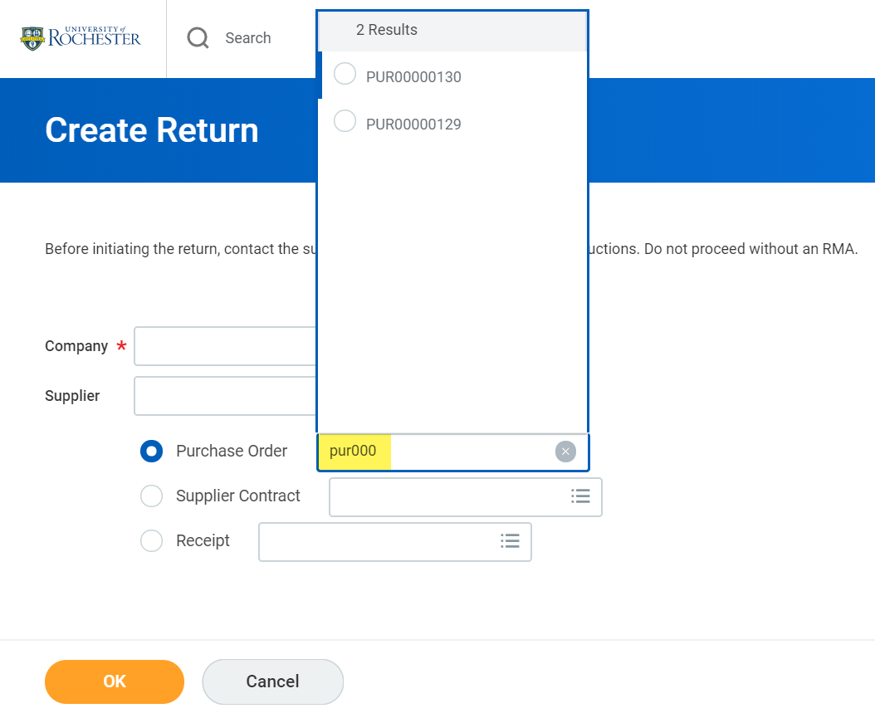
- Enter the Return Reason & Date  - Enter the Supplier Invoice Reference  - Enter the Supplier RMA  - Scroll down to the line level details | 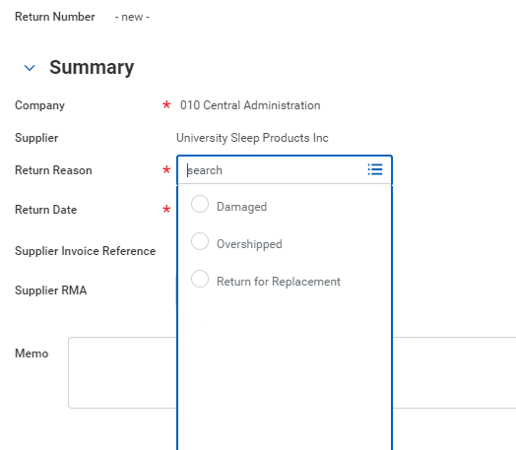
- Enter the To Return quantity for the appropriate line items | 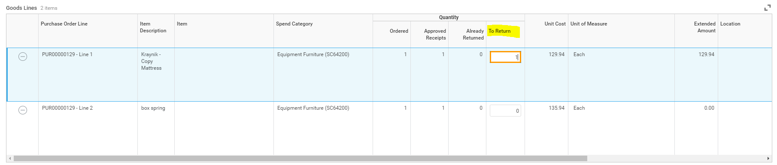
When ready, select <Submit> button. | 
Then follow the Suppliers return instructions. | Creating a Return in Workday only reverses a receipt. This does not send any information to the supplier and you will need to contact the supplier directly in order to arrange for the receipt.

