**Finding Payment Status for Supplier Invoice Requests (SIRs)**

Departments have access to look for Supplier Invoice Requests charged within their Cost Center. Access to that Cost Center is needed in order for the reports below to be available. If you still have questions after following these instructions, contact the Procurement Service Center for help.

Several ways to look for a Supplier Invoice Request are available.

1. Search for the invoice you submitted to be paid via SIR in Workday by entering the invoice # in the **Search Box** then clicking on **All of Workday** under **Categories**.
   1. 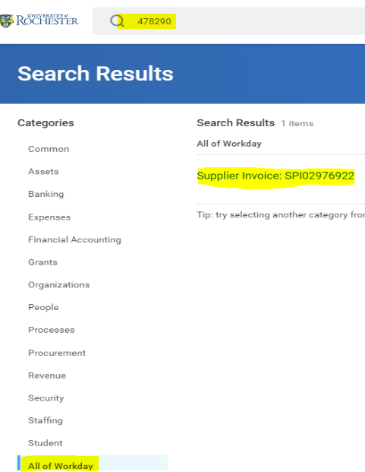If the invoice number has any special characters, spaces, or preceding 0s, omit them when entering the invoice number.
   2. Click on the **Search Result**, then on the next screen refer to **Payment Status** across the top of the screen.
   3. If it says Unpaid, look at the due date to see when the invoice is due. If it’s not due yet, you will not be able to see payment information until it is due.
   4. Accounts Payable settles check payments 1 day before their due date, and ACH payments 2 days before their due date.
   5. If it says Paid, refer to the steps below.
   6. From the **View Supplier Invoice** screen, click on the **Activity Tab** for payment details.

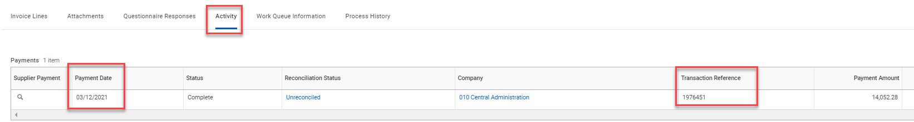

* + ***ACH Payments:*** 
    - ACH payments are usually received within 2 days of the payment date.
* ***Check Payments:*** 
  + The **Transaction Reference** number is the check number.
  + The **Payment Date** is the date the check was printed and mailed out.
  + **Reconciliation Status** will be reconciled if they cashed the check. If they didn’t cash the check yet, the status will be unreconciled.

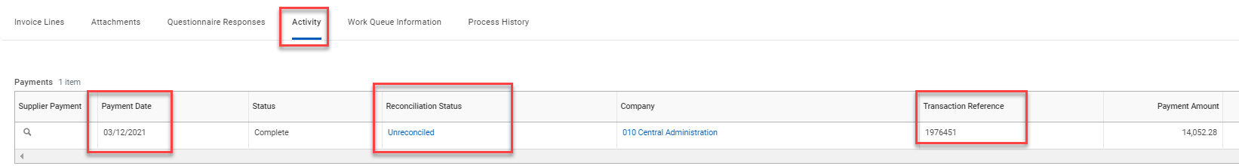

* + If it has been more than 3 weeks since the check was mailed, and it is still unreconciled, the supplier’s remit-to address is within the US, and they confirm they have not received the check, email Accounts Payable (accountspayable@finance.rochester.edu) and ask that we submit a stop payment due to the check being lost. A form will be available to use in the future, and it will be accessible via the Accounts Payable website.
* ***EFT Payments*:** 
  + The Transaction Reference number will be blank.
  + EFT Payments are issued by Cash Management.
  + The payment date is the date the EFT was sent.

1. Search for the invoice by looking up the SIR number using the **Search Box** in Workday or by going to your **UR Procurement Dashboard**.
   1. If you use the **Search Box**, enter the full SIR number, click **All of Workday** under **Categories**, then on the **Search Result**.

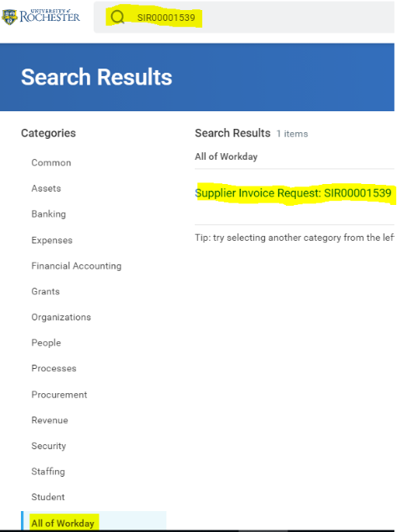

* 1. If you use your UR **Procurement Dashboard**, click on UR Procurement under Applications, then click on View More under **My Supplier Invoice Requests**.

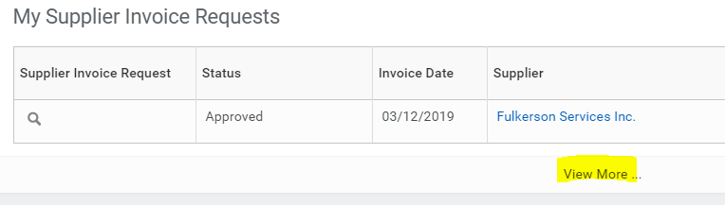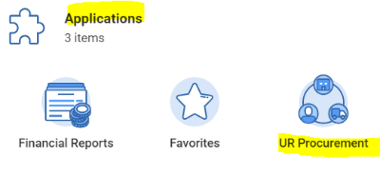

* 1. On the next screen, remove any default filters if needed, and use the fields provided to filter your results depending on the SIR you’re looking for, then click OK.

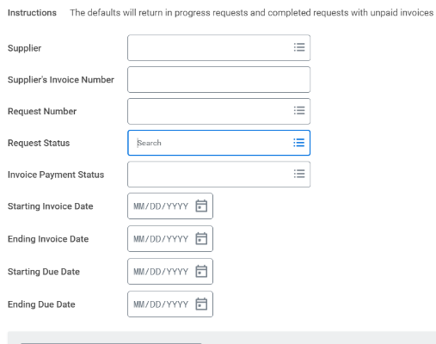

* 1. The next screen will show the report generated. After you locate the SIR you are looking for, open it by clicking on the Icon shown below.

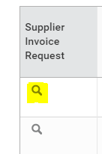

* 1. The next screen will be labeled **View Supplier Request**. If the SIR is fully approved, you will see a **Supplier Invoice** you can click on under Additional Information.

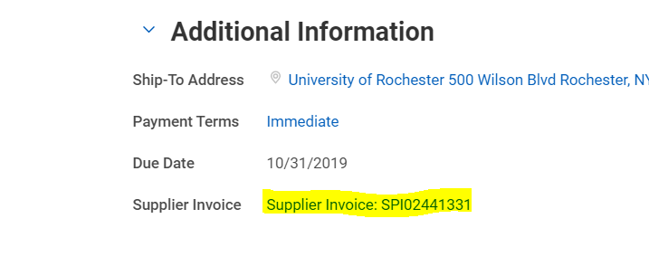

* 1. The next screen will be labeled **View Supplier Invoice**. Use the instructions on page 1-2 of this document to look for payment status.