

March 2021 UR Procurement Feature Release – User Interface Changes

On March 13th, UR Procurement, successfully completed its March Feature Release upgrade. All users will notice slight changes in how the system appears. Below are the improvement highlights.

If you experience any issues after the upgrade, please contact the P2P Service Center at [procurement_service_center@ur.rochester.edu](mailto:procurement_service_center@ur.rochester.edu) (585) 275-2012, or [submit a Support ticket.](https://uidp.its.rochester.edu/idp/profile/SAML2/Redirect/SSO?execution=e1s1)

**Default Approval/Submit Buttons**

The default **Approval, OK** and **Submit** buttons have changed from orange to blue.  This is to increase contrast for accessibility and screen readers.



**Mini Conclusions – What’s Next?**

It’s now easier for you to keep tabs of what happens after completing select tasks. Once the **Submit**,or **Save for later** button is selected at the end of a task, a small summary window appears. This pop up lets you know the next steps on the task you just completed. For example, it may show that an approval or further processing (i.e. questionnaire) is needed, with additional links to related resources.

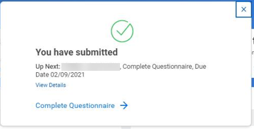

**End to End Status**

You can now see an end to end status with P2P Transactions including invoice and receiving status

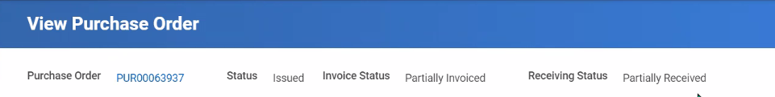

You will also see line item level **business document status** information

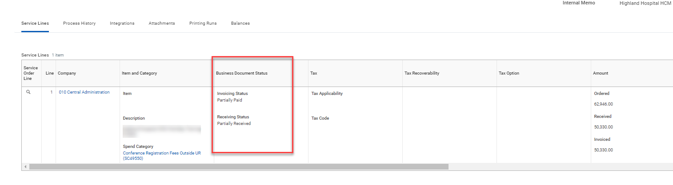

|  |  |  |  |  |  |  |  |
| --- | --- | --- | --- | --- | --- | --- | --- |
| **Reports, Tables and Grids**  Select read-only tables, grids and reports have increased their performance and usability by adding new viewing options for assistive technologies. These new options include table-viewing features to expand and collapse table cells, page numbers for long reports and more.   * Exporting Report Option  |  |  | | --- | --- | |  | - This **View Printable Version (PDF)** icon replaces the print icon by first downloading it as an Adobe PDF file to save or send to print from your browser tab. | |  |  |  * Reporting Filters – The New ‘Back Button’  |  |  | | --- | --- | |  | - This **Change Selection** icon returns users to the report criteria page to change criteria filters and rerun reports. Use this instead of the back button | |  |
|  |  |

* + Tables View

When selecting the new tables view (blue toggle), this feature will be turned on for all supported tables in the system. Users can turn it off at any time and the tabs will disappear*.

|  |  |  |  |
| --- | --- | --- | --- |
|  | | - **Collapse Rows** reduces the height of the rows which allows more rows to be seen on screen. Cells with more data can be individually expanded by using this icon when seen | |
|  | | - **Expand Rows** (default view) shows the full content in rows. | |
| \**In future releases, this toggle will be removed and all supported tables will remain in expanded rows view.* | | | |

* Pagination Control

|  |  |
| --- | --- |
|  | – Long reports have been broken into separate shorter pages allowing users to navigate to specific pages without having to scroll throughout the entire table. This pagination control now appears below tables with more than 30 rows saving you time when working with large data sets.  Note: When filtering or sorting, it will sort or filter on the entire table data set, not just what is on screen. |