UR Procurement – Create Change Order

Instructions | Details and Screenshots
Home page:  - Use the UR logo to return to this Home screen  - Use the Search field with keywords  - Use the Inbox for Workday messages  - Use the Procurement worklet for frequently used tasks and reports | 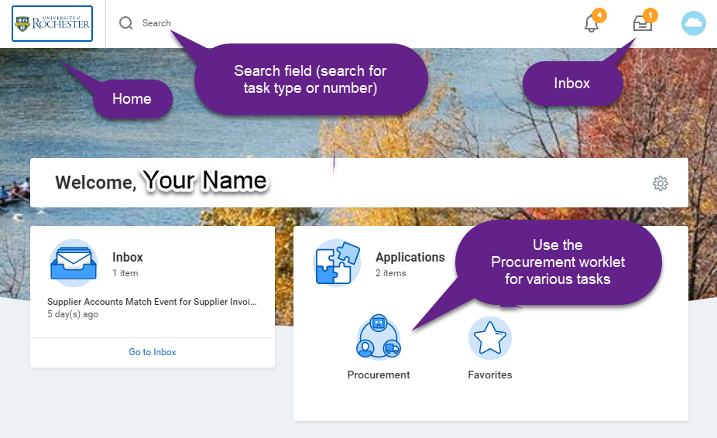
Rules | - Change Orders can be used to revise the purchase order to:  - Change the FAO. This change will trigger the approval hierachy.  - Increase the value of the purchase order. This change will trigger the approval hierarchy and be sent to purchasing also.  - Requisitioners can create a change order for their own purchase orders to resolve:  - Quantity discrepancies. The change order can be used to increase the quantity on the purchase order.  - For example: if you’ve ordered 10 of something and the supplier shipped 15. If you are going to keep the extra 5, you will create a receipt for 15 and create a change order to increase the quantity from 10 to 15. This change order will be submitted for approval.  - Price discrepancies. The change order can be used to add additional funds to a purchase order to cover an overbill.  - Once an invoice is applied to a PO line, the unit cost cannot be changed. If there is a unit price discrepancy and purchasing has reassigned the match exception to you in order to initiate a change order, you can use the change order to add a new line with the correct unit cost.
- A change order is typically required to resolve a Supplier Account Match Exception.  - This reference guide will use the following example:  - PO has a goods-based line for a quantity of 2 (of something)  - Requisitioner created a receipt for 2 when the order came in.  - A few days later, another shipment of 2 arrived  - An invoice was sent to AP for a total of 4. | The requisitioner received the following Supplier Account Match Exception notification in his/her Inbox:  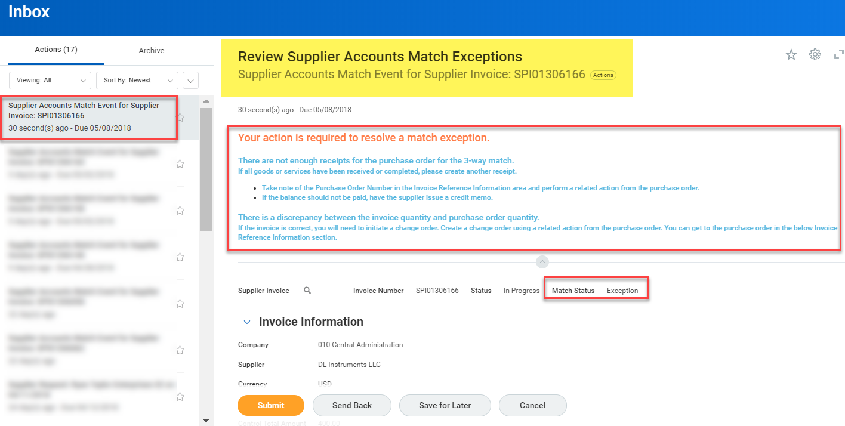
- Notice there are two requirements in the notification to the requisitioner  - Not enough receipts  - Quantity discrepancy  - In this case, the department wants to keep the extra shipment and instructs the requisitioner to create a Change Order so the invoice can be paid | 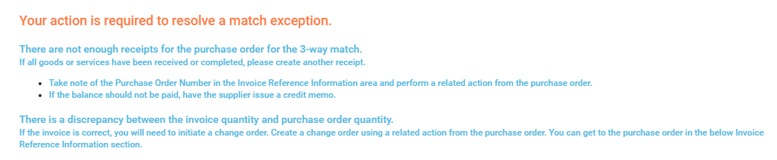
- Find the purchase order number within the Supplier Accounts Match Exception notification. It is located in the Invoice Reference Information section.  - Hover your mouse cursor over the purchase order number and select the Related Actions button appears and | 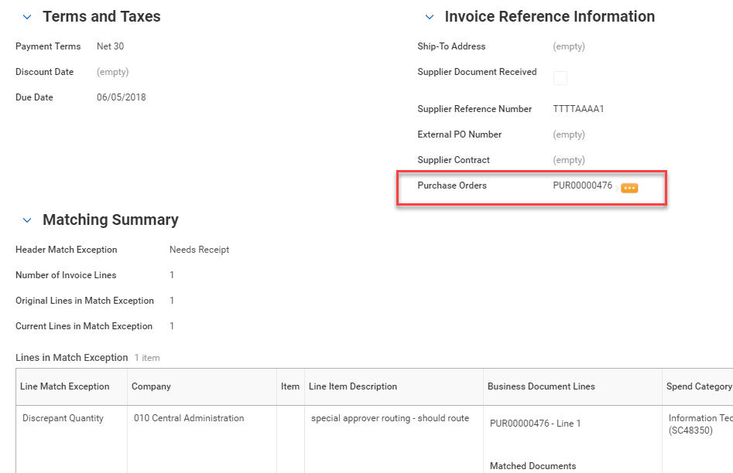
- Select the purchase order number | 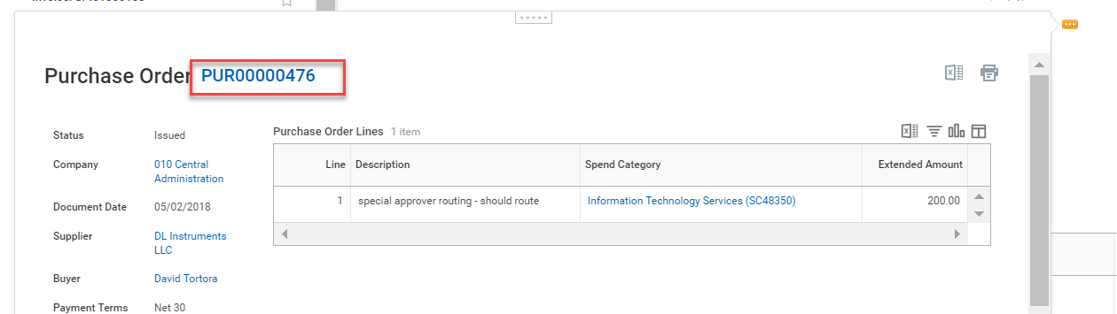
- Select the Related Actions button next to the purchase order number  - Select Purchase Order  - Select Create Change Order | 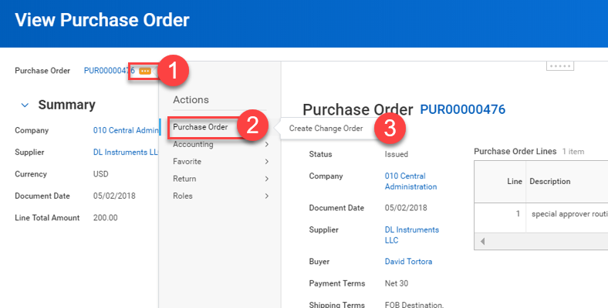
- Take note of the Help Text at the top of the Change Order screen  - If the Change Order should not be sent to the supplier, such as for internal changes, change the Issue Option to Phone | 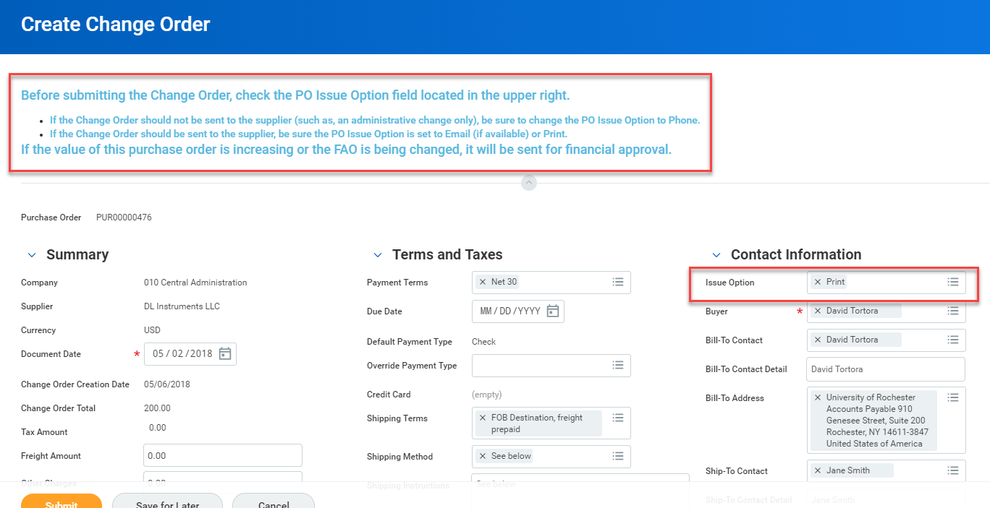
- In this case, the goods are already received and invoiced and we don’t want the supplier to ship more; therefore change the Issue Option to Phone. | 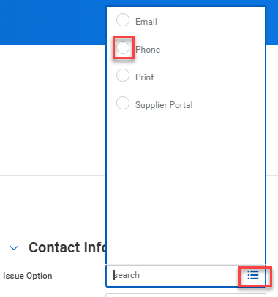 now becomes =>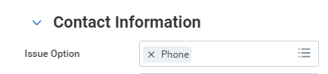
- Scroll down to the Goods Line area.  - Take note of the Quantity area | 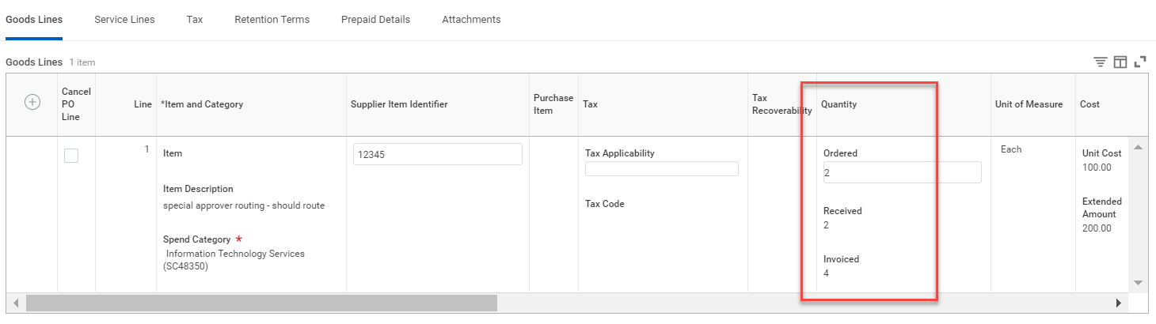
- Increase the Quantity Ordered from 2 to 4.  - Notice that the Extended Amount automatically updates to the new extended amount. | 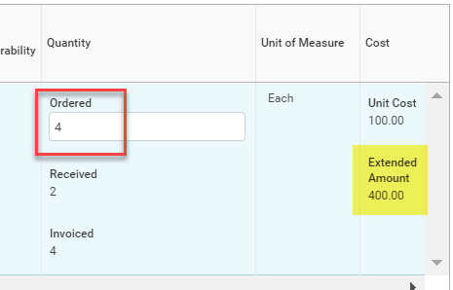
- Add a note in the Internal Memo field to explain the change you are submitting | 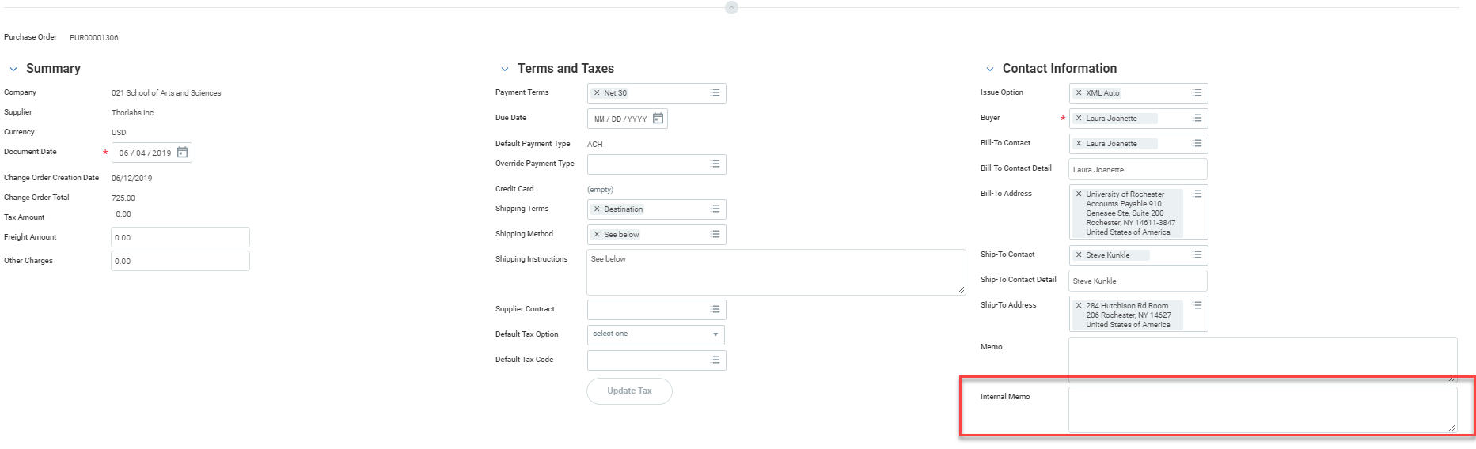
- Select <Submit>  - The Change Order has been submitted for approval. | 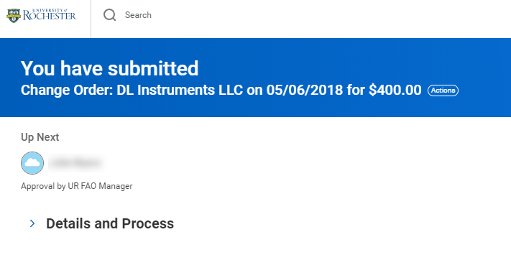  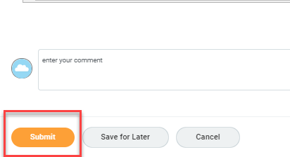
- The status of the Purchase Order shows Change Order In Progress | 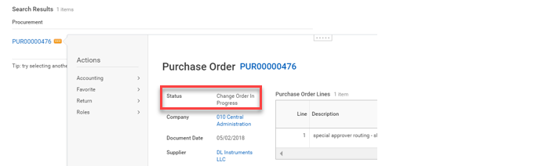
- You can check the status by going to the purchase order and viewing the Version History and selecting the magnifying glass icon in the Pending Changes area. | 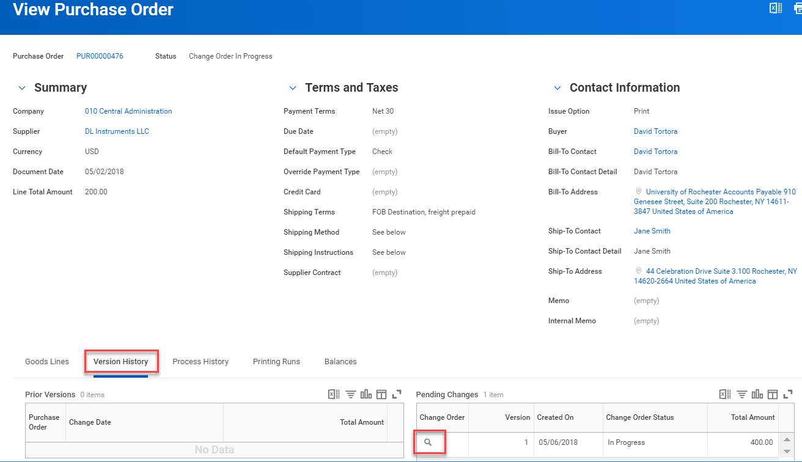
- The requisitioner will still need to create a receipt since there is still a supplier accounts match exception in the Inbox for ‘not enough receipts.’  - Follow the Create a Receipt reference guide for help with receipts. | 