UR Procurement – Supplier Invoice Request (F4/request for payment replacement)

Instructions | Details and Screenshots
Home page:  - Use the UR logo to return to this Home screen  - Use the Search field with keywords  - Use the Inbox for Workday messages  - Use the Supplier Accounts dashboard for frequently used tasks and reports | 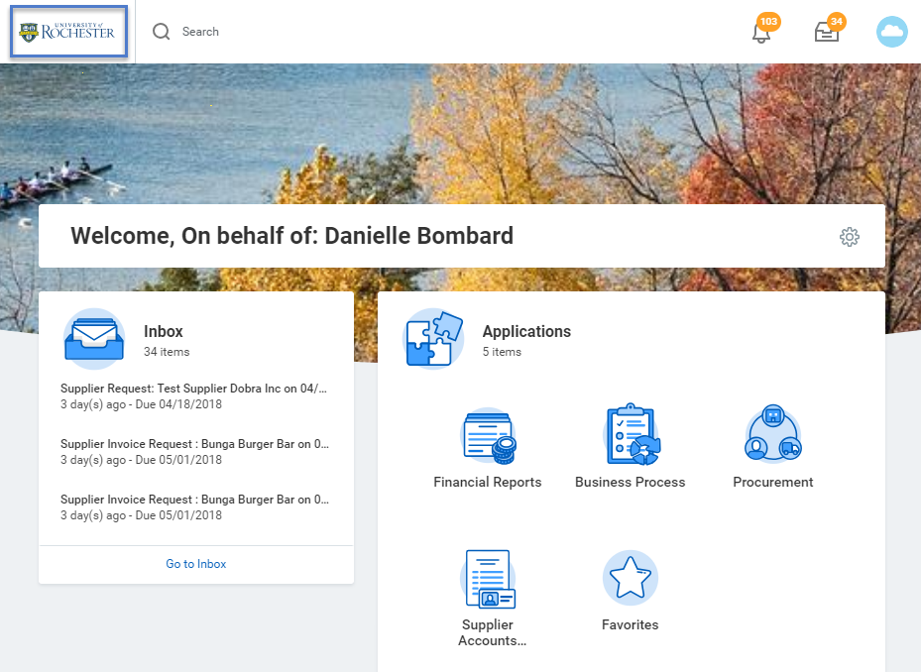  Home  Search field (search for task type or number  Inbox  Use the Procurement worklet for various tasks  Use to view/access Supplier Invoice and Supplier Accounts
Rules | - Before initiating the Supplier Invoice Request, be sure you are familiar with Acceptable Usage.  - It is best practice to search for an invoice/payment prior to creating a Supplier Invoice Request to prevent duplicate payment  - Find Supplier Invoice Lines (NCL) URF0992  - Find Supplier Invoice Requests
Select the <Supplier Accounts> dashboard  - Select <Create Supplier Invoice Request> from the Tasks area.  - You can also search for ‘create supplier invoice request’ in the global search box and select <Create Supplier Invoice Request> | 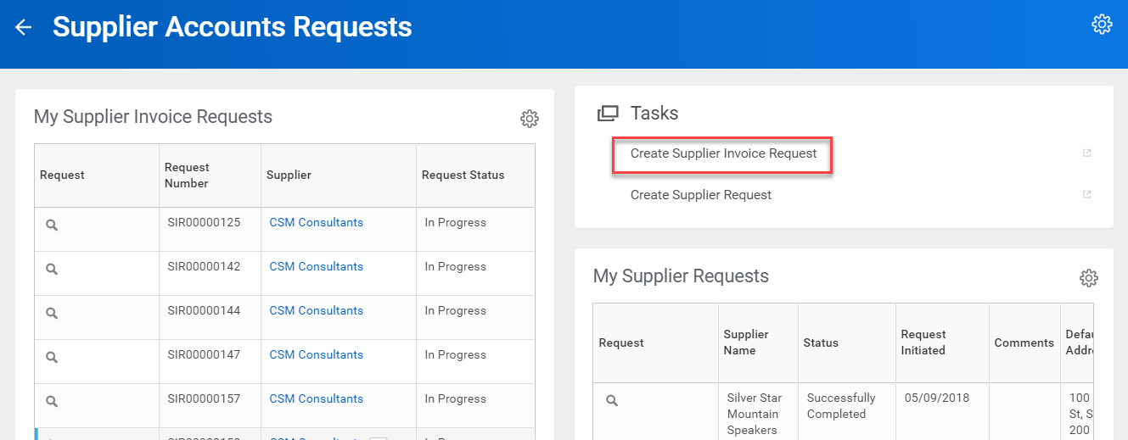  Or use global search…  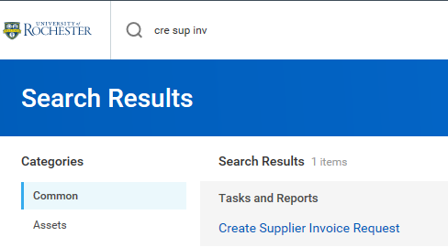
After selecting <Create Supplier Invoice Request> you will be prompted to complete the request form. Header information:  - Invoice Date. This defaults today’s date so be sure to select the actual invoice date from the invoice.  - Company  - Supplier Name  - Control Total Amount  - Supplier’s Invoice Number (if applicable)  - Ship-To Address – Ignore since this is only used on requisitions/purchase orders  - Payment Terms – Default Payment Terms for the supplier populate when the supplier is selected. Keep in mind you will need to explain on the Questionnaire if you feel payment is needed differently than the default.  - Handling Code. Be sure to select one of the following Handling Codes when initiating a SIR. Below are the guidelines for selection:  - Pickup: Select this if you want to be contacted to pick up the check when it is ready. Given the inherent urgency of this selection, Rush is implied, but only one special handling fee will be charged.  - Mail Back: Select this if you must have the check returned to a department for distribution.  - Enclosure: Select this if you think the payee will find it beneficial to receive documentation with their check payment so that they better understand what they are receiving the check payment for.  - Memo – Keep in mind anything you type here will be forwarded to the supplier in the remittance information provided on their check stub or ACH confirmation | 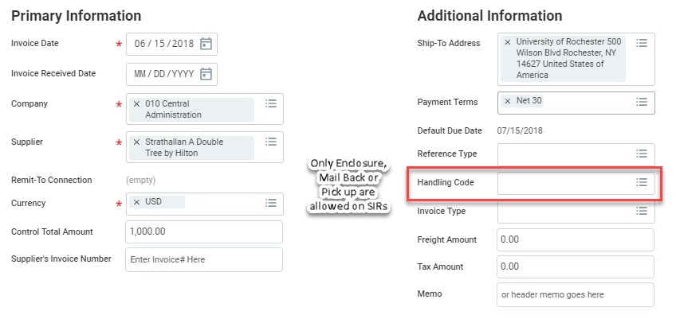
Next enter Line information  - Select Goods or Services Line as appropriate and enter the details:  - Item Description  - Spend Category  - Quantity  - Unit of Measure  - Unit Cost  - Additional Worktag: Enter your FAO and select <enter>. The other required worktags will automatically populate. Do NOT enter the Company for FAO, Cost Center or Fund individually.  - Memo – Line Memo  - Internal Memo – enter the business purpose for the request. Can also be used to enter tracking information for your department’s internal reporting (e.g. 4th digit of the subcode)  - Additional lines can be added for different items or to charge different FAOs or Spend Categories by clicking on the Add button  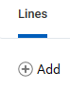 | 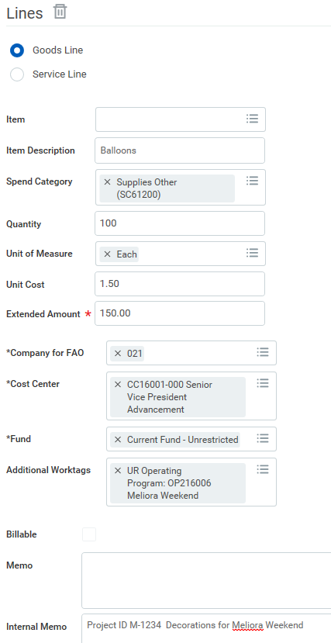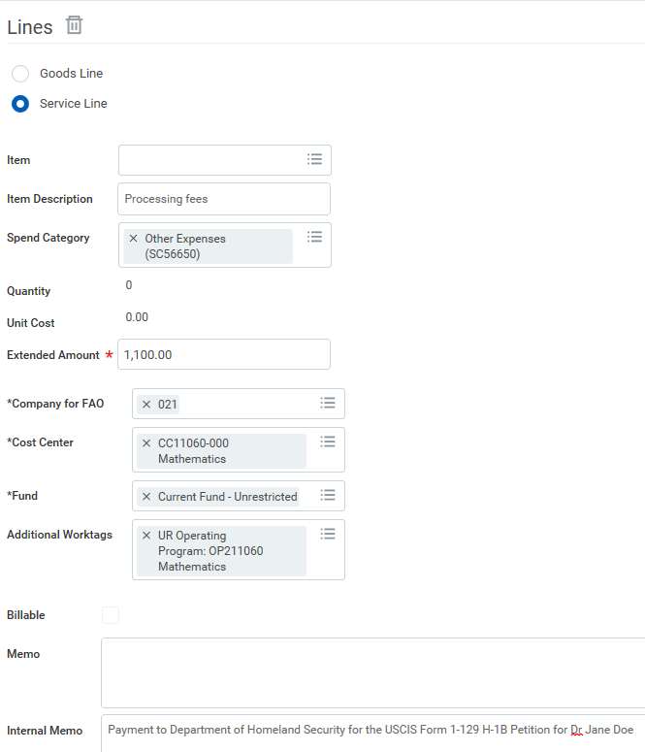
- Attachments are almost always required. The only exception is for study participation payments when a W9 is not required. | 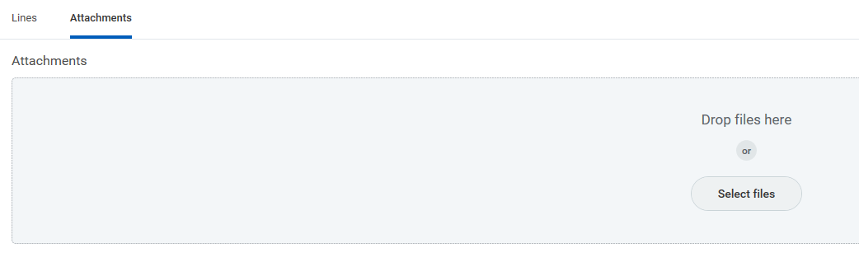  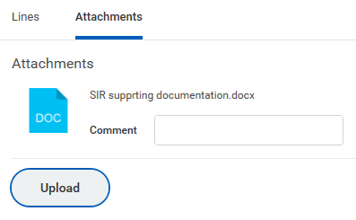
- Select Submit when you have finished  - Select Save for Later if you do not have time to complete the required fields or need to research something before finishing  - Select Cancel if you determine the SIR should not be submitted | 
- Several custom validation are in place to ensure correct entries.  - Select View All for guidance on what data needs to be corrected | 
- Once you Submit you will see a confirmation screen  - You can view the Details entered and Process information  - Click on <Complete Questionnaire>. It is required before the SIR moves on for any approvals/reviews. | 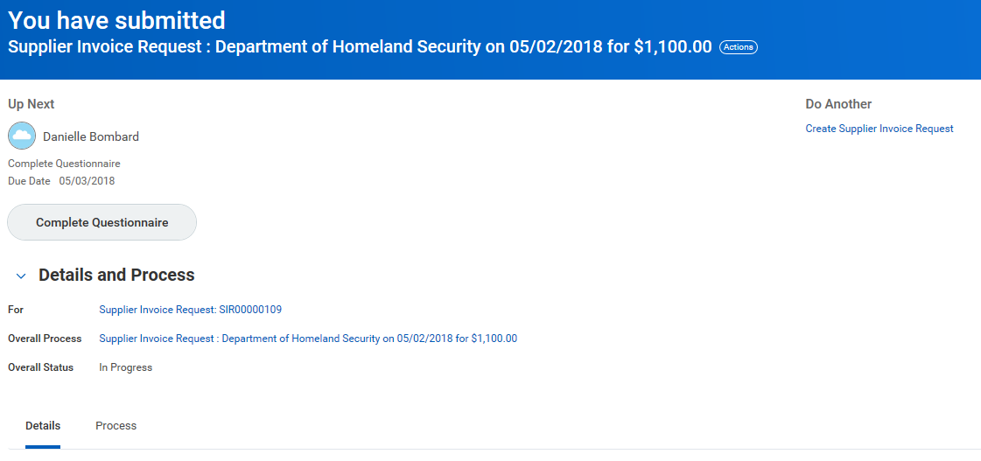
- Complete the Questionnaire  - The questions are designed to ensure proper usage of the SIR and provide additional instruction  - If you answer <Disagree> to any SIR question, you may be required to explain or justify your response through a comment or follow up question.  - Branching questions and/or attachments are required for some responses | 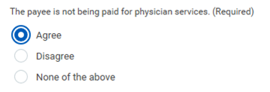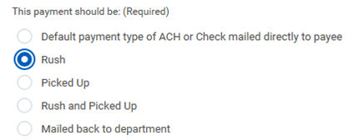    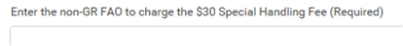
- Select Submit when you have finished

- Once you Submit you will see a confirmation screen  - You can view the Details entered and Process information  - Others Awaiting My Action is a listing of other SIR Questionnaires that are not started or incomplete (saved for later)  - Note who is Up Next in the process. In this example the Spend Category is marked for Procurement Usage  - The Procurement Category Manager may coach you to use preferred purchasing methods in the future or let you know they are cancelling your SIR and you must submit a Requisition for the invoice to be matched/paid  - The Accounts Payable 1099 Analyst may contact you for a W9, to clear up Independent Contractor paperwork, or clarify other tax reporting issues  - Approvers cannot edit your submission. If changes are needed they will Send Back to you and when you re-submit with corrected information it will re-start the approval process.  - Note that the Workday Invoice Number (SPI #) is assigned upon Accounts Payable submission when the Supplier Invoice is created. | 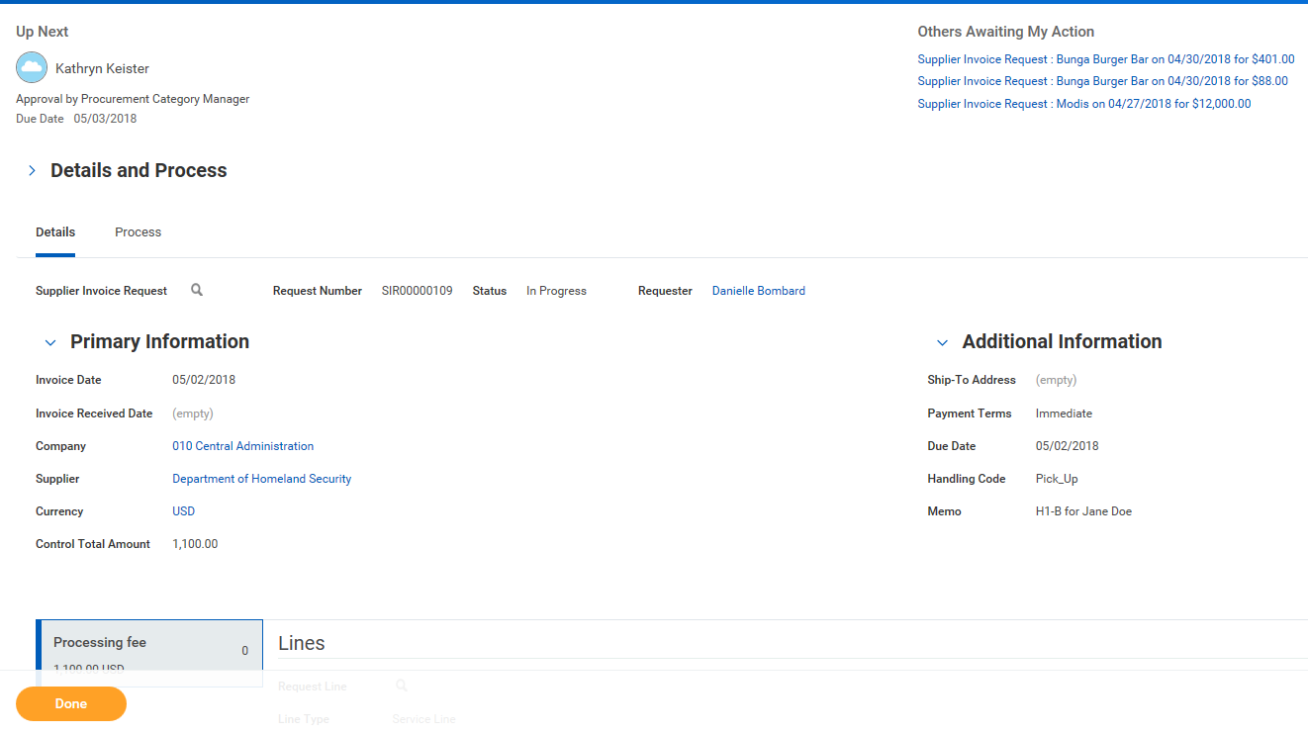
To find your supplier invoice request:  - Go to the Supplier Accounts dashboard to see your pending and completed Supplier Invoice Requests  - You can also use the global search box and search on <Supplier Invoice Requests>  - Select My Supplier Invoice Requests | 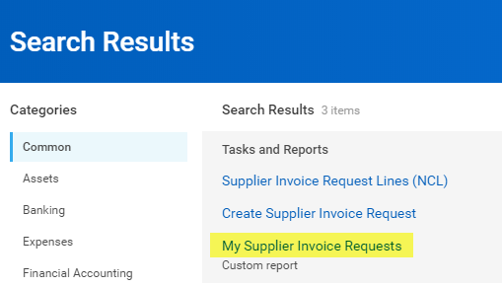  Select to see all your supplier invoice requests
- To see all your supplier invoice requests, select <OK>  - You can also narrow the search by selecting additional filters. | 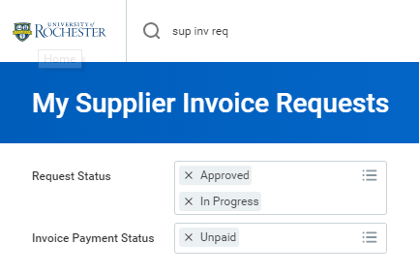
- Locate the supplier invoice request in question and notice the Status.  - If it’s In Progress, select the supplier invoice request record and view the Process History section to see who is responsible for the next business process step. | 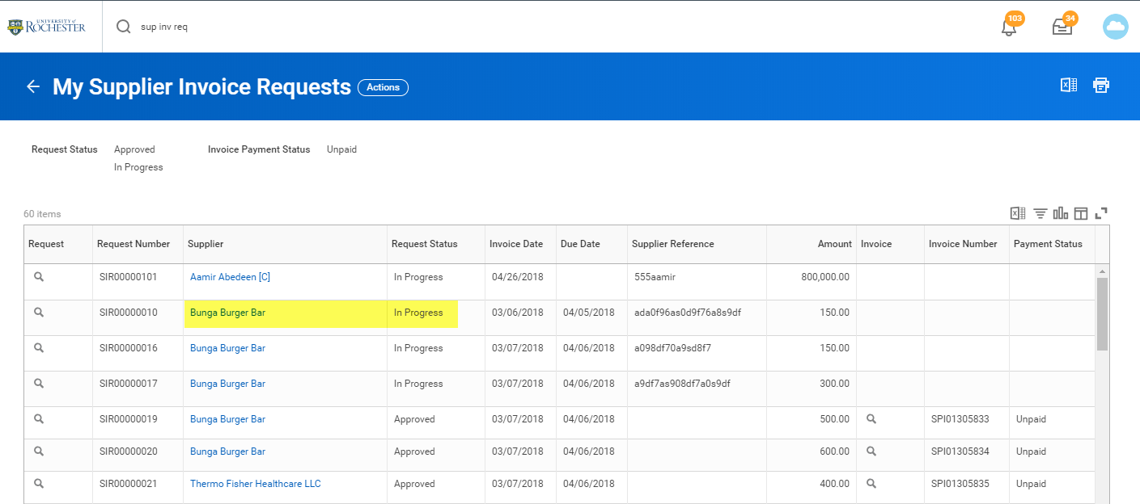  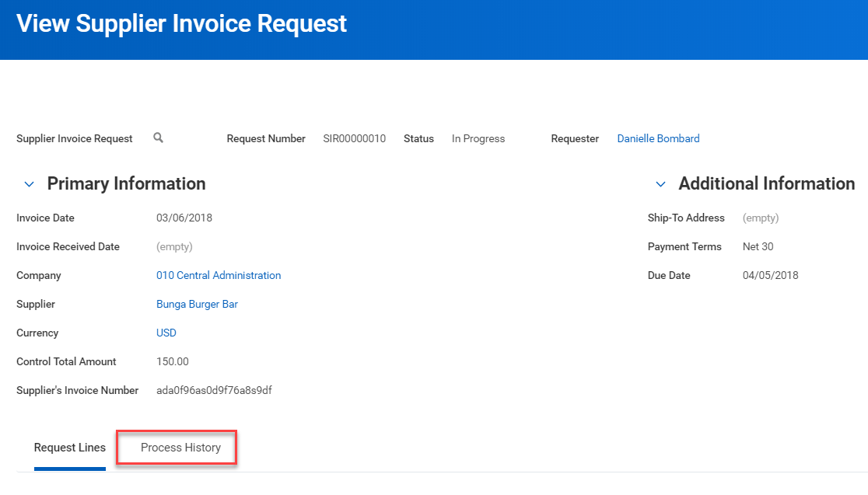
- The process history tab will show where the SIR is in the approval cycle. | 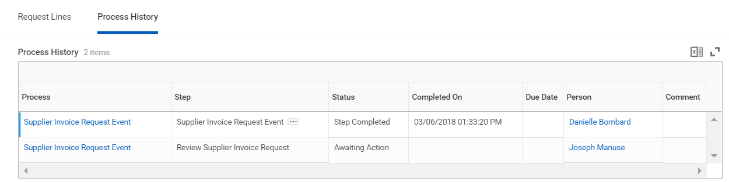

Instructions | Details and Screenshots
Cancelling a Draft or In Progress SIR  - If you need a cancel a draft or in-progress SIR, locate the SIR from the Procurement Dashboard worklet called My Supplier Invoice Requests.  - Select the Related Action [orange] button next to the magnifying glass.  - Under the Actions, hover your mouse over Supplier Invoice Request and select <Cancel>.  - Then select <OK> to confirm cancellation. | 